DEPARTMENT OF AGRICULTURE AND RURAL DEVELOPMENT OF QUANG NINH PROVINCE
water resources INVESTMENT AND DEVELOPMENT MANAGEMENT UNIT NO. 2

DAM REHABILITATION AND SAFETY IMPROVEMENT PROJECT

REPORT
ENVIRONMENTAL AND SOCIAL IMPACT ASSESSMENT (ESIA)
Sub-project: REPAIRING AND UPGRADING
HEADWORKS COMPLEX OF KHE CHE RESERVOIR

April, 2019
DEPARTMENT OF AGRICULTURE AND RURAL DEVELOPMENT OF QUANG NINH PROVINCE
WATER RESOURCES INVESTMENT AND DEVELOPMENT MANAGEMENT UNIT NO. 2

DAM REHABILITATION AND SAFETY IMPROVEMENT PROJECT

REPORT
ENVIRONMENTAL AND SOCIAL IMPACT ASSESSMENT (ESIA)
Sub-project: REPAIRING AND UPGRADING
HEADWORKS COMPLEX OF KHE CHE RESERVOIR

HANOI
April, 2019

EXECUTIVE SUMMARY

1. Background: The repair and upgrading of Khe Che Reservoir is one of the 12 sub-projects being proposed for first year implementation of the World Bank-assisted Dam Rehabilitation and Safety Improvement Project (DRSIP). An Environmental and Social Impact Assessment (ESIA) is carried out to comply with the requirements of the World Bank Environmental Assessment Policy (OP/BP 4.01) and the Vietnam Law on Environment Protection (LEP). As part of the ESIA, the subproject underwent consultations with local communities regarding its associated social and environmental issues and impacts.

2. The reservoir is located at An Sinh Commune, Dong Trieu District, Quang Ninh Province, 78 km from Ha Long City and Hanoi Capital from 90 km, the reservoir was constructed in1986. In 1995-1998, the dam was repaired and a number of items under head works system was upgraded. The reservoir lake has a basin area of 22.4 sq. km and the capacity of the reservoir is 12 million cubic meters. The head works and auxiliary works complex of the reservoir consist of the following:

- Dam: Dam is built with homogeneous soil at a height of 20m and length of 658 m. The crown level is at 26.9 m and 4.2 m wide.
- Spillway: The spillway is a long based weir with cement lining. The overflow is 5 m long and 14 m wide and a height of 23.48 m.
- Off take regulator: The off take regulator at the right abutment of dam has valve house at the upstream of dam. The regulator has a reinforced concrete structure with dimension of 1.0m × 1.3m.
- Management and operation road: The management and operation road along the inter-commune road up to the bridge has a concrete pavement while the section from bridge up to dam surface (about 110 m in length) is currently a dirt road. This road connects to the local road next to the lake.

3. Present condition of dam is poor and unsafe. The Khe Che reservoir has been operating for nearly 30 years now since the last major repair. Based on the Dam Safety Assessment conducted as part of the DRSIP preparation, the issues include: overflow channel has not been reinforced and the left abutment has a 30m long section of masonry. The wing wall at right abutment of the input section has been cracked; the dam surface has been raised. In the course of long-term use, landslides have occurred and sweating potholes have formed. Underbrush has grown sparsely along the crest while the upstream wall has some cracks. The head of coping dam has been broken. The management road is rough and full of potholes, making regular reservoir monitoring difficult and inefficient. The off take regulator valves installed in the 1990s has been rusted and no longer in use. The reservoir was designed and rated as a level III facility. However, recent floods have already exceeded the original designed parameters. The three communes downstream of Khe Che namely An Sinh, Tan Viet, Viet Dan with over 3000 inhabitants are currently at risk.

4. Proposed repair and upgrading works: The proposed works will: (i) ensure dam safety and the flood regulation function of the reservoir; (ii) ensure reliable irrigation water source for about 1,000 hectares of cultivated land, including 534 ha of rice; (iii) enhance the dam landscape and ecology for tourism; (iv) promote economic growth in the project zone, including the development of aquaculture. The following are the proposed work items:

- Earth Dam: Repair on the dams include rehabilitation and expansion of the downstream section to restore embankment at the desired compaction coefficient; reinforcement of the top of the dam by a 20-cm thick M200 concrete; exterminate termites; and fixing of the water seepages and penetration in the dam body and foundation.
- Flood Spillway: Works include expansion and upgrade of the overflow weir from 14 m to 24 m; the rehabilitation of the chute and flanks with reinforced concrete and rebuilding of the weir bridge, among others.
- Water Intake: Various repair works including clearing and re-lining of the culvert, reinforcement of the external valve tower, repair of the tower building and service bridge, replacement of the steel gate, etc.
- Operation House and Communication System: Construction of head works operation house with 4th grade house standard and gross area of 150m² and installation of automatic reservoir water level observation system to facilitate the works management and operation.
- Power Line: Installation of 1.8 km long LV wire lines from weir shoulder to flood spillway for management and operation purpose.
- Management Road: Reinforcement of the section behind the water intake to flood spillway with specifications of 1.7 km length, M200 concrete, 20cm thickness and 3m width. Hardening of 139-m road section towards the dam surface. Construction of rescue road which would also serve as the access road to the weir extension works.
- Culverts: Upgrading of existing two (2) culverts under the management road with reinforced concrete M250 to increase their flood discharge capacity. The two culverts are: Tan Viet culvert with 4 gates: 4 x (6x3.5)m; and Ba Xa culvert with 2 gates: 4 x (6x3.5)m.
- Others: Provision of equipment for rescue in case of floods and storms and monitoring equipment.

5. The subproject is designed based on the Dam Safety Assessment conducted following the World Bank Safety of Dam Policy (OP/BP 4.37) as well as the standards of the Socialist Republic of Vietnam.

6. Environmental and Social Screening. There are no critical natural habitats near the dam and the area is not known to harbour any rare or endangered species but a small portion (0.4 ha) of forested land will be permanently converted for use by the dam. The An Sinh commune where the construction activities will be implemented is mainly inhabited by Kinhs who constitute the mainstream ethnic group in Vietnam. There are no ethnic minority households to be affected, however, there are 135 beneficiaries’ ethnic minority households in sub-project, It is necessary to prepare an Ethnic Minorities Development Plan for the sub-project. The Dam is categorized as large dam and therefore subject to review by a Panel of Expert and submission of Dam Safety Plan. There are no grave, temple or any culture, belief, religious structures affected in the project area. Although the proposed repair works will use new lands but these are currently unoccupied and hence no households will be affected. The sub-project is an Environmental Category A as per World Bank OP/BP 4.01.

7. Environmental and social impacts. The implementation of the sub-project will bring huge benefits to the local community in a form of stable and reliable water supply, improved safety and better protection against floods. However, the subproject will have some negative impacts that need to be mitigated. The significant impacts are as follows:

8. Loss of trees and secondary vegetation - The sub-project will require acquisition of a total 16,706.3 sq. m of lands, 600 puine trees, 15 sq.m of brick wall and yard of 8 households. These lands are unoccupied by any private individual and hence do not need Land Clearance from the government. There will be no impacts on households or crops.

9. Impacts of construction activities. According to the calculations, the total volume of excavated soil for construction works of the project is about 55,459 cubic meters while the volume of backfill soil is 3,412 cubic meters. Thus, about 51,051 m3 needs to be moved to the disposal area. The disposal area is located along the foot of the dam with total capacity of 52,500 cubic meters. The number of workers in the peak period is about 50 workers. The number of trucks is 3600 turns over a period of 10 months. Based on these, the impact of construction will be as follows:

- Temporary increase in sedimentation and turbidity of the reservoir
- Elevated concentration of dust at the excavation site, the foot of the downstream slope of the dam where excess soils will be disposed
- Interruption in the water supply for about 5-7 days during the repair of the intake
- Possible damage to roadways along construction routes, particularly on the 300-m route to Hai San pit and the 10-km inter-commune route to the Dong Trieu town centre
- Increased health and safety risk for residents and workers due to exposure to various hazards brought about by the construction activities, equipment traffic and migrant workers
- Potential conflict between migrant workers and local residents
- Construction waste management including domestic waste from workers, discarded or excess materials, and hazardous wastes items
- Temporary migration of wildlife

10. The amount of domestic wastes (i.e. wastewater and solid waste) will not be significant but these would require standard containment (i.e. septic tank, soak pit), collection and disposal (i.e. solid wastes to the landfill).

11. Long term impacts. Long term impacts includes possible land and soil degradation at the construction site and vicinities due to loss of vegetation, alteration of terrain due to excavation, compaction, construction spoils, litters and wastes. The improved irrigation water supply is also expected to promote intensive agricultural production in the service area thereby increasing use of pesticides.

12. Mitigation Measures: A detailed Environmental and Social Management Plan (ESMP) has been prepared and included in the ESIA Report. The specific mitigation measures are as follows:

- Requiring the contractor to undertake restoration of the top soil and landscaping of the unused portions of the 4,000 sq meter levelled mountain side, with trees and grasses
- Undertaking the construction only during the dry months, newly placed embankments and landfill should be immediately compacted and stockpiles should be placed away from runoff.
- Regular sprinkling of the ground in the excavation area, the routes to the landfill and to Hai San pit, as necessary throughout the construction period should be undertaken.
- Consulting the farmers on the exact timing of the cut-off with a lead time of at least one month
- Requiring the contractor as part of the contract, to undertake repairs and provide adequate detours, if necessary, along the routes and to restore any damage sustained by the routes after completion of the construction.
- To reduce health and safety risks for local residents, the contractor is also required to provide safe passageways for residents as well as barrier fences and warning signs in dangerous areas of the construction site; impose vehicular speed limits on residential areas; provide water and sanitation facilities at its campsite; undertake medical screening of its workers; and, strictly implements standard health and safety protocols for workers and maintain good community relations
- Regular collection of domestic garbage and hazardous waste and dispose them into the community landfill/garbage dump
- Imposition of ban of wildlife poaching and hunting among workers and avoidance of construction activities during night time
- Requiring the contractor undertake clearing and restoration of sites after completion of works;
- Introduction and promotion of the Integrated Pest Management approach among farmers in the area
- Adoption and setting up of Grievance Redress Mechanism. The GRM should be set up at prior to the start of construction
- Adoption of DRSIP Chance Find Procedure; and,
- Adoption of the Unexploded Ordnance Procedure.

13. Consultations: In the process to prepare the ESIA report for the Khe Che reservoirs improvement sub project, the two community consultation meetings were held. The first community consultation meeting conducted on January 31, 2015 at the Dong Trieu irrigation exploitation company. The second round consultation conducted from March 11, 2015. The participants include representatives of DARD, Department of Culture, DoNRE, Designer consultants and representatives of An Sinh and Viet Dan communes and community members. The result of community consultation reveals that 100% participant consent with the project implementation. Local people and government are ready to support for the project implementation. The consultation also recorded some recommendation from community namely: The constructor and project owner should comply the right mitigation environmental and social measures; comply the labor safety requirements to prevent the risk for the local community and affect the rural infrastructure. The constructor needs to well manage their workers to ensure the public order in the project area. Based on the community recommendation, the project owners commit to comply the social and environmental mitigation measures proposed in the EISA and request the constructor to comply the labor safety requirements for worker and sanitation in the construction site; and request constructor are responsible to compensate for the local people if constructor break/ cause any lost to asset of local people.

14. Resettlement Action Plan (RAP): The implementation of Khe Che reservoir will require acquisition of a total 16,706.3 sq. m of lands, 600 puine trees, 15 sq.m of brick wall and yard of 8 households.
Total compensation and resettlement value: VND 251,782,000
Including,
Compensation for land and assets on land is: VND 201,034,162
Support amount: VND 45,748,180
Cost for site clearance: VND 4,936,000

15. Ethnic Minority Development Plan: Tay Ethnic minority account for 91,8% (124 HHs) of the total Ethnic minority in the Sub - project area (135 HHs). All the EM households benefited from the project and do not bear negative impact due to project implementation. The consultation with EM in the FPIC manner shows that there is broad community support from EM peoples for the subproject implementation. Besides, based on the EM consultation result, the Sub project has designed the 3 development activities to bring more benefit for EM. These activities include: i) Training on sweet corn production; ii) Communication support; iii) Training on business development skills. The total budget of Development activities is 504,000,000 VND. EMDP will be further updated on the basis of the detailed design of the subproject.

16. Risk of dam broken failure: The dam failure of Khe Che reservoir will affect 8 communes and 1 town including: An Sinh commune, Binh Duong commune, Duc Chinh commune, Viet Dan commune, Tan Viet commune, Thuy An commune, Trang An commune, Nguyen Hue commune and Dong Trieu town of Dong Trieu district with estimation of effect: 11,464 households; 38,076 people; area of agriculture and aquaculture land: 4,298 ha; 39 historic and culture vestiges that have 4 historic vestiges in national-level vestiges; public works including: 09 People's Committee headquarters of communes, towns, schools, hospitals and clinics; affecting the highway 18, railway crossing region of districts, and a lot of district roads, inter-communal road.

17. Cost Estimate. The estimated cost of the subproject is VND 53.271.995.161 (Equivalent to 2.536.762 USD). This includes about VND 881,199,000 estimated cost of ESMP implementation and compliance monitoring.

ACRONYMS AND ABBREVIATIONS
AH : Affected Household
CPO : Central Project Office
DARD : Department of Agriculture and Rural Development
DRSIP : Dam Rehabilitation and Safety Improvement Project
EM : Ethnic Minority
ESIA : Environmental and Social Impact Assessment
ESMoP : Environmental and Social Monitoring Plan
ESMP : Environmental and Social Management Plan
IPM : Integrated Pest Management
MARD : Ministry of Agriculture and Rural Development
MONRE : Ministry of Natural Resources and Environment
MoIT : Ministry of Industry and Trade
MWL : Medium Water Level
ODA : Official Development Assistance
PMU : Project Management Unit
PPC : Provincial People’s Committee
PPCH : Plant Protection Chemicals
RAP : Resettlement Action Plans
WB : World Bank
TSP : Total Suspended Particles

TABLES OF CONTENTS
EXECUTIVE SUMMARY c
ACRONYMS AND ABBREVIATIONS g
TABLES OF CONTENTS 2
LIST OF TABLES 5
LIST OF FIGURES 6
CHAPTER I: INTRODUCTION 1
1.1. Spatial Coverage of the Assessment 1
1.2. Environmental Aspects Covered 1
1.3. Methods and Approaches for Environmental Assessment 1
1.4. Approaches and Methodology for Social Assessment 2
1.5. Consultants 2
CHAPTER II: SUB-PROJECT DESCRIPTION 31
2. 1. Background 31
2.2. The Proposed Repair Works 33
2.3. The construction schedule 43
CHAPTER III: POLICY, LEGAL AND ADMINISTRATIVE FRAMEWORK 44
3.1. Country's Environmental and Social Safeguards Policies and Legislations 44
3.1.1. Environment 44
3.1.2. Dam safety regulations 45
3.1.3. Land acquisition 46
3.1.4. Indigenous/Ethnic minority people 47
3.2. Implications of National Policies and Regulations on the Proposed Project 47
3.3. World Bank Safeguard Policies 48
3.4. Implications of World Bank Safeguard Policies on the Proposed Project 48
CHAPTER IV: BASELINE ENVIRONMENTAL AND SOCIO-ECONOMIC CONDITIONS 50
4.1. Physical environment 50
4.1.1. Characteristics of the catchment area 50
4.1.2. Receiving stream of the spillway 50
4.1.3. Climatic Conditions 50
4.1.4. Water environment 51
4.1.5. Air Environment 54
4.1.6. Soil environment 54
4.2. Biological environment 55
4.2.1. Observation location of ecological background 55
4.2.2. Flora 56
4.2.3. Fauna 57
4.2.4. Sensitive area 58
4.3. Socio-economic and socio-cultural environment 58
4.3.1. Overview on socio-economic situation in the project site 58
4.3.2. Results of the Survey 60
4.4. Past Incidences 70
CHAPTER V: IMPACTS ASSESEMENT 71
5.1. Social and Environmental Screening 71
5.2. Positive Impacts 71
5.3. Negative Impacts and Issues 72
CHAPTER VI: ANALYSIS OF ALTERNATIVES 78
CHAPTER VII: ENVIRONMENT AND SOCIAL MANAGEMENT PLAN 79
7.1. Mitigation Measures 79
7.2. Monitoring 81
7.3. Responsibilities and Capacity Building 82
CHAPTER VIII: PUBLIC CONSULTATION AND INFORMATION DISCLOSURE 84
8.1. Public consultantation objectives 84
8.2. Social impact assessment consultantion 84
8.3. Environment impact assessment consultantion 84
REFERENCES 86
APPENDIX OF KHE CHE ESIA 87
APPENDIX A1. DRAWING OF WORKS ITEMS 87
APPENDIX A2. CLIMATIC AND METEOROLOGICAL DATA IN KHE CHE RESERVOIR AREA 91
APPENDIX A3. ANALYSIS RESULTS OF QUALITY OF SURFACE WATER ENVIRONMENT 93
APPENDIX A4. ANALYSIS RESULTS OF GROUND WATER AT 3 COMMUNES: AN SINH, VIET DAN, TAN VIET 94
APPENDIX A5. OBSERVATION RESULTS OF AIR SAMPLE 95
APPENDIX A6. OBSERVATION RESULTS OF SOIL QUALITY 96
APPENDIX A7. PHYTONPLANKTON DENSITY AT SURVEY AREA 97
APPENDIX A8. ZOOPLANKTON DENSITY AT SURVEY AREA 98
APPENDIX A9. MAPS 99
APPENDIX A10. ENVIRONMENTAL AND SOCIAL SCREENING FOR SUB-PROJECT 103
ELIGIBILITY SCREENING 103
SCREENING AND ENVIRONMENTAL CATEGORIZATION 103
ADDITIONAL REQUIREMENTS AND SUGGESTED TOOLS 107
LEVELS OF POTENTIAL ENVIRONMENTAL AND SOCIAL IMPACTS TO BE ADDRESSED 108
APPENDIX A11. PICTURES OF SUB-PROJECT 113
PICTURES OF THE CURRENT STATUS OF THE PROJECT 113
PHOTOS OF FIELD SURVEY AND PUBLIC CONSULTATION 114
PHOTOS OF SAMPLING 115
APPENDIX A12. CHANCE FIND PROCEDURES 117
APPENDIX A13. TERMITE TREATMENT PROCEDURES 118
APPENDIX A14. MITIGATION MEASURES 120
MEASURES TO MINIMIZE THE ENVIRONMENTAL IMPACTS OF THE SUB-PROJECT IN THE PREPARATION PHASE 120
MEASURES TO MINIMIZE THE SOCIAL IMPACTS OF THE SUB-PROJECT IN THE PREPARATION PHASE 120
THE MITIGATION MEASURES OF SOCIAL IMPACTS IN THE CONSTRUCTION PHASE 120
THE MITIGATION MEASURES OF ENVIRONMENTAL IMPACTS IN THE CONSTRUCTION PHASE 122
THE MITIGATION MEASURES OF SOCIAL IMPACTS IN THE OPERATION PHASE 124
THE MITIGATION MEASURES OF ENVIRONMENTAL IMPACTS IN THE OPERATION PHASE 125
ESTIMATECOST OF MITIGATION MEASURES 127
ESTIMATED COST FOR ENVIRONMENTAL MONITORING THE CONSTRUCTION PHASE 132
APPENDIX B1. PUBLIC HEALTH INTERVENTION PLAN 133
APPENDIX B2. PUBLIC CONSULTATION, PARTICIPATION AND COMMUNICATION STRATEGY 137
APPENDIX B3. GENDER ACTION PLAN 142
APPENDIX B4. SYSTEM OF COMPLAINT SOLVING 145
APPENDIX B5. DESCRIPTION OF IMPELMENTATION PREPARATION INCLUDING ORGANISING, INSTITUTION, SUPERVISION AND EVALUATION 148
IMPLEMENTATION OF EVALUATING REPORT 148
RESPONSIBILITY OF RELATED PARTIES 150
APPENDIX B6. OPERATION AND MAINTENANCE PLAN 152
APPENDIX B7. EMERGENCY PREPAREDNESS PLANNING (PPE) 154
APPENDIX C1. DUST ASSESSMENT FROM CONSTRUCTION ACTIVITIES 156
APPENDIX C2. NOISE ASSESSMENT 158
APPENDIX C3. ASSESSMENT OF WASTEWATER FROM CONSTRUCTION 160
APPENDIX C4. AIR EMISSION ASSESSMENT FROM CONSTRUCTION EQUIPMENT 161
APPENDIX D1. IPM PLAN 162
APPENDIX D2. PUBLIC CONSULTATION AND INFORMATION DISCLOSURE 171
Public consultation objectives 171
Social impact assessment consultation 171
Environment impact assessment consultation 171
ESIA disclosure 174

LIST OF TABLES
Table 2.1. Subproject Cost Estimate 33
Table 2.2. Work Items of the Sub-project and their configuration 34
Table 2.2. Auxiliary work items 37
Table 2.3. Volume of main materials for the project 39
Table 2.4. List of Equipments to be Used during Construction 42
Table 4.6. Weather station 51
Table 4.7. Sampling location at Khe Che Lake 52
Table 4.8. Sampling point at other locations of the project 52
Table 4.9. Sampling locations at the affected area of the project 53
Table 4.10. Coordinate of survey points at Khe Che Lake, Dong Trieu, Quang Ninh 55
Table 4.11. Population structure of communes at the downstream of Khe Che reservoir 59
Table 4.12. Several criteria for economic development in period of 2010 - 2013 59
Table 4.13. Agricultural production at downstream areas 60
Table 4.14. Demography and averag laborers per household 60
Table 4.15. Main occupation of laborers (including all member of HHs involved in labor force) 62
Table 4.16. Education level of household members (Unit %) 63
Table 4.17. Health and health care conditions 63
Table 4.18. Kinds of land of households 64
Table 4.19. Percentage of HHs in the project communes using water sources for domestic usage (%) 65
Table 4.20. Percentage of households using drinking water in the project areas (%) 65
Table 4.21. Types of toilets of surveyed households 66
Table 4.22. By income (%) 67
Table 7.1. Environmental and Social Mitigation Measures for the Khe Che Reservoir 79
Table 7.2. ESMP Compliance Monitoring Report Format 81
Table 7.3. Environmental Quality Monitoring Plan 81
Table 7.4 ESMP Implementation and Compliance Monitoring Responsibility Matrix 82
Table C1.1. Vehicle flow for material transportation in the project region 156
Table C1.2. Dust load in the process of extending the spillway and hardening the dam, road to the dam. 156
Table C1.3. Dust diffusion coefficient in the atmosphere in the z direction 156
Table C1.4. Dust content in atmosphere 156
Table C2.1. Maximum noise level (dBA) from the operations of means of transportation and mechanical equipment 158
Table C2.2. Harm effects of noise at the high level for human health 158
Table D1.1. Cost estimates for implementation of IPM programs IPM 167
Table D1.2. Support programs to improve environment management capability and techniques 168
Table D2.1. Summary of consultation process 172

LIST OF FIGURES
Figure 2.1. Location of project area 32
Figure 2.2. Location of work in Dong Trieu District 32
Figure 2.3. The sub-project area 39
Figure 2.4. Layout of estimated transport route for backfill soil 41
Figure 2.5. Layout of estimated transport route for material 42
Figure 3. 1. EIS process and public participant 45
Figure 4.1. Location of sampling station at the sub-project area of Khe Che reservoir 55
Figure 4.2. The size of households by income group 61
Figure 4.3. Occupation of Household Members in commune/ward 62
Figure 4.4. Percentage (%) of the causes adversely affecting to the health today 64
Figure 4.5. Kinds of toilets 66
Figure 4.6. Purposes of loan 68
Figure 4.7. Physical support in difficulties 69
Figure 4.8. Rate of receiving moral support in difficulties 69

CHAPTER I: INTRODUCTION

The Repair and Upgrading of the Headworks of Khe Che Reservoir is one of the subprojects identified for priority implementation under the Dam Rehabilitation and Safety Improvement Project (DRSIP), a World Bank-funded project in support of Vietnams Dam Safety Program. DRSIP aims to rehabilitate the aging dams to restore its designed functions and capacities and to protect residents and assets downstream of the dam from possible dam failure. The repair and upgrading works on Khe Che were identified through a Dam Safety Assessment. An Environmental and Social Impact Assessment (ESIA) was undertaken on the works in compliance with the requirements of the World Bank Environmental Assessment Policy (OP/BP 4.01) and the Vietnam Law of Environmental Protection (LEP). This report contains the result of the ESIA.

1.1. Spatial Coverage of the Assessment

The affected area considered in impact assessment for the sub-project include main construction areas at dam, offtake regulator, spillways; rock and soil pit, construction site, materials storage area , machinery and equipment, parking area, disposal sites, temporary and permanent sewage, accommodation for workers, public service road to dam, material and rock pits, waste dumps; water level in reservoirs; downstream channel. The affected area also includes areas that will be benefited or damaged by the sub-project. These include three communes/towns at downstream area (namely: An Sinh, Tan Viet and Viet Dan) who would benefit from stable supply of irrigation water and reduced risk of dam failure.

1.2. Environmental Aspects Covered

The ESIA covers the following environmental aspects:
- natural environment (i.e. climate, water, soil, minerals, and ecosystems).
- physical environment (i.e., water resources, hydrology, air, water and soil pollution, erosion and sedimentation, drainage, safety for stakeholders and existing infrastructure, taking into account for basic conditions such as climate, geography, topography, air quality)
- biological system such as flora and fauna, natural habitat, fisheries, etc. and
- socioeconomic and socio-cultural issues such as employment and income, gender, social security and life stability, access to basic services such as water, energy, health and education.

1.3. Methods and Approaches for Environmental Assessment

Method of field investigation, survey: Investigation, survey for the current state of environmental resources, rapid assessment of some indicators of water quality in the field to update and supplement the newest materials for project area.

Method of sociological investigation: Investigation, interview of people, leaders of affected and benefited areas.

Method of actual environment survey: Survey of actual environment in the field by sampling and analyzing indicators in the laboratory to determine the current status of air atmosphere, surface water quality, groundwater quality and soil quality in project area and surrounding areas.
- Air samples are taken by the absorption method with appropriate solutions, stored in accordance with TCVN 5975-1995, ISO 7934-1998; TCVN 5978-1995, ISO 4221-1980; TCVN 5968-1995; TCVN 5971-1995, ISO 6767-1990 and analyzed under TCVN 5971-1995, ISO 6768/1995.
- Soil samples are taken under the guideline of sampling, preservation engineering in accordance with TCVN 7538-2: 2005: (Soil quality - Guideline for sampling engineering)
- Quality of surface water, ground water is taken by water sampling device according to TCVN 6663-6: 2008 (ISO 5667-6: 2005). Handling and storage of water samples according to TCVN 6663-14: 2000 (ISO 5667-14: 1998);
- Soil, water samples shall be preserved and taken to the laboratory to ensure standards.

1.4. Approaches and Methodology for Social Assessment

The purpose of this social assessment (SA), conducted in an integral manner with environmental assessment for this subproject, is two-fold. First, it examined the potential impacts of the subproject positive and adverse impact on the basis of planned project activities. Second, its findings inform the design of measures addressing identified potential adverse impact and proposing community development activities that are relevant to the project development goal. For identified adverse impact that could not be avoided, consultation with local people, governmental agencies, project stakeholders, etc., were carried out to ensure affected peoples will be appropriately compensated for, and supported in a manner that their socio-economic activities will be promptly and fully restored to the pre-project level, at least, and that their livelihoods will not be worsen off, in the long run, as a result of the subproject.

As part of the social assessment, where ethnic minority (EM) peoples are present in the subproject area as confirmed by the EM screening (as per Bank’s OP 4.10), consultation with them were carried out in a free, prior, and informed manner, to confirm if there is broad community support from affected EM peoples for the subproject implementation. EM screening was conducted as per Bank’s OP 4.10, and was done the scope and coverage of the social assessment vis-à-vis the environmental assessment (OP 4.01). A gender analysis was also done as part of the SA to understand underlying gender dimensions (from project impact perspective) to enable gender mainstreaming to promote gender equality, and enhance further the development effectiveness of the subproject, and the project as a whole. Depending on the magnitude of the identified potential project impact, and the project development objective, a gender action plan and gender monitoring plan were prepared (please see these plans in the Appendix 4 of this SA).

To ensure all potential impact could be identified during project preparation, the SA was conducted through series of consultations with various project stakeholders. A particular focus was maintained on households who are potentially affected (both positively and adversely). The research techniques employed for this SA include 1) review of secondary data, 2) field observations; 3) focus groups discussions/ community meetings, 4) key informant interview, and 5) households survey (Please see Appendix 1 for how the Sampling Frame). A total of 165 of respondents participated in the SA exercise for this subproject, of which 127 people participated in the household survey (quantitative), and 29 people participate in focus groups discussions, community meetings, key informant interview (qualitative).

1.5. Consultants

Consultant: Institute for Hydropower and Renewable energy
The list of involved officer:
No. | Full name | Qualification | Position in ESIA Performance
Employer
1 | Mr. Tran Van Nang | Engineer of Hydraulics | Director of Water resource Investment and Construction No. 2
Consultant for ESIA
1 | Pham Thi Ngoc Lan | Doctor of Environment | The head of ESIA report, general management; field investigation; preparation of environmental management program; environmental monitoring program
2 | Bui Thi Thuy | Master of Environmental Engineering | Field investigation, preparation of ESIA report
3 | Pham Thi Thuan | Engineer Environmental Engineering | Field investigation, preparation of ESIA report
4 | Le Hung Anh | Doctor of Ecology | In charge of ecology
5 | Nguyen Duc Long | Engineer Environmental Technology | Field investigation, water quality analysis
6 | Nguyen Thanh Hoa | Master of Environmental Technology | Water quality analysis

CHAPTER II: SUB-PROJECT DESCRIPTION

2. 1. Background

The Khe Che Reservoir is located at An Sinh Commune, Dong Trieu District, Quang Ninh Province, 78 km from Ha Long City and Hanoi Capital from 90 km (Figure 2.1). Constructed in 986, the dam underwent various repair and upgrading works from 1995-1998. The reservoir lake has a basin area of 22.4 sq. km and the capacity of the reservoir is 12 million cubic meters. It supplies irrigation water to about 1,056 ha of cultivated land including 534 ha of paddy rice, in three communes: An Sinh, Tan Viet, Viet Dan in Dong Trieu District (Figure 2.2).

The head works and auxiliary works complex of the reservoir consist of the following:
- Dam: Dam is built with homogeneous soil at a height of 20m and length of 658 m. The crown level is at 26.9 m and 4.2 m wide.
- Spillway: The spillway is a long based weir with cement lining. The overflow is 5 m long and 14 m wide and a height of 23.48 m.
- Off take regulator: The off take regulator at the right abutment of dam has valve house at the upstream of dam. The regulator has a reinforced concrete structure with dimension of 1.0m × 1.3m.
- Management and operation road: The management and operation road along the inter-commune road up to the bridge has a concrete pavement while the section from bridge up to dam surface (about 110 m in length) is currently a dirt road. This road connects to the local road next to the lake.

The Khe Che reservoir has been operating for nearly 30 years now since the last major repair in 1998.
Based on the Dam Safety Assessment conducted as part of the DRSIP preparation, the issues include: overflow channel has not been reinforced and the left abutment has a 30m long section of masonry. The wing wall at right abutment of the input section has been cracked, the dam surface has been raised. In the course of long-term use, landslides have occurred and sweating potholes have formed. Underbrush has grown sparsely along the crest while the upstream wall has some cracks. The head of coping dam has been broken. The management road is rough and full of potholes, making regular reservoir monitoring difficult and inefficient. The off take regulator valves installed in the 1990s has been rusted and no longer in use. The reservoir was designed and rated as a level III facility. Recent floods have already exceeded the original designed parameters. The three communes downstream of Khe Che namely An Sinh, Tan Viet, Viet Dan with over 3000 inhabitants are currently at risk.

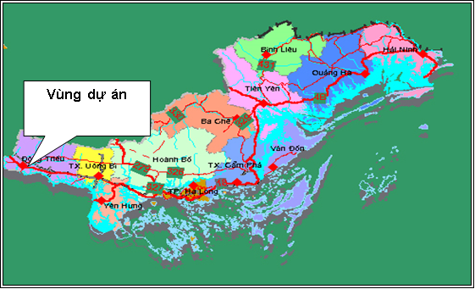
Figure 2.1. Location of project area
(Source: Water resources Investment and Construction Management Unit No. 2)

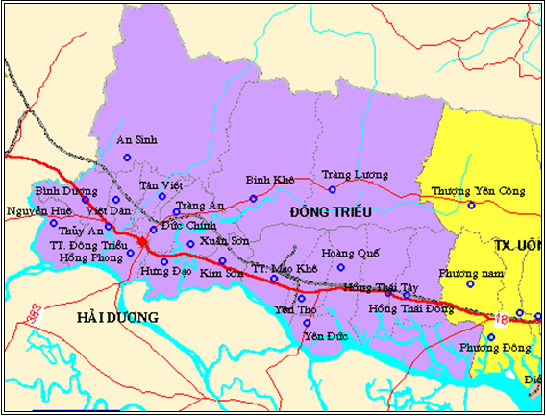
Headworks area
Figure 2.2. Location of work in Dong Trieu District
(Source: Water resources Investment and Construction Management Unit No. 2)

2.2. The Proposed Repair Works

The proposed rehabilitation and improvement of the dam and reservoir aims to: (i) assure reservoir safety during operation principally by repairing and retrofitting for extreme weather events; (ii) meet increasing demand for water in the lowland area by restoring the initial design capacity and stable supply of irrigation water to 2,300 hectares of rice paddy field and other crops whole year round; and, (iii) to ensure domestic water supply with flow rate of 10.000m³ per day and night.

The proposed repair and upgrading works would involve the following:
- Earth Dam: Repair on the dams include rehabilitation and expansion of the downstream section to restore embankment at the desired compaction coefficient; reinforcement of the top of the dam by a 20-cm thick M200 concrete; exterminate termites; and fixing of the water seepages and penetration in the dam body and foundation.
- Flood Spillway: Works include expansion and upgrade of the overflow weir from 14 m to 24 m; the rehabilitation of the chute and flanks with reinforced concrete and rebuilding of the weir bridge, among others.
- Water Intake: Various repair works including clearing and re-lining of the culvert, reinforcement of the external valve tower, repair of the tower building and service bridge, replacement of the steel gate, etc.
- Operation House and Communication System: Construction of head works operation house with 4th grade house standard and gross area of 150m² and installation of automatic reservoir water level observation system to facilitate the works management and operation.
- Power Line: Installation of 1.8 km long LV wire lines from weir shoulder to flood spillway for management and operation purpose.
- Management Road: Reinforcement of the section behind the water intake to flood spillway with specifications of 1.7 km length, M200 concrete, 20cm thickness and 3m width. Hardening of 139-m road section towards the dam surface. Construction of rescue road which would also serve as the access road to the weir extension works.
- Culverts: Upgrading of existing two (2) culverts under the management road with reinforced concrete M250 to increase their flood discharge capacity. The two culverts are: Tan Viet culvert with 4 gates: 4 x (6x3.5)m; and Ba Xa culvert with 2 gates: 4 x (6x3.5)m.
- Others: Provision of equipment for rescue in case of floods and storms and monitoring equipment.

Table 2.1. Subproject Cost Estimate
No | Items | Before Tax | Tax | After Tax Cost
1 | Construction | 33,309,769,616 | 3,330,976,962 | 36,640,746,578
2 | Equipment | 426,957,591 | 42,695,759 | 469,653,350
3 | Project management | 650,842,120 | 0 | 650,842,120
4 | Construction investment consultancy | 5,441,638,430 | 544,163,843 | 5,985,802,273
5 | Other expenses of the Project | 675,308,752 | 67,530,875 | 742,839,627
6 | Implementation of social and environmental management plan | 801,090,000 | 80,109,000 | 881,199,000
7 | Social and environmental monitoring plan | 75,408,016 | 7,540,802 | 82,948,818
8 | Provision | 4,050,451,651 | 398,536,744 | 4,448,988,395
9 | Site clearance support | 2,500,000,000 | 0 | 2,500,000,000
10 | Support programs to improve environment management capability and techniques | 52,000,000 | 0 | 52,000,000
11 | The Ethnic Minority Development Plan | 270,000,000 | 0 | 270,000,000
12 | Abbreviated Resettlement Action Plan | 546,975,000 | 0 | 546,975,000
 | Total Value | 47,983,466,176 | 4,471,553,985 | 53,271,995,161
 | Equivalent to USD |  |  | 2,536,762

The itemized details of the proposed repair and upgrading are provided in Table 2.2. These repair and upgrading works were identified based on the Dam Safety Assessment conducted as part of the preparation of the DRSIP project. The subproject was designed and will be implemented in accordance with the requirements of the World Bank Safety of Dam Policy (OP/BP 4.37) and the national dam safety standards of the Socialist Republic of Vietnam. The cost of the repair and upgrading works is estimated at VND 53,272 billion (Equivalent to 2,536,762USD) (Table 2.1).

Table 2.2. Work Items of the Sub-project and their configuration
Items | Parameters of current situation | Contents of repair
Flood spillway | Configuration of current situation:  Type of spillway: Long based weir.  Number of chamber: 1 piece.  Spillway structure: Masonry wall plastered cement.  Overflow weir width: 14m.  Overflow weir length: 5m.  Overflow weir level: 23.48 m.  Length after sill: 9.46 m.  Width after sill: 14.00 m.  Slope after sill: 1.0 %.  Length of narrowed section: 15.58 m.  Width of narrowed section: 7.80 m.  Slope of narrowed section: 1.00%.  Length of transition section: 31.40 m.  Width of transition section: 7.80 m.  Slope of transition section: 1.00 %.  Length of slope section: 43.40 m.  Width of slope section: 7.80 m.  Slope of slope section: 12.00 %.  Length of injecting nozzle section: 2.21 m.  Opposite slope of injecting nozzle: 10.0 %.  Open angle of injecting nozzle: 9.0⁰  Current situation:  Flood spillway at the left abutment of dam, long based weir, water level at the time of survey is lower than the overflow weir of 60cm; the overflow channel to the surface has not been reinforced, the left abutment has a 30m long section of wall by masonry, some sections have been come off cement mortar. The wing wall at right abutment of the input section has been cracked, come off cement mortar.  The surface of spillway base with cement mortar have been come off; the slope with spilling abutments bxh = 0.2x0.2m in distance of 1.15 m per abutment; the spillway tail unreinforced has been eroded, erosion hole on the bed-rock. | Configuration:  + Overflow weir width: 24.0m.  + Width of narrowed section: 24.0m --> 18.90m  + Width of transition section: 18.90m.  + Width of slope section: 18.90m  + Length of bed to overflow weir: 41.80m  + Overflow weir thickness: 5.00m  + Length after sill: 9.46m  + Length of narrowed section: 15.58m  + Length of transition section: 31.41m  + Length of slope section: 43.40m  + Length of injecting nozzle section: 2.21m  + Slope of bed to overflow weir: 1º  + Overflow weir level: +23.68m  + Level after sill: +23.68m  + Slope of narrowed section: 1º  + Slope of slope section: 12º  + Opposite slope of injecting nozzle: 10%  + Level of injecting nozzle: +14.77m  + Level of left spillway wall to overflow weir: +26.25m  + Level of crest on overflow weir: +27.08m  + Level of wall base of injecting nozzle: +8.16m  + Height of wall after overflow weir, transition, narrowed, slope, injecting nozzle sections: 2.20m  + Open angle of injecting nozzle: 9º  + Length of wing wall: 6.66m  + Dimension of lateral ditch: bxh=(0.5x0.7)m  + Dimensions of speed bump: bxh=(0.2x0.2)m  + Distance of speed bumps: 1.54m  + Spillway structure: Load-bearing reinforced concrete structure with form of harden frame on base-rock  + Structure of injecting nozzle wall: Mass reinforced concrete structure with form of counterfort wall on base-rock.  Contents of repair and upgrade:  + Expanding flood spillway, ensuring safety of reservoir.
Surface of soil dam | Parameters:  + Length of dam surface: 658.0m  + Width of dam surface: 4.20m  + Width of circulation: 4.20m  + Horizontal slope of dam surface: 1,5%  + Structure of dam surface: structure of hard pavement, coated concrete M200 with 20 cm in thickness.  Current situation:  - The dam surface is raised by masonry wall, coated by fine stone to protect surface. During the long-term use process, the dam surface is rough with many pot-holes, underbrush has grown sparsely along the crest.  - The upstream breakwater with masonry structure and plastered crest has some breaks with dimensions of bxh=0.3x1.0m, the head of crest has a break of 1.5m in length.  - The downstream dam surface is also raised by masonry wall with 30cm in height; the crest is plastered by cement mortar. | Parameters:  Concrete for dam surface:  + Length of dam surface: 658.0m  + Width of dam surface: 4.20m  + Width of circulation: 4.20m  + Horizontal slope of dam surface: 1.5%  Contents of repair and upgrade:  + Hardening dam surface by concrete, repairing cracks, breaks on breakwater.  + Structure of dam surface: structure of hard pavement, coated concrete M200 with 20 cm in thickness.
Management road | Parameters:  + Length of management road: 139.56m  + Width of road surface: 5.0m  + Width of road base: 3.50m  + Maximum vertical slope of road surface: 10.97%  + Horizontal slope of road surface: 1.5%  + Width of road-side: 2x0.75m  + Road line: based on current soil road line  + Structure of management road: The structure of management road is hard pavement structure, lower-layer foundation is made of rubble, upper-layer foundation is made of crushed aggregate, and pavement is coated by M200-20 cm concrete, road-side of 0.75m in width making use of waste soil and stone.  Current situation:  Management and operation road along the inter-commune road to bridge is built by concrete; the section from bridge to dam surface with 110 m in length is currently soil road. After running through the dam surface, this section is linked with the local road next to the lake. The road surface is rough with many pot-holes, which is not convenient for management and especially for flood prevention and fighting. | Parameters:  Hardening concrete for management road:  + Length of management road: 139.56m  + Width of road surface: 5.0m  + Width of road base: 3.50m  + Maximum vertical slope of road surface: 10.97%  + Horizontal slope of road surface: 1.5%  + Width of road-side: 2x0.75m  + Road line: based on current soil road line  Contents of repair and upgrade:  + Hardening concrete for management road.  + Structure of management road: The structure of management road is hard pavement structure, lower-layer foundation is made of rubble, upper-layer foundation is made of crushed aggregate, and pavement is coated by M200-20 cm concrete, road-side of 0.75m in width making use of waste soil and stone.
Offtake regulator: | Parameters:  + 01 main gate: b x h = (2,20 x 2,30) m  + Color paint for interior and exterior decoration of offtake regulator tower house has been faded  + Current system of the tower house's door: wooden door.  Current situation:  + The offtake regulator at the right abutment of dam is arranged a valve tower house at the upstream of dam, the regulator has reinforcement concrete structure; the downstream of offtake regulator has standing water holes under the dam.  The tower house of offtake regulator has wooden doors and windows, for a long time, such doors and windows have been damaged and not ensured usability, the door leaves have been rotten, the tower is often splashed in it when it rains.  + The inside and outside paint of the tower house has been come off, the walls have been painted and dirty.  + Valve leaf at downstream used from the 1990s has been rusty and no longer used. | Parameters:  + 02 main doors: b x h = (2,20 x 2,30) m.  + System of the tower house's door: two-layer iron door.  Contents of repair and upgrade:  + Supplementing a main door: b x h = (2,20 x 2,30) m  + Supplementing three windows: b x h = ( 2,00 x 2,50)m  + Painting interior and exterior decoration of offtake regulator tower house;  + The current system of tower house's doors area replaced by two-layer iron doors, decorated by cast-iron patterns with shutter, inside door is protected by shape steel - square steel 12.
Salvage and rescue road in combination with spillway line construction | Parameters:  + Length of road: 480.0m  + Width of road surface: 6.50m  + Width of road base: 6.50m  + Width of road-side: 2x0.m  Current situation:  Soil road surface, many potholes, difficult to travel. | Parameters:  + Length of road: 480.0m  + Width of road surface: 6.50m  + Width of road base: 6.50m  + Width of road-side: 2x0.m  Contents of repair and upgrade:  + Upgrading road surface.  + Road structure: The road foundation is paved by rubble, road base by grade 2 crushed aggregate, road-side by compacted soil and stone.
Attendant house for flood prevention and work management | Parameters:  + Grade 4 houses.  + Tone roof.  + Wooden doors, windows.  Current situation:  + Main door and side doors are broken  + Current door system: wooden door.  + Inside and outside walls and ceiling painted have been come off and fusty. | Parameters:  + Used area: 250m².  + Two-floor structure.  Contents of repair and upgrade:  Newly building attendant house for flood prevention and work management, use area of 250m2, two floors, reinforced concrete structure:  + Floor 1: Arranging working offices and common toilet (for male and female).  + Floor 2: Arranging meeting room, attendant room, + control room, working offices and common toilet (for male and female).  + The elevation of Operation house is designed under modern architecture in combination with finish materials such as: finishing colour paint, plastic door with steel core, white glass etc…  + The roof of Operation house is designed with large cantilever, in accordance with height of the house together with concrete cons on system to support lower roof, the upper false roof is covered by red tile creating shadow to the work to avoid rain, sunny for door system.
Rebuilding of 2 undergrounds through spring: Tan Viet and Ba undergrounds | Current situation:  No capacity enough for flood discharge. | Parameters:  + Tan Viet underground with 4 gates: 4 x (6x3,5)m.  + Ba Xa underground with 2 gates: 4 x (6x3,5)m.  Contents of repair and upgrade:  + Rebuilding 02 undergrounds through spring by M250 reinforced concrete structure on management road due to no capacity enough for flood discharge (designed calculation of flood discharge of 1%):  + The upstream and downstream of undergrounds are arranged to connect to natural spring bed by 2 stone lines with dimension of (0,5 x 1,0 x 2,0)m.

The auxiliary facilities to support the construction works are identified in Table 2.2 below. These include the existing Hai San burrow pit as source of about 1,000 cubic meter of additional embankment requirements, a 1,750 sq. m Greenfield landfill area at the foot of the dam, a 200 sq. m stockyard and a 400 sq. m hut/tent area.

Table 2.2. Auxiliary work items
Items | Location | Quantity (deposit of exploitation) | Description
Borrow pit | Hai San pit, located in the West side of the project and 5km far from project | Hai San pit is being operated in An Sinh Commune with the reserve of 3.3 million cubic meter | 5km far from the Work, contiguous with asphalt road being exploited  Specialized vehicles used to transport soil taken from Hai San pit (about 300 meters from the provincial road) will take the route along the inter-communal road routes (in Tan Vietnam on to the construction site. This route is only serving households scattered on both sides of the road, and passes over the residential area of Ba Xa commune (next to the Work).
Landfill site | Poured at the position of the dam foot | Area: 17,500 m² with the capacity of 52.500 m³. | Within the scope of project, right at the foot of the dam, it is arranged along the dam foot (dimension 35x500m). 200m far from the construction road. Scope of transport from construction position to the landfill site is smaller than 1000m along the construction road route.
Lay-down yard | Warehouse area, downstream dam foot, near the operator house (the hut area) on its right side. Area of the material lay-down yard is 200m². | Area: 200 m² | 100m far from the foot of spillway.  300m far from the inter-communal road (asphalt road).  The current status of the area: Greenfields of the downstream, under the management area of Khe Che Lake.
The hut area | Arranged near the operator house | Area: 400m² | 100m far from the foot of spillway  300m far from the inter-communal road(asphalt road)  The current status of the area: Greenfields of the downstream, under the management area of Khe Che Lake.

Burrow Pit. The Han San burrow pit will be the source of a relatively small amount of embankment materials (about 1000 cubic meters) as most of the backfilled materials will be coming from the excavation on the side of the mountain. The burrow pit is about 200 m from the construction site.

Landfill. The designated landfill site is the 5m x 350m strip at the foot of the dam. It was selected based on the following advantages:
- It is very near the construction site being located right at the foot of the dam (Figure 2.3);
- The site is owned by the Khe Che reservoir management hence no household is affected and Land Clearance is not needed;
- The landfill will enhance downstream face of the dam by providing additional backfill and reinforcing it.

Lay down yard – This 200 sq meter lot is located near the warehouse also in the downstream foot of the dam. The site is 100m away from the foot of spillway and 300 m away from the inter-commune road. The land is also under the management area of Khe Che Reservoir.

The hut area. Located near the operator house, the lot is about 400 q m. It is 100m away from the foot of spillway and about 300 m from the inter-commune road. The area is also under the management area of Khe Che Reservoir.
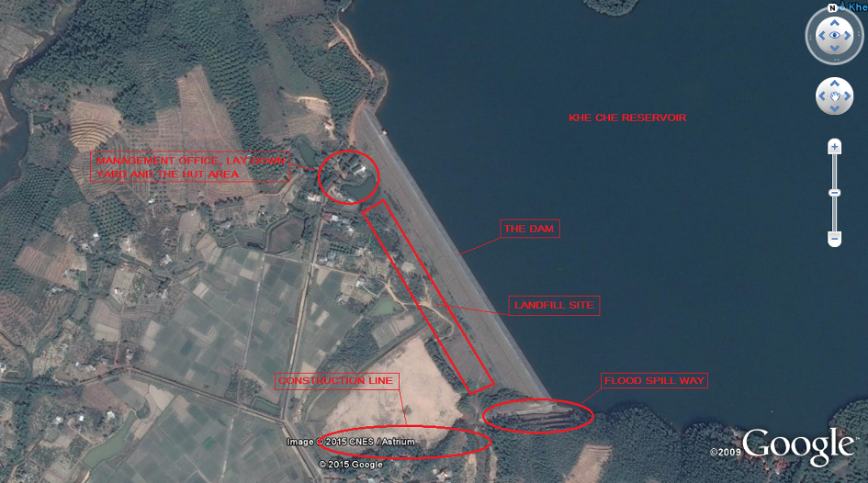
Figure 2.3. The sub-project area

Table 2.3. Volume of main materials for the project
Materials/ manpower | Calculating unit | Total
Stone powder | kg | 1,385.444
Fine sand | m³ | 180.019
Black sand | m³ | 9.638
Yellow sand | m³ | 393.235
Crushed aggregate 0.075-50mm (upper layer) | m³ | 1,216.998
Steel wire | kg | 4,022.506
Stone (rubble) | m³ | 1,475.364
Crushed stone 1x2 | m³ | 2,953.179
Crushed stone 4x6 | m³ | 293.707
Rubble | m³ | 1,273.368
Bitumen No. 4 | kg | 2,411.829
Asphalt | kg | 611.800
Soldering stick | kg | 904.159
Synthetic paint | kg | 28.445
Square hollow iron 12x12 | kg | 745.350
Steel pipe | kg | 83.349
Steel shape | kg | 1,644.299
Plae steel | kg | 3,957.976
Round steel d<=10mm | kg | 91,142.133
Round steel d<=18mm | kg | 148,518.752
Round steel d >18mm | kg | 32.391
Backfill soil for items | m³ | 3,412
Volume of excavation soil for items | m³ | 55,459
Source: Collection from cost estimate of the project

According to the calculations, the total volume of excavation soil for construction works of the project is about 55,459 m3, volume of backfill is 3,412 m³. In particular, the required volume of backfill soil to be sourced from the burrow pit is only 996 m3, The remaining amount will come from the excavated volume. Thus, about 51,051 m3 needs to be moved to the disposal area. The disposal area is located along the foot of the dam, with dimension of 35 x 500m. The total capacity of disposal area is about 52,500 m³.

Material transport route. Materials are purchased at Dong Trieu Town, 8-10km from the site. The materials will be transported through the Inter-commune route to Tan Lap, Tan Thanh, Dong Tranh, Dong Dung, Ba Xa and to the foot of the site. Some people live along the route, particularly at segments on Dong Trieu Town, Tan Lap and Dong Tranh Communes.

Soil transport route for backfilling-Backfilling soil is purchased at Hai San pit of An Sinh Commune. The backfill will be hauled from Hai San pit (about 300m far from provincial road) through the inter-commune road (through Tan Viet Commune to the foot of the site. Some households are living sporadically on both sides of the road. This route travels through Ba Xa commune only (right next to the foot of the Work).

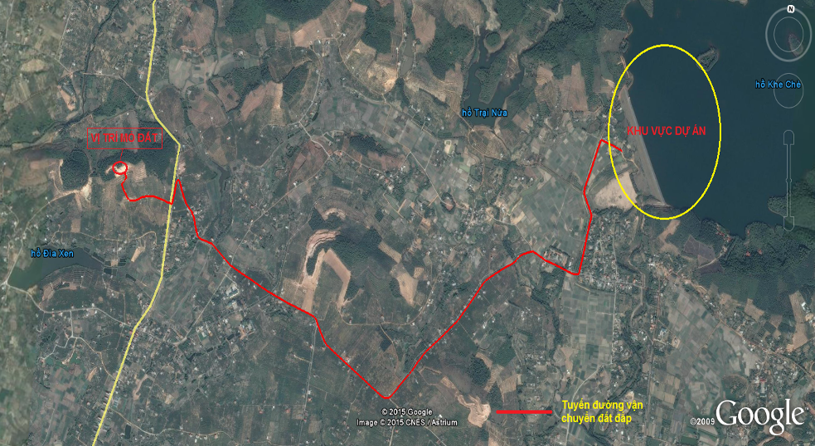
Project Site
Borrow Pit
Backfilling Transportation Road
Figure 2.4. Layout of estimated transport route for backfill soil
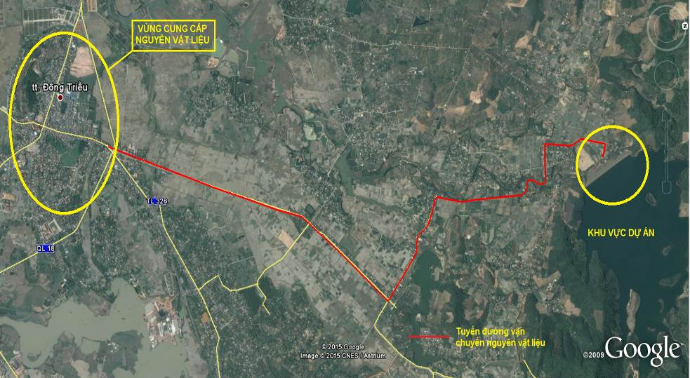
Material Supply area
Material Transportation Road
Project Site
Figure 2.5. Layout of estimated transport route for material

Table 2.4. List of Equipment to be used during Construction
Equipment | Function | Quality requirement
Excavator 0.8m³ | Land excavation | All means and vehicles must be provided with: ‘Certificate of Conformity to Quality Standard, Technical Safety and Environmental Protection” in accordance with Decision no 35/2005/QD-BGTVT to prevent excessive noise from machines which are not maintained properly.  - Certificate of Conformity to standard of technical safety and environmental protection applied to motorbike participating in road traffic (22 TCN 278 - 01)  - Certificate of Conformity to the technical safety and environmental protection standard applied to motorized vehicles (22 TCN 224 - 01)
Bulldozer 110 CV | Land excavation
Roller 9T | Base backfill
Dump truck | Transport for materials
Water sprinkler 5m³ | Watering
Compactor 8,5T | Construction of aggregate base course, culvert.
Compactor 10T | Construction of aggregate pavement
Tire compactor 16T | Construction of aggregate pavement
Vibratory compactor 25T | Construction of aggregate pavement
Paver 50 – 60 m³/h | Construction of aggregate pavement
Mixer 500L | Mixing concrete
SIR system – 10B machine | Termite treatment
Sonic detector – 3A | Detecting termite and other incidents
Pumper 7 CV | Pumping water
Injection boring machine KPV-DB30 | Termite treatment
Drilling rig YRB 50 m | Drilling

2.3. The construction schedule

The total estimated execution time of sub-project is 14 months with the first two months would be spent on preparation/mobilization. The actual construction period will be 10 months. The estimated length of time to demobilize including land restoration would be two months.

The construction work affects only a small portion of the dam. The construction would not affect the irrigation water supply and will not have significant impact on aquaculture. The amount of water in the reservoir in months of dry season (from November to March) is small.

The work is executed in two dry seasons (from October to April) as follows.
- Dry Season 1:
  - Mobilization and site preparation (October – November);
  - Embanking construction road on spillway tail from downstream of the soil dam (December - January);
  - Opening foundation and completing construction of flood spillway (February – April).
- Dry Season 2:
  - Construction for hardening surface of soil dam (October – November);
  - Construction for hardening management road (December – January);
  - Completion for items, clearing and land retorate, disposal of refused materials (February – April).

CHAPTER III: POLICY, LEGAL AND ADMINISTRATIVE FRAMEWORK

3.1 Country's Environmental and Social Safeguards Policies and Legislations

This chapter provides the brief of the relevant environmental and social policies of the GoV and the World Bank. Annex-I includes the detailed description and discussion.

3.1.1 Environment

Law on Environmental Protection (No.55/2014/QH13) dated June 23, 2014 and Decree on Environmental Protection Planning, Strategic Environmental Assessment, Environmental Impact Assessment and Environmental Protection Plans (No. 18/2015/ND-CP) dated February 14, 2015 are key legal frameworks for environmental management in Vietnam. Law on Environmental Protection (LEP) provides statutory provisions on environmental protection activities; measures and resources used for the purpose of environmental protection; rights, powers, duties and obligations of regulatory bodies, agencies, organizations, households and individuals who are tasked with the environmental protection task. LEP is applicable to regulatory bodies, public agencies, organizations, family households and individuals within the territory of the Socialist Republic of Vietnam, including mainland, islands, territorial waters and airspace. LEP is on regulating strategic environmental assessment, environmental impact assessment and environmental protection commitment. According to Article 10, chapter II of LEP, the responsibility for preparing the planning for environmental protection are as following:

- The Ministry of Natural Resources and Environment shall prepare the national-level planning for environmental protection.

- People’s Committees of centrally-governed cities and provinces (hereinafter referred to as provincial People’s Committee) shall take charge of formulating processes or preparing the local planning for environmental protection.

Furthermore, the law also indicated to consultation on, inspection and approval of the planning for environmental protection (Article 11, chapter II) as well as the list of entities subject to strategic environmental assessment in appendix I and II of the Decree No. 18/2015/ND-CP dated February 14, 2015 of the Government:

- The Ministry of Natural Resources and Environment shall consult with Ministries, regulatory agencies and provincial People’s Committees in writing and hold an official consultation with relevant regulatory agencies and organizations during the preparation of the national-level planning for environmental protection.

- Provincial People’s Committees shall consult with departments, regulatory agencies and People’s Committees of a district, town or city (hereinafter referred to as district-level People's Committee) in writing and hold an official consultation with relevant regulatory agencies and organizations during the preparation of the provincial-level planning for environmental protection.

Inspection and approval of the planning for environmental protection shall be required as follows:

- The Ministry of Natural Resources and Environment shall establish a Council for interdisciplinary inspection and prepare the national-level planning for environmental protection for submission to the Prime Minister with the intent to seeking the approval for that planning.

- Provincial People’s Committee shall inspect and approve the report on the provincial-level planning for environmental protection after obtaining written advice from the Ministry of Natural Resources and Environment.

Ministries, ministerial level agencies and Government bodies shall have the responsibility to establish the council or organize the selection of review service organizations to review environmental impact assessment reports of the projects within their competence of decisions and approvals, except inter-sector and inter-provincial projects

Provincial level People’s Committees shall have the responsibility to establish the council or organize the selection of review service organizations to review environmental impact assessment reports of the projects that take place within their territories and subject to their competence of decision and approval and that of the People’s Councils of the same level.

Management: Unit for Industrial Parks, Export Processing Zones and Hi-tech Zones: Provincial people’s committee can authorize the Management Unit for Industrial Parks, Export Processing Zones and Hi-tech Zones as regulated in Decree 29/2008/ND-CP dated 14/03/2008 by the Government on industrial parks, export processing zones and economic zones.

The Section 3 of Chapter II of LEP describes the requirements of Environmental Impact Assessment. Owners of projects regulated in Clause 1 Article 18 of this Law shall carry out, on his own, or hire an advisory organization to carry out the environmental impact assessment and take statutory responsibility for the conclusive result after carrying out such assessment. The environment impact assessment must be performed in the preparatory stage of the project. The conclusive result yielded after carrying out the environment impact assessment shall be expressed in the form of the report on environmental impact assessment. Expenses incurred from the formulation and inspection of the report on environmental impact assessment, and included in total investment budget shall be covered by the project owner.

According to Article 21 of LEP, the consultation to be required in the process of environmental impact assessment is aimed at completing the report on environmental impact assessment. It emphasis that consultation helps minimize the negative impacts on the environment and human beings and ensure the sustainable development of the project. Project owners are obliged to consult with regulatory agencies, organizations and communities that are directly affected by the project.

The Article 22 of LEP describes the scope of EIA reporting. It will include: (i) origin of the project, project owners, and the competent authority's approval of the project, method of the environmental impact assessment; (ii) evaluation of technological choice, work items and any activity relating to the project which can cause bad effects on the environment; (iii) assessment of current status of natural and socio-economic environment carried out at areas where the project is located, adjacent areas and demonstration of the suitability of the selected project site; (iv) assessment and forecast of waste sources, and the impact of the project on the environment and community health; (v) assessment, forecast and determination of measures for managing the risks of the project posed to the environment and community health; (vi) waste disposal measures; (vii) measures for minimizing the impact of the project on the environment and community health; (viii) consultation result; (ix) environmental management and supervision programs; (x) budget estimate for the construction of environmental protection facilities and measures to be taken to minimize the environmental impact; and (xi) alternatives to the application of measures for the environment protection.

The Article 23 of LEP defines the authority to verify the report on EIA. The Ministry of Natural Resources and Environment shall arrange to verify the report on environmental impact assessment in respect of the following projects: (a) Projects subject to the decision on investment intentions made by the National Assembly, Government and the Prime Minister; (b) Interdisciplinary or inter-provincial projects stipulated at Points b and c Clause 1 Article 18 in this Law, exclusive of those classified as the secret projects in the field of national defense and security; and (c) Projects verified by the Government’s authorized entities. The Ministries and quasi-ministerial agencies shall inspect the report on environmental impact assessment in respect of projects that shall be permitted under their decision and approval, but are not specified in regulations mentioned at Points b and c Clause 1 of this Article. The Ministry of National Defense and the Ministry of Public Security shall arrange to verify the report on environmental impact assessment in respect of projects that shall be permitted under their decision and approval, and those classified as the secret projects in the field of national defense and security. Provincial People’s Committees shall arrange to verify the report on environmental impact assessment in respect of investment projects within their territories that are not regulated at Clause 1, 2 and 3 of this Article.

The Article 26 of LEP describes the responsibility assumed by the project owner after being granted the approval of their report on the environmental impact assessment. These include – Clause 1: comply with the requests specified in the approval of their report on environmental impact assessment. Clause 2: where any change in the project size, capacity and technology applied in the project execution is blamed for the negative impact on the environment in comparison with the alternatives given in the approved report on environmental impact assessment, but is not too serious to make another report as stipulated at Point c Clause 1 Article 20 pf this Law, the project owner must send their explanation to the agency who grants the approval of the report on environmental impact assessment, and the project shall be commenced only after obtaining the permission from such agency.

The Article 27 of LEP explains the responsibility assumed by the project owner before bringing the project into operation. These include - Clause 1: apply measures for the environmental protection under the decision on the approval of their report on environmental impact assessment; and Clause 2: notify the agency who grants the approval of the report on environmental impact assessment of the developmental process of environmental protection works functioning as an ancillary part of major projects that can cause bad impacts on the environment in accordance with the Governmental regulations. These projects will be commenced only after the agency in charge of the approval of the report on environmental impact assessment has inspected and certified the completion of environmental protection works.

The Article 28 of LEP mentions the responsibility of the agency in charge of approving the report on the environmental impact assessment. These include – Clause 1: Bear the statutory responsibility for their conclusive result and decision on the approval of the report on environmental impact assessment. Clause 2: Within a period of 15 days as from the date on which the project owner’s report on the completion of environmental protection works under the regulations specified in Clause 2 Article 27 of this Law, the agency in charge of approving the report on environmental impact assessment must examine and issue the certificate of completion of environmental protection works. Where an analysis of complicated environmental criteria is required, the time span for the issuance of the certificate of completion of environmental protection works can be extended for less than 30 days.

The Article 13 of the Decree (No. 18/2015/ND-CP) explains the requirement of the pertaining EIA agencies. Clause 1: the project owner or the advisory organization conducting EIA must meet all requirements – (a) there are staff members in charge of EIA meeting requirements prescribed in Clause 2 of this Article; (b) there is specialist staff members related to the project obtaining at least Bachelor’s degrees; and (c) there are laboratories, inspection and calibration devices eligible for performing measurement, sampling, processing and analysis of environmental samples serving the EIA of the project; if there is not any laboratory with decent equipment for inspection and calibration, it is required to have a contract with a unit capable of carrying out inspection and calibration. Clause 2: the staff members in charge of EIA must obtain at least Bachelor’s degrees and Certificate in EIA consultancy and Clause 3: the Ministry of Natural Resources and Environment shall manage the training and issuance of Certificates in consultancy of EIA.

In addition, the following Articles are important for EIA approval and reporting.
Article 14: the authorities for different scales of EIA report approval with deadlines
Article 15: re-compilation of EIA reports
Article 16: responsibility of project owners pertaining to the approved EIA reports
Article17: inspection and confirmation of environmental protection works serving the operation phase of the projects
Article 21: Reporting

3.1.2 Dam safety regulations

Decree no.72/ND-CP on date 07/05/2007 of the government of Vietnam regarding on dam safety management. According to the decree, a big dam is the dam with the height calculating from the floor face to the top of the dam equal to or greater than 15 meters or dam of water reservoirs with the scale of capacity equal to or greater than 3,000,000 m³ (three million cubic meters). Small dam is the dam with the height calculating from the floor face to the top of the dam smaller than 15 meters. Dam owners are organizations and individuals owning dams to harness the benefits of water reservoirs or assigned to manage, operate and harness water reservoirs by the competent state agencies. Ministry of Agriculture and Rural Development takes responsibility before the Government for the implementation of state management of dam safety. The Ministry of Industry presides over and coordinates with ministries, branches and relative localities to appraise, approve or submit to the Prime Minister for approval of the process of operating hydropower reservoirs. The provincial-level People's Committees implement its state management on dam safety in the areas.

In chapter 4 of Decree no.18/2015/ND-CP on date 14/02/2015, from the article 12 to article 17 were specified in the formulation, evaluation and approval of environmental impact assessment reports, the implementation of projects and the designed mitigation measures to protect environment before and after a project officially operation. In the article 12 of this Decree also regards on environmental impact assessment process to the project implementation, the project owner have to organize meetings to public consultants, such as Provincial People's Committees, local authority (Commune People's Committees level- CPC), affected (direct or indirect) people or committees in the local by the project implementation, mandatory; analysis the feedbacks, comments obtained from the affected groups, and consider advantage or disadvantage the impacts of the project to community and to design the mitigation measures to reduce the negative impacts on natural environment, biodiversity, community. According to the annex no.2 of the Decree, the project has to make EIA if the reservoir capacity is of 100,000m³ or more. According to the regulations of Vietnam Government, the all proposed subprojects under DRSIP project have to perform the report of Environment Impact Assessment (ESIA).

3.1.3 Land acquisition

The GOV’s Legal Framework: The legal framework with respect to land acquisition, compensation and resettlement is based on the Constitution of the Socialist Republic of Vietnam (2013), and the Land Law 2013 (revised), and other relevant decrees/guidelines. The principal legal documents applied for this RPF include the followings:

- Constitution of Vietnam 2013;
- The Land Law 45/2013/QH13 which has been effective since July 1, 2014;
- Decree No.43/2014/ND-CP dated on May 15, 2014 guiding in detail some articles of Land Law 2013;
- Decree No.44/2014/ND-CP dated on May 15, 2014 provides on method to determine land price; make adjusted land price brackets, land price board; valuate specific land price and land price consultancy activities;
- Decree No. 47/2014/ND-CP dated on May 15, 2014 providing compensation, assistance, resettlement when land is recovered by the State;
- Decree No. 38/2013/ND-CP dated on April 23, 2013, on management and use of official development assistance (ODA) and concessional loans of WB;
- Decree No. 72/2007 / ND-CP dated on May 07, 2007 of the Government on management of dam safety;
- Decree No. 201/2013 / ND-CP dated on November, 27, 2013 of the Government detailing the implementation of some articles of the Law on Water Resources;
- Circular No. 36/2014 / TT-BTNMT dated on 30 June 2014, regulating method of valuation of land; construction, land price adjustment; specific land valuation and land valuation advisory;
- Circular No. 37/2014/TT-BTNMT dated on 30 June 2014, regulating compensation, assistance and resettlement when the State acquires land;
- Decision No. 1956/2009/QD-TTg, dated on November 17, 2009, by the Prime Minister approving the Master Plan on vocational training for rural labors by 2020;
- Decision No. 52/2012/QD-TTg, dated on November 16, 2012, on the assistance policies on employment and vocational training to farmers whose agricultural land has been recovered by the State;
- Others.

Other laws, decrees and regulations relevant to land management, land acquisition and resettlement include the Construction Law 50/2014/QH13, dated on 18 Jun 2014, on construction activities, rights and obligations of organization and individual investing in civil works construction and construction activities; Decree 102/2014 / ND-CP on sanctioning of administrative violations in the field of land replaced by Decree No. 15/2013 / ND-CP dated on February, 06, 2013 on quality management of constructions;, Decree No. 12/2009/NĐ-CP of the Government, dated 12 February 2009 on the management of construction investment projects and replacing the Decree 16/2005/ND-CP, the Decree 38/2013/ND-CP of the Government on the management and use of Official Development Assistance (ODA) fund, and Decree 126/2014/ND-CP of the Government on marriage and family Law implementation, stipulating that all documents registering family assets and land use rights must be in the names of both husband and wife; Decisions of project provinces relating to compensation, assistance and resettlement in provincial territory will be also applied for each relevant project province.

3.1.4 Indigenous/Ethnic minority people

Viet Nam has a large number of policies and programs specifically designed to assist ethnic minorities’ development. The Government of Viet Nam (GOV) has paid much attention to the welfare of ethnic minority groups. There is a ministerial-level government body, the Committee for Ethnic Minority and Mountainous Area Affairs (CEMA), which is in charge of management functions for ethnic minorities and mountainous areas. A country profile of Viet Nam published by the International Work Group for Indigenous Affairs (IWGIA) reports that:

“Indigenous peoples are full citizens of the Vietnamese state and enjoy constitutionally guaranteed rights to their languages and cultural traditions....On the legislative level, the “Council on Ethnic Minorities” has the mandate to advise the National Assembly on ethnic minority issues and to supervise and control the implementation of the government’s ethnic minority policies and development programs in ethnic minority areas.”

The document also reports that since the 1960s, a number of policies and programs have been designed specifically for ethnic minorities, but these are mainly aimed at integrating them into mainstream society rather than enabling them to strengthen their own institutions. Regarding land issues, it reports that “it is important to highlight that the present legislation in Viet Nam allows for obtaining use right certificates for land and forest and that in 2004 the National Assembly passed a new land law which, most relevant for indigenous peoples, now includes the category of ”communal land”. By introducing the concept of communal land, the new law provides for the possibility of communities to apply for certificates over communal land.

3.2. Implications of National Policies and Regulations on the Proposed Project

Based on the analysis of the national legal framework, the project will have to fulfil the following minimum requirement and process:

- PPMU or the consulting firm conducting EIA must have staff members in charge of EIA must obtain at least Bachelor’s degrees and Certificate in EIA consultancy. They will also have or arrange adequate laboratory facility for performing measurement, sampling, processing and analysis of environmental samples serving the EIA (Ref. Article 13 of Decree).

- Considering the nature of the subproject, the Provincial People’s Committee (PPC) shall assess and approve EIA reports (Ref. Article 14 of Decree). PPC shall arrange to verify the report on environmental impact assessment in respect of investment projects within their territories (Ref. Article 23 of LEP).

- The assessment of EIA report shall be conducted by the EIA report assessment council established by the Heads of the EIA report assessment authority with at least 07 members. Members of EIA report assessment council shall consist of 01 President, 01 Vice President where necessary, 01 Secretary member, 02 Opponent members and other members, which at least 30 percent of the Assessment council members having at least 06 years' experience in the EIA field (Ref. Article 14 of Decree).

- Deadlines for assessment of EIA report is within 30 working days from the date on which the satisfactory application is received (Ref. Article 14 of Decree).

- PPMU will have to comply requests specified in the approval of their report on EIA. For any change, the project owner must send their explanation to PPC (Ref. Article 26 of LEP).

- PPMU will have to notify PPC and the rehabilitated dam will be commenced only after the agency in charge of the approval of the report on environmental impact assessment has inspected and certified the completion of environmental protection works (Ref. Article 27 of LEP).

- PPMU will prepare a completion report for environmental protection work and within 15 days of receiving the report, PPC must examine and issue the certificate of completion of environmental work (Ref. Article 28 of LEP).

- The inspection of environment protection works serving the operation phase of the subproject shall be carried out by an Inspectorate which is established by the Head of PPC (Ref. Article 17 of Decree).

- The PPC shall send a report on assessment and approval for EIA report, registration and inspection of specific environment protection plans, inspection and approval for environment protection works in the province of the previous year to the Ministry of Natural Resources and Environment before every January 15 (Ref. Article 21 of Decree).
.
- MARD shall send reports on assessment and approval for EIA report, inspection and approval for environment protection works of the previous year related to project under their management to the Ministry of Natural Resources and Environment before every January 15 (Ref. Article 21 of Decree).

3.3. World Bank Safeguard Policies

The objective of safeguard policies is to prevent and mitigate undue harm to people and their environment in the development process. Safeguard policies provide a platform for the participation of stakeholders in project design, and act as an important instrument for building ownership among local populations.

The effectiveness and development impact of projects and programs supported by the Bank has substantially increased as a result of attention to these policies. The World Bank Safeguard policies are available in its website: http://web.worldbank.org/WBSITE/EXTERNAL/PROJECTS/EXTPOLICIES/EXTSAFEPOL/0,,menuPK:584441~pagePK:64168427~piPK:64168435~theSitePK:584435,00.html.

3.4. Implications of World Bank Safeguard Policies on the Proposed Project

Eight World Bank policies have been triggered for the project. These are: Environmental Assessment (OP/BP 4.01), Natural Habitats (OP/BP 4.04), Pest Management (OP/BP 4.09), Physical Cultural Resources (OP/BP 4.11), Indigenous Peoples (OP/BP 4.10), Involuntary Resettlement (OP/BP 4.12), Safety of Dams (OP/BP 4.37) and Projects on International Waterways (OP/BP 7.50).

According to WB Operational Policy (OP 4.01), the nature of environmental assessment to be carried out for a particular sub-project would largely depend on the category of the sub-project. As mentioned earlier, The World Bank Operational Policy (OP) 4.01 classifies projects into three major categories (category A, B and C), depending on the type, location, sensitivity and scale of the project, and nature and magnitude of potential impacts. Considering the environmental risk and complexity related to a large number of subprojects to be implemented in a widespread area, the project has been classified as category ‘A’. However, the subprojects to be funded under the projects can be categorized as ‘A’ or ‘B’ or ‘C’ depending on the extent, scope and impact of the specific subproject.

The project physical activities would only work on existing dams and are not expected to lead to conversion or degradation of critical or semi-critical natural habitats. However, it is required to scope, screen and assess potential impacts to natural habitants as part of the subproject ESIA. The project will not finance any procurement of fertilizers and pesticides. However, since the dam rehabilitation work will increase the agriculture command areas, there are chances of more uses of fertilizers and pesticides in the project influence areas. The project will promote the application of Integrated Pest Management (IPM) and guidance has been included in ESMF.

Since the exact subproject locations are unknown at this stage, there is possibility that some rehabilitation work and access road may pass through areas with physical cultural resources. The impacts will be examined as part of the environmental screening/assessment of different subprojects. In addition, ‘Chance find’ procedures conforming to local legislation on heritage would be evaluated so that any physical or cultural resources are not impacted.

The project may intervene in areas where indigenous people live (specific subproject locations will be determined during implementation). In addition, the project may require land acquisition and resettlement. As such, an Ethnic Minority Policy Framework (EMPF) and Resettlement Policy Framework (RPF) are required for the project and will be prepared separately.

The project will not finance construction of any new dams or significant change in dam structure. This policy is triggered as the project will finance rehabilitation and improvement of existing dams including large dams (15 meters or more in height). Thus, it requires to arrange for one or more independent dam specialists to (a) inspect and evaluate the safety status of the existing dam, its appurtenances, and its performance history; (b) review and evaluate the owner's procedures for operations and maintenance; and (c) provide written report of findings and recommendations for any remedial work or safety-related measures necessary to upgrade the existing dam to an acceptable standard of safety. Policy and practice relating to dam safety needs to meet international benchmarks, such as those are laid out by ICOLD and the World Bank regulatory frameworks for dam safety. These measures are designed into the project, which includes the establishment of a national dam safety review panel (DSRP). Also the project will establish an independent Panel of dam safety Experts (PoE) who will carry out independent review of dam safety reports and proposed mitigation measures. This PoE will be working closely with the to-be-established DSRP to ensure the technical integrity of investment interventions. Each subproject will have separate Dam Safety Plan (DSP) in addition to the ESMP.

There are six transboundary river basins in the country; however Vietnam is an upstream riparian only in the Sesan-Srepok basin – a tributary of the Mekong, upstream of Cambodia, and the Bang Giang-KyCung basin, upstream of China. So, it is expected that some of the dams will be located on international river basins, and therefore the policy is triggered.

The WBG guidelines provide guidance on certain EHS issues, which include standards for environmental parameters (ambient air quality, water and wastewater quality, noise level, waste management), hazard and accident prevention, occupational and community health and safety (during commissioning and decommissioning works) etc. These guidelines will be directly applicable to the proposed project. As a general rule, the WBG guidelines should complement the existing Vietnam guidelines or standards. In case the Vietnam guidelines or standards differ from the WBG guidelines, project is expected to follow the more stringent ones.

The World Bank access to information policy would be directly followed. The project will make the environmental/social assessment and ESMF documents available to the public by publishing it in their websites. In addition, hard copies of these documents in English (including Vietnamese language) will be made available in the MARD and all DARDs..

CHAPTER IV: BASELINE ENVIRONMENTAL AND SOCIO-ECONOMIC CONDITIONS

4.1. Hydrology and Ecology of the Khe Che Reservoir and its Receiving Stream

The water sources of the Khe Che reservoir are small streams around the reservoir area. However, the main source of the Reservoir is the Khe Che stream whose entire flow empties into the reservoir. Khe Che stream is a small stream with an average flow rate of only 1.3 m3/s. (please Figure 4.1.) The length of the upstream stretch of the Khe Che stream is 6 km. The catchment area of Khe Che Reservoier is an area of about 22,4 sq km and the reservoir area of hilly terrain, slopes 15-20 (average 18º). The vegetative cover of this area is mainly regenerated forest consisting of plantation tree species of Acasia, Eucalyptus and party of primary forest. The vegetation in upstream reservoir is mainly reforested with a part of primary forest and a small portion of cultivated area. The vegetation on the banks of the reservoir consists of overgrown grasses followed by Eucalyptus. According to field surveys and consultation with local authorities and people, the Department of Natural Resources and Environment of Quang Ninh province, Khe Che stream has no aquatic animals and plants that need protection or in the prohibited list. (Please see in section 4.2)

The Khe Che dam impounds water from Khe Che Stream upto a capacity of 12,000,000m³. Beyond the 12,000,000 m³, the excess water flows through a spillway go to Ho Lao stream. It is a natural water way and pass through the Ba Xa village, and running down Dong Tranh and Dong Dung village area and flow into Dam River. The length of the downstream stretch before the confluence with Dam river is about 13 km (please Figure 4.2). It should be noted that the spillway of the dam is free flowing overflow type (i.e. it has no control gate). This means that when the reservoir is full and the irrigation intake is closed, the water flowing out through the spillway into Ho Lao stream will be equal to its original natural flow rate of Khe Che stream. If the irrigation intake is open and the reservoir is full, only the residual flow will go to the downstream stretch of the river. When the reservoir is not full there will be no water will flow into the downstream of the river. These have the effect of altering the hydrology of the downstream stretch of the Ho Lao stream. This has been going on for more than 20 years or since the dam starts to operate. Any changes in the aquatic environment of the downstream area must have occurred during the early years. Base on survey, this is not recall of any migratory fish species on the Ho Lao River before the dam was constructed.

At present the stretch of the Ho Lao stream frequently dries up during months of low precipitation (i.e. December to February). The flood peak flow of the stream (which is also the same amount that flows out of the spillway when the reservoir is full and irrigation intake is closed) is Q1% = 115,58m3/s; Q0,2% = 157,13m3/s. This flow can easily be accommodated by the Ho Lao stream as its slope allows high velocity water flows towards the Dam River. This hydrologic regime apparently is not able to support sensitive aquatic species. Thus, the present ecology of the downstream stretch of Ho Lao stream can be characterized as unimportant both biologically and economically. The Ho lao stream basin at downstream of the Khe Che Reservoir has vegetation mainly consisting of overgrowths usually found on the banks, followed by rice fields, orchards areas.

The highest flood flow (at designed frequency P = 1%) of the reservoir is 370,1m3/s. After the impact of regulating reservoirs, flood through the spillway is Q1% = 115,58m3/s; Q0,2% = 157,13m3/s. Before and after the expansion of spillway, the discharge flood flow is not changed. Besides, the width of spillway is 24m, small than the width of the Ho Lao stream (from 30-50m). Therefore, the flood discharge without affecting the flow of the receiving Stream.

Compared with the flow regime before having the work, water level after having the work is more stable, static. There are no fish species of endemic, rare, or species listed as endangered. Based on the analyses of water samples taken from the reservoir, the water quality of the reservoir meets the national standards for irrigation (See Section 4.1.4)
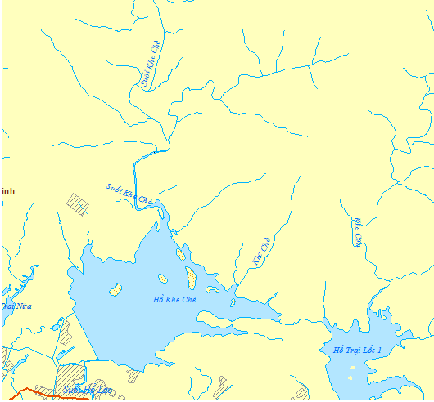
Khe Che reservoir
Khe Che stream
Figure: Location of Khe Che stream and Khe Che reservoir

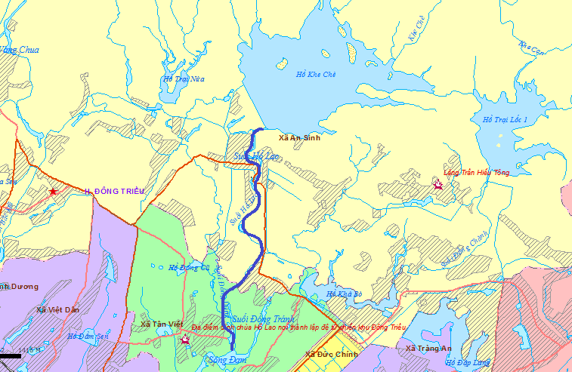
Ho Lao stream
Dam river
Khe Che reservoir
Figure 4.2: Location of Ho Lao stream and Dam river

4.2. Climatic Conditions

Temperature – The average air temperature in many years is 23.3ºC, the highest level are from June to August and the lowest level is on January and February. (See Appendix 4, Table 4.1).

Humidity – The Average air humidity in many years is 82%, the highest level are on February, March and August with average value of 86% (see Appendix 4, Table 4.2).

Amount of evaporation- The average amount of evaporation in many years is 998.2mm at Uong Bi (measured by Piche tube). The minimum level is on February and March and maximum level if on October and November (see Appendix 4, Table 4.3).

Precipitation - Dong Trieu is the region with low average annual precipitation of Quang Ninh, X_{o}=1459,4mm, the maximum daily precipitation measured on 28 October 2005 is 335mm (see Appendix 4, Table 4.5).

Meteorological Observation Status - At the basin without any meteorological observation station, the region has the weather stations as follows:

Table 4.6. Weather station
Name | Location |  | Measuring factors | Measuring time
 | Longitude | Latitude
Uong Bi | 106º46’ | 21º02’ | Rain, wind, evaporation, temperature | 1961-2008
Dong Trieu | 106º30’ | 21º05’ | Rain | 75, 78~2008
(Source: http://quangninh.gov.vn/vi-VN/huyenthi/huyendongtrieu/Trang/default.aspx/)

Extreme Weather Events - Each year Dong Trieu on the average suffers the impacts of about 5 to 6 hurricanes with the wind speed of 20 to 40m/s that causes heavy rain, precipitation of from 100 to 200mm, evenly up to 500mm for some places. The hurricane makes the huge damages for activities in fields of agriculture – forestry – fishery, living activities and people’s livelihood. Salt flog is also observed within December to March, in the mountain regions of An Sinh, Binh Khe, Trang Luong when the temperature falls to 3⁰C.

Terrain -The region planned for the project is the area transforming from the mountains to the plain so much of Quang Ninh is sloping terrain with round peak, gentle slope, attitude of 5-100m that is good for development of industrial and agricultural crops, forest planting. However, Quang Ninh has many high peaks of approximately 1000m comparing to the slopes, mixing the sharp peaks with deep creeks on the West side of the Province.

Geology - The formation in this region is characterized as the water penetration from the average level to the weaker one, monolithic bedrock which is less cracks, weak penetration and considered as the waterproof layer, covering layer and chronozone IA2 with water penetration from the average level to the higher level with the thin layer.

Features of aquifers, auriferous complex – The aquifer can be characterized as follows:
- The formation is characterized as water penetration from the weak level to the higher one, monolithic bedrock which is less cracks and considered as the waterproof layer. Groundwater is stagnated in the empty holes of covering layer and in the cracks of weathered zones. It could be divided the aquifers under the studied zones as followed:
- The aquifers in the alluvia, deluvia-proluvia sediments: Water stagnates and moves in the empty holes formed by clay loam, clay sand, pebble stone that are derived from the alluvial grounds and mixture of proluvia-deluvia.
- The main water sources are rainfall, water from the surface of auriferous complexes and Khe Che lake. Movement mechanism and chemical composition of alluvia, deluvia-proluvia accumulated water are closely related to the conditions and chemical composition of lake.
- Aquifer in the rock formations: Because the lithological components are formed by quaternary sediment and terrigenous sediment under the mixed and layered structure, water storage capacity of the complex is higher. It probably relates to pressured water.
- Groundwater is clear, odorless, tasteless and used as domestic water source of residents.
- Topography, geomorphology: Spillway line is located on the left of Khe Che dam, on a hillside with an average slope of 20-250.
- Stratum, lithology: According to the results after drilling, the spillway line appears fine rock, purple grits classified under Binh Lieu layer, weak-weathered rock with purple brown or reddish brown color, layered structure, and medium hardness.
- Mash and compress: According to the results after drilling, there is no sign of broken stone in the drilling holes. Rocks are weathered at the medium level to high level so the RQD ratio of stone is low.

4.3. Water environment

Surface water - Location of headwork of Tea Khe reservoir locates in areas with abundant precipitation, total average annual precipitation of 1495.5 mm. Basin of Khe Che reservoir is low hills, average-level phytoplankton, and basin area of 22.4 km². Residents here live mainly on agriculture and industrial production. The reservoir is responsible for providing water to irrigate about 1,000 hectares of cultivated land.

Water quality is determined through analysis of typical samples of the lake. Because of having the ecological activities in this area, the investigation team took 06 samples and the specific sampling locations are shown in Table 4.7 below.

Table 4.7. Sampling location at Khe Che Lake
(Time: Morning 11 March 2015)
KH | Coordinate |  | DESCRIPTION OF SAMPLING POINT
 | Latitude | Latitude
H1 | 21°08’38.1” | 106°32’20.9” | Far from the ecological zone, depth of 10m, small rain, temperature of 24ºC
H2 | 21°08’51.7” | 106°31’57.9” | Water near the ecological zone, next to the spillway. In summer, the ecological zone is crowded with tourism services and festival activities.
H3 | 21°08’38.0” | 106°31’30.6” | Water: 3m far from the sewer
H4 | 21°08’23.3” | 106°31’37.6” | Water: 3m far from the spillway
H5 | 21°08’33.7” | 106°31’51.3” | Water: 3m far from the lake bank, green colour from the aquatic organisms
H6 | 21°08’16.3” | 106°31’52.6” | H6: Water at the centre of lake, depth of 13-14m

The project area has many ponds, lakes, rivers with the average-to-high density comparing with the rest of country, abundant water surface resource.

Table 4.8. Sampling point at other locations of the project
(Sampling time: Morning 11 March 2015)
KH | Coordinate |  | DESCRIPTION OF SAMPLING POINT
 | Latitude | Longitude
N1 | 21°07’59.7” | 106°31’32.8” | Sewer 1 An Sinh contains the stagnant water when draining through channels
N2 | 21°07’15.2” | 106°31’47.1” | Sewer 2 Tan Viet contains the stagnant water
N3 | 21°06’52.3” | 106°32’03.6” | Tan Viet pump station, Dong Khe Ha hamlet
N4 | 21°05’39.9” | 106°31’03.0” | Duc Chinh drainage ditch, cultivated land is near to the Tan Viet livelihood zone.
N5 | 21°05’45.3” | 106°31’05.1” | Viet Dan pump station, the surrounding is cultivated zone
N6 | 21°05’41.3” | 106°29’45.3” | Ba Xa Hamlet, An Sinh Commune
N7 | 21°07’37.6” | 106°31’54.3” | Binh Duong pump station locates at Dang Thuy village
N8 | 21°07’38.0” | 106°31’43.0” | Thuy An pump station; water in the pump station is low and dirty
N9 | 21°08’07.0” | 106°31’07.3” | Trang An drainage ditch, dirty

To specify quality of surface water environment in the area under the sub-project’s impacts, sampling points are defined at 3 communes (An Sinh, Tan Viet, Viet Dan) which will suffer the impacts from headworks of Khe Che reservoir. Sampling is conducted at underground sewers (An Sinh and Tan Viet Commune) and drainage stations (An Sinh, Tan Viet, Viet Dan Commune). Locations of other sample area in the affected and beneficiary area are presented in Table 4.8.

Comments: By analysis results of sampling the lake water and surface water at communes within the affected areas of the project that upgrades and extends the spillway for headworks of Khe Che reservoir (Appendix A3.1), we can see that:
- Generally, surface water quality at the areas under the acceptable limit of QCVN 08: 2008/BTNMT.
- Several criteria have not met the requirements:
  - At the sampling point H1 and H6 in Khe Che lake, COD concentration (31 and 34 mg/L) exceeds the acceptable values under QCVN (30 mg/L); However, these value are under the limit. Moreover, at sampling locations at Duc Chinh, Viet Dan drainage ditch, Thuy An sewer, water also is polluted by the organic matters (COD level exceeds the acceptable standards). It can be predicted that initial cause is due to the local residents washing their tools and pesticide bottle on the drainage system, leading to increase COD concentration at the above-mentioned positions.
  - Almost water samplings in the lake have not met the standards on the level and microorganism, shown by Coliform or E.Coli concentration subject to QCVN 08:2008/BTNMT. Coliform concentration in the surface water at most of sampling points exceeds the limited values (except for underground sewer 2 Tan Viet and Thuy An pump station).
- Basically, quality of water surface at the affected areas of the project is quite good.

Groundwater –The terrain of Dong Trieu District is sloping from North to South. In the North, Dong Trieu Mountains consecutively run in the curve shape with Bay Deo peak of over 1,000 meters. In the South, there is Cao Bang, Dong Son, Dao Quan Mountains with the height of approximately 500m. From the North, many rivers and stream flow down. The West has Vang River. Dam Thuy River, Ky Cam River, Trang Bang River in order of appearance. The East is Tan Yen River. Rivers are small and upstream slope is high, the downstream is quite wide, groundwater source is abundant because of dense limestone mountains.

The headwork of Khe Che reservoir mainly affects to 03 communes: An Sinh, Viet Dan and Tan Viet so the groundwater shall be sampled at these points to assess the water quality.

Location for sampling at 03 communes: An Sinh, Tan Viet and Viet Dan are shown in the table below.

Table 4.9. Sampling locations at the affected area of the project
(Time: Afternoon, 11 March 2015)
KH | Coordinate |  | DESCRIPTION OF SAMPLING POINT
 | Latitude | Longitude
NN1 | 21°07’47.7” | 106°30’25.5” | An Sinh well, Mr. Pham Van Tien and his family - livestock farming at large scale (20 pigs). Sampling depth of 15m.
NN2 | 21°06’19.4” | 106°28’21.8” | An Sinh well, Mr. Pham Phu Be and his family - livestock farming at small scale. Sampling depth of 20m.
NN3 | 21°05’41.6” | 106°29’11.3” | Tan Viet well, Mrs. Luu Thi Men and her family – using water from the drilling well. Sampling depth of 25m.
NN4 | 21°05’17.0” | 106°29’11.2” | Tan Viet well, Mr. Vuon Van Chinh and his family – using water for livestock farming. Sampling depth of 20m.
NN5 | 21°05’18.6” | 106°30’59.1” | Viet Dan well, Mr. Nguyen Van Thanh and his family – Khe Ha. Water has abnormal smell. Sampling depth of 20m
NN6 | 21°06’30.1” | 106°31’37.3” | Viet Dan well, Mr. Nguyen Van Thuc and his family – An Lang. Water has abnormal smell but be used for living activities. Sampling depth of 20m
NN7 | 21°05’45.6” | 106°30’03.9” | Viet Dan well, Mr. Nguyen Van De and his family – An Trai. Water has abnormal smell. Sampling depth of 25m
Quality of groundwater at these sampling points is shown in Appendix A3.2.

Comments: By the analysis results of groundwater samples taken at 03 communes that have suffered the most impacts from the headwork of Khe Che reservoir, we can see that:
- The quality of underground water at 03 communes does not meet the standards on microbiology (Coliform and E. coli levels exceed the permissible limit).
- At An Sinh commune, COD concentration meets the standard QCVN 09: 2008 / BTNMT (National Technical Regulations on groundwater quality) while the groundwater at Tan Viet and Viet Dan commune has a signal of organic pollutants (COD values in the samples exceeds the permissible limit prescribed under QCVN).
- Other factors are under the permissible limits. Generally, groundwater quality of the three communes is relatively good.

4.4. Air Environment

To assess the air quality of the project area, conduct the survey and measure 4 air samples: KK01: Air sample from the main dam (X:574641,32; Y:2258850,51); KK02: Air sample form the entry to the main dam (X:574728,86; Y:2258698,76); KK03: Air sample from spillway (X:574337,74; Y:2259062,54); KK04: Air sample from paddy field (X: 574612,45; Y:2259128,53);

Analysis results of air quality of the sub-project area are shown in Appendix A3.3.

Comment: Basing on the observation results of air environment at 4 points KK01. KK02, KK03, KK04, we can produce some comments as follows:

Comparing the criteria on TSSP, noise, concentration of CO, SO₂, NO₂ with QCVN 05-2008/BTNTM (Air quality), it is proved that these criteria have satisfied the standards.

Basically, air quality of this area is quite good, has not appeared the pollution signs yet.

4.5. Soil environment

The terrain of the lake centre is mainly hill with the slope of approximately 15-200, average level of 180. The streams at the spillway flow from the Southwest to the Northeast, width of 30-70m, mountain slope of 20-25⁰

Geomorphology of the survey area is divided under the patterns and backgrounds, including:
- The original surface inclined from the synthetic erosion: Widely distributed on the hillside. On the topographical surface, development of erosion and landslide processes forms thick coating layer made by eluvial-deluvial components.
- The original side eroded and wiped out: Unconsolidated materials are weathered and washed away, accumulating the large and multi-components block on the washout surface, evenly exposed bedrock.
According to planning documents, land in the project area is mainly formed from weathered rocks, sediments washed out. So, it should not be fertile.

To determine soil quality of areas around the headwork, soil samples were taken at 3 communes An Sinh (D01), Viet Dan (D02) and Tan Viet (D03). This is the area suffering the most impacts from Khe Che reservoir.
The results on analysing the land samples at 03 communes An Sinh, Viet Dan and Tan Viet are shown Appendix A3.4.

Remark:
Đ1: Sediment sample at Tan Viet pump station (X: 21°06’52.3” ;Y:106°32’03.6”).
Đ3: Sediment sample at Viet Dan pump station (X: 21°05’45.3”;Y:106°31’05.1”)
Đ4: Sediment sample at An Sinh Commune (X: 21°05’41.3”;Y:106°29’45.3”)
Comment: According to the analysis results of soil samples at 03 communes suffering the most impacts from the headwork, we can see that:
- Comparing metal content in soil samples with the standard QCVN 03-2008/BTNTM (Soil quality - National technical regulation on the allowable limits of heavy metals in the soils), it is seen that the metal contents can be acceptable. Soil at the sampling points belongs to the neutral type, no signs of alum or saline.
- Area of soil sampling is mainly used for agricultural purposes (rice planting), no waste sources and far from residential zones so that the metal content is low. The soil quality is quite good, no signs of contamination.

4.6. Biological environment

Observation location of ecological background Irrigation systems for controlling the water flow and irrigating the near-by villages and private farms for commercial plants, fruit trees, especially in the channels, has certainly affected the aquatic system in this area. Research and survey activities were conducted at the end of the spring season, or 11 March 2015. The location of sampling stations are given in following sketch map (Figure 4.1) and coordinates (Table 4.10):

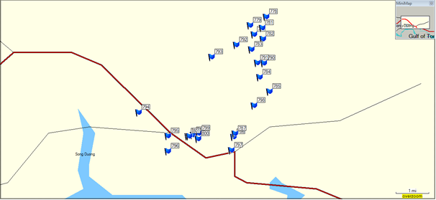
Figure 4.1. Location of sampling station at the sub-project area of Khe Che reservoir

Table 4.10. Coordinate of survey points at Khe Che Lake, Dong Trieu, Quang Ninh
(Time: 11 March 2015)
Code of Coordinate | Latitude | Longitude | Attitude (m)
Points on Khe Che lake
777 | 21°08’38.1” | 106°32’20.9” | 10
778 | 21°08’51.7” | 106°31’57.9” | 9
779 | 21°08’38.0” | 106°31’30.6” | 11
780 | 21°08’23.3” | 106°31’37.6” | 12
781 | 21°08’33.7” | 106°31’51.3” | 16
Others
782 | 21°08’16.3” | 106°31’52.6” | 16
783 | 21°07’59.7” | 106°31’32.8” | 1
784 | 21°07’15.2” | 106°31’47.1” | 1
785 | 21°06’52.3” | 106°32’03.6” | 7
786 | 21°05’39.9” | 106°31’03.0” | 1
787 | 21°05’45.3” | 106°31’05.1” | 2
788 | 21°05’43.3” | 106°29’54.0” | 17
789 | 21°05’41.3” | 106°29’45.3” | 16
790 | 21°07’37.6” | 106°31’54.3” | 24
791 | 21°07’38.0” | 106°31’43.0” | 22
792 | 21°08’07.0” | 106°31’07.3” | 18
793 | 21°07’47.7” | 106°30’25.5” | 40
794 | 21°06’19.4” | 106°28’21.8” | 13
795 | 21°05’41.6” | 106°29’11.3” | 11
796 | 21°05’17.0” | 106°29’11.2” | 11
797 | 21°05’18.6” | 106°30’59.1” | 10
798 | 21°06’30.1” | 106°31’37.3” | 12
799 | 21°05’45.6” | 106°30’03.9” | 4
800 | 21°05’36.9” | 106°30’02.5” | 5
801 | 21°05’40.9” | 106°29’47.6” | 6

4.2.2. Flora

Studied area belongs to agricultural ecosystem with the landscape of low hills in Red River Delta. In this type, it is mainly planted forests, cultivation of commercial crops, fruit trees, waters rice, and irrigation channels. Therefore, biological system in the study area is mainly aquatic groups.

By the field surveys, interview of residents and the published and approved documents, the project have listed components of terrestrial flora and fauna (the area around the project at An Sinh Commune) as follows: flora has 38 species, 27 families under 2 divisions: Pteridophyta and Magnolia.

There are three main types of vegetation:
- Different tree species planted in the agricultural land: There are 13 plant species belonging such flora. Most of them are short-term cultivated plants with the largest area. This flora occupies up to 2/3 entire area relating to irrigation dam.
- Forestry trees and fruit trees planted in the hills and uplands: There are 22 plant species and wild species allocated in such flora. This flora covers the second-largest area behind the flora planted in the agricultural land.
- Fruits, foods and routine consumption purposes in the residential areas: There are 26 plant species in such flora. This flora covers the smallest area among 3 types of flora.

Macrophyta - Macrophyta in the survey area includes the following habitats:

Floating-leaf macrophyte refers to species with roots buried into the water basin bottom and leaves to be floated in the water or water surface: including different types of Nelumbo nucifera, Nymphaea nouchali, N. pubescens, N. tetragona, Cyperus spp., Phylidrum lanuginosum, etc

Freely floating macrophyte refers to the water-fens of various species with fasciculate root submerged in water: Pistasia stratiotes, Salvia cuculata, and Eichnornia crassipes

Emergent macrophyte refers to species with roots submerged inside the water basin bottom with body and leaves floating above water, including: E. dulcis, Ludwidgia adscendens, Centrostachys aquatica, Hymenachne acutigluma, Coix aquatica, L. hexandra, etc. Besides, the natural aquatic plants as mentioned above include water rice population regarded as crops.

Submerged macrophyte cover seaweed species with roots deeply submerged into water basin bottom, all of its body and leaves completely submerged into water, including Ceratophyllum demersum, Nymphoides indicum, Utricularia flexuosa, U. fasciculata, U. confervifolia, Hydrrilla verticilata, etc

Moreover, together with the above aquatic plants, there are some floating plants such as Lemna tenera, L. aequinoctialis, Azolla pinnata, etc

Phytoplankton - The primary analysis results of floating macrophyte determined 42 species under 17 families and 6 braches (Appendix 1). Bacillariophyta has 16 species, accounting for 38.1%, Chlorophyta has 14 species, accounting for 33.33%, Cyanophyta has 7 species, accounting for 16.67%, Pyrrophyta has 1 species, accounting for 2.38% and Euglenophyta has 4 species, accounting for 9.52%. The floating macrophyte is many popular and widely allocated tropical species without specific species. With about 42 species of floating macrophyte as mentioned above, it is relatively low against the same aquatic macrophyte forms at other places.

The density analysis results of floating macrophyte (Table 1) unveiled some comments: Density of floating macrophyte rarely varies among survey stations. It fluctuates within the range of 2,000-4,000 TB/L. The Bacillariophyta, Chlorophyta and Cyanophyta branches domain in terms of density. The Cyanophyta branch obtains the least domain, accounting for 35-40% among total floating macrophytes. The Euglenophyta branch obtains low rate (3-5%), in accordance with the aquatic form in the agricultural ecosystem in the plain and highland landscape.

4.2.3. Fauna

The fauna in the sub-project site is described as follows: 15 mammal species belonging to 8 families and 4 sets; 74 species of birds belonging to 37 families and 15 sets; 19 reptile species belonging to 9 families and 2 sets; and 13 amphibian species belonging to 5 families and 1 set.
Zooplankton- The sample analysis results determined 28 species of Zooplankton belonging to 12 families and 21 breeding (Appendix 2), in which Copepoda has 7 species, accounting for 25% of total species, Cladocera has 10 species, accounting for 35.71%, Rotatoria has 10 species, accounting for 35.71% and insect larvae has 1 species, accounting for 3.57%. Quantity of Zooplankton determined in the site may be lower than that in practice. There is no specific water basin species.

In the reservoir-shaped waters, the largest quantity of species (21 species) is available at irrigation channel (16-18 species), irrigation ditch (15-16 species) and the smallest quantity of species is available at ditch and rice paddy field (8-12 species).

The Zooplankton density analysis results (Table 2) releases some comments as follows:

- Regarding the Zooplankton density, the variation is remarkably high, from 50 units/m3 to 18,000 unit/m3. Concretely, at Khe Che Irrigation Reservoir (T1; T2; T3; T4; T5), the highest density is available (3,333-17,959 units/m3), the next is the large channel and internal irrigation ditch (T 6; T7) with density of 1,450-3,300 units/m3 and the lowest is available in small ditch (where directly circulates the rice paddy field and suffers the significant impacts of pesticides as well as pesticide bottle and empty container after directly discharging here). The density is suddenly reduced and obtained only 50-100 units/m³.

- In general, the waters are characterized by non-diversified components of species and sharp fluctuation in terms of Zooplankton density. At such waters, the random water discharging of pesticide bottles, empty containers and application of many pesticide types in a rice crop may be a pollution source.

Zoobenthos - The Zoobenthos analysis results determined over 13 freshwater oysters and snails belonging to 6 families and 10 breeding (Appendix 3), in which Viviparidae, Corbiculidae and Bithyniidae had 3 species. At the survey sites in the irrigation channel or ponds or reservoirs, some species were higher than that in others, the lowest was available at small ditches bordering with rice paddy field. Generally, the local freshwater oysters and snails are popular in waters of Vietnam.

Therefore, the oyster and snail components of served site were not diversified. Among the obtained snails, there were two species of yellow snails namely Pomacea canaliculata and P. bridgesi. These two species has been immigrated into Vietnam since the early of 1980s and 1990s. It was originated from Amazon River delta (Argentina, Brazil), migrated to Asian and Southeast Asia counties for food purposes. However, after a short period of time, such nails released adverse impacts after being discharged into the natural environment. They destroyed plants in the field with fast speed and caused remarkable damages to Vietnam agriculture.

Components of domestic and natural fishes -Through survey and statistics in the region, the fish components included 22 species belonging to 8 families and 5 sets. Number of natural fishes available in the survey area was not larger than that of domestic fish raised by households (surrounding ponds or lakes).

Popular domestic fishes include Cyprinus carpio, Cirrhinus molitorella, Labeo rohita, Cirrhinus mrigala, Hypophthalmichthys molitrix, Hypophthalmichthys nobilis, Oreochromis mossambicus and Colossoma brachypomum.

Popular natural fish species include Acheilognathus cf. kyphus, Anabas testudineus, Hemiculter leucisculus, Monopterus albus, Anabas testudineus, Macropodus opercularis. There is no rare and specific fish species.

4.2.4. Sensitive area

Within the site to be launched with the sub-project on "Rehabilitating and improving head works complex of Khe Che Reservoir", no sensitive areas are available such as wetlands, parks and protected areas, conservation areas and ecological zones, gene and biosphere reserves, and national defence areas.

4.3. Socio-economic and socio-cultural environment

4.3.1. Overview on socio-economic situation in the project site

Demography. According to the figures released by Statistics Department of Dong Trieu District, the average population of Dong Trieu District was 172,178 persons, including 85,427 female. The urban population was 44,412 persons, accounting for 25.8%, the rural population was 127,766 persons, accounting for 74.2% of population in the District. Dong Trieu is home to 14 ethnic groups with the mainstream group (Kinh) accounting for 97.6% of population and the remaining was other ethnic groups.
- Number of household in the district: 48,329 household, 3.5 persons/household on average, in which:
  - Urban area: 11,300 households, 3.9 persons/household on average;
  - Rural area: 37,029 households, 3.4 persons/household on average.
- Households by production field:
  - Industrial household: 2,628 households, accounting for 5.44%
  - Agricultural household: 25,624 households, accounting for 53.02%
  - Trading and service household: 7,715 households, accounting for 15.96%
  - Transportation household: 1,400 households, accounting for 2.9%
  - Others: 10,962 households, accounting for 22.7%
- Average population density in 2013 were 433 persons/km² increase by 39 persons/km² compared to 2010 (394 persons/km²).

Table 4.11. Population structure of communes at the downstream of Khe Che reservoir
Content | Name of communes
 | An Sinh | Binh Duong | Duc Chinh | Nguyen Hue | Tan Viet | Thuy An | Trang An | Viet Dan | Dong Trieu Town
Total | 6904 | 8213 | 7740 | 6188 | 3311 | 4200 | 6071 | 4240 | 5282
Female | 3592 | 4124 | 4016 | 3155 | 1725 | 2200 | 3053 | 2164 | 2506
Male | 3312 | 4089 | 3724 | 3033 | 1586 | 2000 | 3018 | 2076 | 2776
Source: Statistics from Department of Statistics of Dong Trieu District (2014)

Socio-economic Profile. Lowlands of Dong Trieu District cover 8 communes and 01 town, in which 3 communes obtained the highest benefits and impacts from the project during the Project was launched, namely An Sinh, Viet Dan and Tan Viet. According to the statistics of Dong Trieu district: the overall production value growth of the District was 16.9%/ year in the period of 2010 – 2013, in which the average growth of industries namely: Agro-fisheries and forestry obtained 11.7%, Industry and construction industries obtained 17.37% and service obtained 18.94%. The above indicators were relatively higher than that of the entire province (at the same period of 2010 – 2013, production value growth of Agro-fisheries and forestry, Industry and construction, Trading and Services of the Province obtained 3.6%, 7.29% and 12% /year, respectively.

Table 4.12. Several criteria for economic development in period of 2010 - 2013
Items | 2010 | 2011 | 2012 | preliminary 2013 | Average increasing rate (%/year)
Competitive price in 1994 | 2,207 | 2,710 | 3,004 | 3,527 | 16.90
Agriculture-Forestry-Fishery | 357 | 387 | 404 | 499 | 11.77
Farming | 191 | 244 | 240 | 239 | 7.89
Breeding | 167 | 128 | 142 | 210 | 7.92
Forestry |  | 1.1 | 2.3 | 4.3
Fishery |  | 14.1 | 19.7 | 45.7
Industry – construction | 1,300 | 1,628 | 1,798 | 2,102 | 17.37
Service | 550 | 695 | 802 | 926 | 18.94
Existing price | 8,176 | 12,665 | 16,488 | 18,515
Agriculture, forestry, fishery | 1,251 | 1,760 | 2,143 | 2,148
Industry – construction | 4,865 | 7,637 | 9,926 | 11,368
Service | 2,060 | 3,267 | 4,419 | 4,999
Structure (%) | 100.00 | 100.00 | 100.00 | 100.00
Agriculture, forestry, fishery | 15.30 | 13.90 | 13.00 | 11.60 | -8.82
Industry – construction | 59.50 | 60.30 | 60.20 | 61.40 | 1.05
Service | 25.20 | 25.80 | 26.80 | 27.00 | 2.33
*Source: Department of Statistics, Reports of Dong Trieu District People’s Committee

Economic structure and transformation of economic structure: Overall economic transformation of the District were actively progressed and gradually decreased by structure of agro-fisheries and forestry and gradually increased by industry, construction and service. The structure of agro-fisheries and forestry reduced from 15.3% in 2010 to 11.6% in 2013, the average reduction speed was 8.82%/year. The structure of construction, industry and service increased from 59.5% to 61.4%, with transformation speed of 1.05%/year; the service industry increased from 25.2% to 27% with transformation speed of 2.33% in the period of 2010 – 2013.

Table 4.13. Agricultural production at downstream areas
Items | Unit | Name of Commune
 |  | An  Sinh | Duc Chinh | Nguyen Hue | Tan Viet | Thuy An | Trang An | Viet Dan | Dong Trieu Town
Farming
Total area | ha | 576,3 | 551,2 | 798,9 | 406 | 439,4 | 403,1 | 435 | 103
Rice | ha | 230,6 | 468,7 | 731,1 | 268,2 | 428 | 290 | 369,5 | 93
Yield | Ton/ha | 5,25 | 5,6 | 5,65 | 5,42 | 5,45 | 5,3 | 5,67 | 5,5
Crops of all types | ha | 345,7 | 82,5 | 67,8 | 137,8 | 11,4 | 113,1 | 65,5 | 10
Yield | Ton/ha | 23,65 | 23,7 | 22,8 | 22,23 | 22,37 | 23,8 | 23,71 | 21,9
Breeding
Livestock, poultry | Con | 56253 | 28178 | 86379 | 31473 | 39569 | 55966 | 24185 | 485
Buffalo |  | 370 | 14 | 104 | 61 | 16 | 160 | 21 | 5
Cow | Con | 257 | 6 | 137 | 7 | 48 | 58 | 42 | 0
Goat | Con | 596 | 0 | 0 | 0 | 0 | 0 | 0 | 0
Others | Con
Pig | Con | 7430 | 1058 | 5238 | 2181 | 2605 | 2348 | 2222 | 180
Fishery | ha | 204 | 27,3 | 24,4 | 23,5 | 55,6 | 39 | 35,7 | 1,8

4.3.2. Results of the Survey

Through the approaches to livelihood resources of households, this section will make an analysis of the socio-economic characteristics of surveyed households according to the human resources (demographic and labor, education, occupation, health), natural capital (productive land: agricultural land, forest land and aquatic land, land use), physical capital (housing, property for living, property for production and business), financial capital (income, changes in living standards, poverty, loans), and social capital (community relations, relatives, authorities and their support) and consider the impact factors including the potential impacts of the project. These resources have been analyzed with the integration with elements such as Gender, ethnic minorities and vulnerability.

Demographics. The average number of household members in the survey sample in the project area is 3.4, lower than the national average demographics in households, which is 3.89 (Statistical Yearbook, 2013). There are no difference in the number of inhabitants per household between communes, ethnic groups, income groups, female-headed households and male-headed households. (Pls refer to Table 4.14)

Table 4.14. Demography and average laborers per household
 | Demography | HH structure by scale of Demography (%)
 | Average in HHs | 1-2 people | 3-4 people | 5-8 people | Above 9 people
Total sample | 3.4 | 28.2 | 47.0 | 24.8 | 0.0
By commune/ Ward
An Sinh ward | 3.5 | 26.3 | 46.2 | 27.5 | 0.0
Tan Viet ward | 3.4 | 21.5 | 55.0 | 23.5 | 0.0
Viet Dan ward | 3.5 | 20.4 | 52.1 | 27.5 | 0.0
By HH gender
+ Male Headed households | 3.4 | 29.7 | 47.3 | 23.0 | 0.0
+ Female Headed households | 3.3 | 28.6 | 44.9 | 26.5 | 0.0
By income group
Group 1 (the poorest) |  | 22.1 | 51.6 | 26.3 | 0.0
Group 2 |  | 11.6 | 53.8 | 34.6 | 0.0
Group 3 |  | 20.0 | 40.9 | 39.1 | 0.0
Group 4 |  | 27.5 | 46.7 | 25.8 | 0.0
Group 5 (The richest) |  | 22.3 | 53.3 | 24.4 | 0.0
Source : Survey Data

By income groups, it is noted that the HH size of 3-4 persons is quite similar in all income groups. This has shown that nuclear HHs are popular, which explains the better household development compared to other sub-project areas (Figure 4.2).

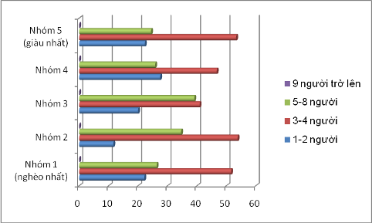
Figure 4.2. The size of households by income group

The analysis of the household structure by demographic scale in the project area showed a majority of households has 3-4 person (47.0%) and 4-5 persons (24.8%); 1-2 person (28.2%) and there is no HHs of 9 people or more. If small family size with a few children is universal as a recognition in Vietnam today, this survey shows that the nuclear family model accounts for around 80%.

Thus, the survey data shows that the model of few member family and nuclear family occupies higher percentage indicating that the development of the project areas is higher than other communes in the province.

Occupation. Among the occupational structures of family members having jobs and income in the project area survey, agro-forestry-fishery sector accounts for 65.6% as the highest; pupils, students have the percentage of 12.5% as the second rank; remaining are staff-officers, employees, workers with the percentage of less than 10% for each category; people doing business / services, and housewives are particularly low of less than 1.4%; handicraft is not included in the structure (see table 4.15). Thus, the agriculture-forestry-fishery is the dominant sector in the economy - society of the project area, where the majority of the workforce lives.

Table 4.15. Main occupation of laborers (including all member of HHs involved in labor force)
 | Labor health loss | Agriculture forestry and fishery | Trade and services | Officials and employees | Pupils and students | Handicraft | Hired | Jobless | Not suitable | Others
Total samples | 2.2 | 65.6 | 6.3 | 6.5 | 12.5 | 0.0 | 4.9 | 2.0 | 1.5 | 0.0
By communes
An Sinh ward | 2.2 | 66.0 | 6.5 | 6.5 | 11.5 | 0.0 | 5.2 | 0.0 | 2.1 | 0.0
Tan Viet ward | 0 | 64.0 | 6.2 | 6.2 | 12.0 | 0.0 | 4.7 | 5.4 | 0.6 | 0.0
Viet Dan ward | 1.5 | 65.5 | 6.2 | 6.5 | 12.5 | 0.0 | 5.2 | 1.5 | 1.1 | 0.0

In terms of occupational status, the contribution to the family income at present, the survey showed that the proportion of dependents is rather high accounting for 20%, of which a significant proportion of the unemployed and semi-unemployment. The subjects included eat most students, students, and the rest are still small / elderly, lost labor and even are in working age, health but does not have a job. The project will increase the area of ​​irrigated land, more seasonal produce in a year, diversifying outside the plantation industry (such as livestock, and professional services that use other countries); thereby increasing jobs and eliminate unemployment and underemployment present in the project area.

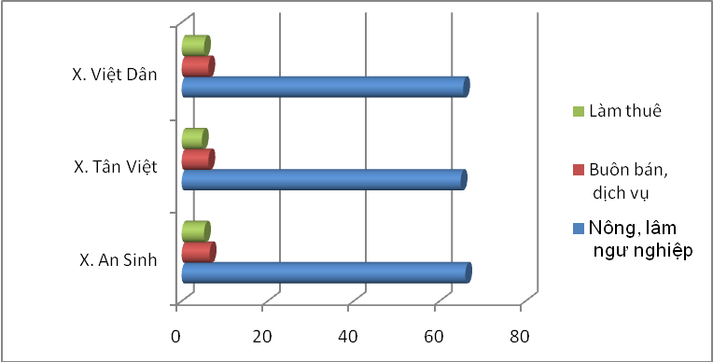
Figure 4.3. Occupation of Household Members in commune/ward

In general, the livelihood of people living in 3 communes benefiting from the surveyed project area is mainly agriculture, commonly two rice crops and one secondary crop a year. Therefore, the safety of dams and water stability for irrigation is very important for agricultural production in the residential areas, while there is a high demand of water for agriculture activities in most surveyed areas but actually it is not proactive.

In actual qualitative surveys in the project area show that in the past there were some contradictions, conflicts between farmers, inequality of water supply amount because some households have more favorable conditions in receiving more water for their slots if they are at the upstream of the water resources. This is caused by the reservoir’s water loss. The repair and rehabilitation of reservoirs will address the lack of equality of water supply for the upstream and downstream.

Education. About 95.0% of the project population graduated from elementary school to college/ university or higher, in which more than 60% people who graduated from junior high school and high school. Up to 18.3% people graduated from college/ university or higher. The illiteracy rate is 0.1% and the rate of preschool people in communes of project areas is 5%, which is lower than the national average as stated in the Statistical Yearbook 2013. This rate does not differ greatly between the surveyed communes.

It is noteworthy that the illiteracy rate of people in ethnic minorities is also very low, only 0.1% (this rate focuses on the elders who are more than 60 years old). According to the standard of living, the illiteracy rate in the poorest income group (group 1) only accounts for 0.1%). The percentage of children at the 6-18 age bracket who dropped out of school is 0.2% and majority is incapable or barely able to study. (Refer to Table 4.16).

Table 4.16. Education level of household members (Unit %)
 | Highest education level
 | Illiteracy | Primary School | Junior high school | High school | College/ University or above | Not suitable | Pre-school | No in-formation
Total | 0.1 | 15.2 | 31.1 | 30.3 | 18.3 | 0.0 | 5.0 | 0.0
By commune
An Sinh ward | 0.1 | 15.0 | 30.2 | 34.5 | 15.2 | 0.0 | 5.0 | 0.0
Tan Viet ward | 0.1 | 15.5 | 30.3 | 32.1 | 17.5 | 0.0 | 4.5 | 0.0
X.Viet Dan ward | 0.1 | 14.7 | 30.9 | 32.5 | 17.8 | 0.0 | 4.0 | 0.0
By income
Group 1 (the poorest) | 0.1 | 16.5 | 35.5 | 37.4 | 5.5 | 0.0 | 5.0 | 0.0
Group 2 | 0.1 | 15.6 | 35.5 | 31.09 | 10.0 | 0.0 | 6.9 | 0.0
Group 3 | 0.0 | 15.0 | 34.1 | 33.4 | 12.5 | 0.0 | 5.0 | 0.0
Group 4 | 0.0 | 15.0 | 35.5 | 30.5 | 15.0 | 0.0 | 4.0 | 0.0
Group 5 (the richest) | 0.0 | 14.5 | 23.9 | 40.6 | 18.0 | 0.0 | 3.0 | 0.0

The reason for children to quit from school accounts for 0.2 % because they are not good at learning, not directly related to economic reasons of HHs.

Health. There is about 18.7% of surveyed households last month were ill (see Table 4.17). This is a high rate and a worrying matter on the health of people in the project areas compared to the average health and better conditions for health care now. There are no large differences in sickness among the surveyed households as well as between rich and poor income groups.

Table 4.17. Health and health care conditions
 | With sick person in the past one month | With medical insurance
Total | 18.7 | 90.3
By commune
An Sinh ward | 20.0 | 90.0
Tan Viet ward | 17.5 | 89.9
Viet Dan ward | 16.5 | 85.0
By income
Group 1 (the poorest) | 18.7 | 85.0
Group 2 | 18.0 | 85.0
Group 3 | 15.8 | 90.0
Group 4 | 16.3 | 93.5
Group 5 (the richest) | 5.2 | 95.5

The number of surveyed households having insurances of all kinds is relatively high, accounting for 90.3%. In particular, the health insurance rate in the highest income group is 95.5%, which is not much higher than that of lowest group (85.0%). This shows that the local people in the project area (including lowest income HHs) all are aware of the necessity of participation in health insurance

According to the respondents of surveyed households, there are four main reasons causing negative impacts on the health situation are listed as follows from the highest to lowest level, namely: polluted water, foods insecurity, lacking of running water and living pollution (see Figure 4.4)

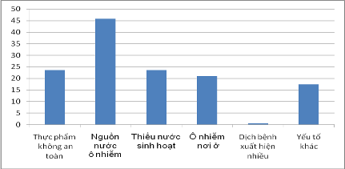
Figure 4.4. Percentage (%) of the causes adversely affecting to the health today

Two out of five main causes adversely impact public health relates to polluted water and lacking of domestic water (accounting for the highest rate of 69.3%).

Access to Land. In surveyed area, agriculture is the main production activities, the basic livelihood of the people, so that land is the main production resource of farmers. Of which, 99.5% HHs have residential land, 95.2% HHs have paddy land, 59.2% HHs have land for vegetables, 13.3% of HHs have land to plant industrial trees and 15.3% of HHs have ponds and water surface.

The data of land of all types of surveyed households in the project area showed that agriculture and farming are popular in the localities. Therefore, the demand for irrigation for agriculture in these regions is very high; the lack of water in 1-2 months will certainly affect the lives of local people.

By income, the two lowest income groups (group 1, 2) have the lowest percentage of arable land types, in contrast, the HHs of higher income shall have higher rate of cultivating land. Poor household have no pond or water surface, so they depend on agricultural land. It is obvious that the lack of arable land is now only one of the reasons causing poverty in agriculture area, rural areas. For the purpose of reducing poverty, the stability and increasing of irrigated areas, increasing crops/ season/ year for the existing area as well as increasing activities of non-agricultural employment is very important.

Table 4.18. Kinds of land of households
 | Residential land | Paddy field area | Land for vegetables, secondary crops | Land for industrial trees | Ponds, surface water
Total | 99.5 | 95.2 | 59.2 | 13.3 | 15.3
By commune
An Sinh ward | 98.1 | 95.0 | 66.5 | 12.9 | 15.8
Tan Viet ward | 100.0 | 96.0 | 77.5 | 25.0 | 12.5
Viet Dan ward | 100.0 | 98.2 | 55.6 | 29.1 | 10.3
By income
+ Group 1 (the poorest) | 100.0 | 89.5 | 60.5 | 10.5 | 0.0
+ Group 2 | 100.0 | 95.6 | 72.3 | 19.2 | 16.4
+ Group 3 | 100.0 | 97.5 | 68.2 | 20.9 | 13.6
+ Group 4 | 100.0 | 98.1 | 69.2 | 20.2 | 17.5
+ Group 5 (the richest) | 100.0 | 94.4 | 73.3 | 32.7 | 20.3

Water source for domestic usage- The majority of surveyed households in the project area use tap-water (95 %) for bathing and daily activities, the usage of other water sources is low: there is no HHs use water from ponds, lakes, rivers; 1.4% use other water sources and 1.0% use well water.

In the rural areas, 91.5% of the water sources used for bathing and daily activities from sources such as wells, private water taps, public water and rainwater are considered to be hygienic.

Table 4.19. Percentage of HHs in the project communes using water sources for domestic usage (%)
 | Private running water tap | Public water | Wells | Water from ponds, lakes | Rainwater | Others
Commune
Total samples | 95.0 | 0.0 | 5.0 | 0.0 | 0.0 | 0.0
By commune
An Sinh ward | 95.3 | 0.0 | 4.7 | 0.0 | 0.0 | 0.0
Tan Viet ward | 92.0 | 0.0 | 8.0 | 0.0 | 0.0 | 0.0
Viet Dan ward | 95.2 | 0.0 | 2.7 | 0.0 | 0.0 | 1.8
In term of income groups
+ Group 1  (the poorest) | 90.0 | 0.0 | 5.0 | 0.0 | 0.0 | 5.0
+ Group 2 | 90.2 | 0.0 | 9.8 | 0.0 | 0.0 | 0.0
+ Group 3 | 95.5 | 0.0 | 4.5 | 0.0 | 0.0 | 0.0
+ Group 4 | 93.9 | 0.0 | 6.1 | 0.0 | 0.0 | -
+ Group 5  (the richest) | 98.5 | 0.0 | 1.5 | 0.0 | 0.0 | 0.0

The survey data shows that 95% of people in the areas using domestic water from tap, which is transmitted from Khe Che lake into supply plant, through filtration system, then provide to end users. As a result, keeping water from being lost in the Khe Che reservoir is a very important for living.

Drinking water sources -Like water for washing and bathing, the drinking water of people in surveyed communes is mainly from tap at the rate of 98%, there is only 2% of people use water from well for drinking.

In consideration of the relatively clean water in rural areas, these sources include: running water, we water, storm water and water purchased, supply of drinking water is relatively assured to up to 98% of people in the project area. However, it must be acknowledged that people in the project area do not use water from ponds and lakes for drinking water.

It can be said that in the surveyed project areas, drinking and domestic water are not being met in terms of quantity and quality, thus keeping water during the water shortage seasons is very important affected to the people in the project area.

Table 4.20. Percentage of households using drinking water in the project areas (%)
Communes | Private running water tap | Public water | Wells | Water from ponds, lakes | Rainwater | Commercial water | Others
Total samples | 98,0 | 0,0 | 2,0 | 0,0 | 0,0 | 0,0 | 0,0
By commune
An Sinh ward | 95,7 | 0,0 | 4,3 | 0,0 | 0,0 | 0,0 | 0,0
Tan Viet ward | 97,5 | 0,0 | 2,5 | 0,0 | 0,0 | 0,0 | 2,5
Viet Dan ward | 94,0 | 0,0 | 6,0 | 0,0 | 0,0 | 0,0 | 0,0
By income
+ Group 1  (the poorest) | 92,7 | 0,0 | 6,3 | 0,0 | 0,0 | - | 1,0
+ Group 2 | 97,2 | 0,0 | 2,8 | 0,0 | 0,0 | - | 0,0
+ Group 3 | 98,0 | 0,0 | 2,0 | 0,0 | 0,0 | 0,0 | 0,0
+ Group 4 | 98,8 | 0,0 | 1,2 | 0,0 | 0,0 | 0,0 | -
+ Group 5 (the richest) | 100,0 | 0,0 | 100 | 0,0 | 0,0 | 0,0 | 0,0

Sanitation. Figure 4.5 shows that up to 94.6% of households in the surveyed area have used sanitary toilets; including 66.1% of households with septic and semi-septic tanks, 28.5% of households with 2 compartment toilets. In addition, about 3.7% of households still use simple toilets, and 1.2% of households haven’t had toilets. In parallel with the implementation of the project, it is necessary to promote greater awareness of people about hygiene to protect health.

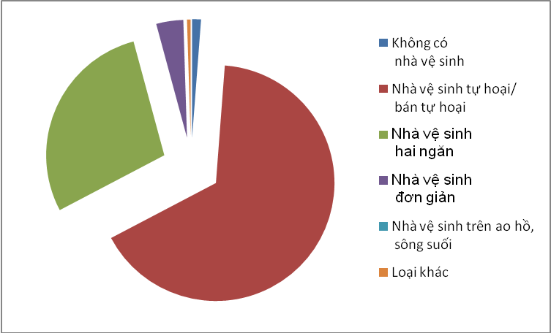
Figure 4.5. Kinds of toilets

Table 4.21. Types of toilets of surveyed households
 | Without toilets | Sanitary toilets |  |  | Unsanitary toilets
 |  | Septic and semi-septic tanks | Two compart  toilets | Total | Simple toilet | Discharge into ponds, lakes | Others
Total samples | 1,2 | 66,1 | 28,5 | 94,6 | 3,7 | 0,0 | 0,5
By commune
An Sinh ward | 0,0 | 60,5 | 22,7 | 83,2 | 3,5 | 0,0 | 0,0
Tan Viet ward | 1,0 | 65,5 | 25,5 | 91,0 | 5,0 | 0,0 | 3,0
Viet Dan ward | 1,2 | 66,0 | 28,3 | 94,3 | 4,05 | 0,0 | 0,0
By income
Group 1  (the poorest) | 1,2 | 66,5 | 26,8 | 93,3 | 5,5 | 0,0 | 0,0
Group 2 | 1,0 | 79,7 | 14,4 | 94,1 | 4,9 | 0,0 | 0,0
Group 3 | 0,0 | 79,1 | 17,3 | 96,4 | 3,6 | 0,0 | 0,9
Group 4 | 0,0 | 86,8 | 10,9 | 97,7 | 2,3 | 0,0 | 1,0
Group 5  (the richest) | 0,0 | 86,4 | 13,4 | 99,8 | 0,2 | 0,0 | 0,0

By income group, it is noteworthy that in the surveyed wards and communes, the proportion of households with toilets meeting standards is very high, accounting for more than 96.4%. The poorest group also has 93.3% of standard toilets. In contrast, the richest income group (group 5) has 99.8% meeting standards.

Income and Standards of Living of households. In the Project areas, the middle income group and above occupy a high rate (43.5% and 33.8% is) and especially the poverty rate in surveyed communes remains only of 2.5%.

Table 4.22. By income (%)
 | By income |  |  |  |  | Total
 | Group 1 | Group 2 | Group 3 | Group 4 | Group 5
Total samples | 2,5 | 2,1 | 43,5 | 33,8 | 18,1 | 100,0
By commune
An Sinh ward | 0,0 | 1,8 | 45,0 | 28,2 | 25,0 | 100,0
Tan Viet ward | 0,0 | 1,1 | 47,0 | 33,0 | 18,9 | 100,0
Viet Dan ward | 2,5 | 5,0 | 35,0 | 45,5 | 12,0 | 100,0
By gender
+ Male headed HH | 2,5 | 2,0 | 44,5 | 30,9 | 20,1 | 100,0
+ Female headed HH | 2,5 | 2,5 | 42,5 | 33,0 | 19,5 | 100,0

According to locality’s self-evaluation, the standard of living is at average with the income group of average and higher level accounting for 90%.

In terms of ethnicity, at poverty level, there is not a big gap between the Kinh and ethnic people (0.5% and 5%, respectively).

Similarly, for gender of the heads of households, female-headed households have the same rate of poverty compared with male-headed households (2.5% versus 2.5%). This number shows the equal role between male and female group in creating income in the project area.

As a result, the Project will contribute to the improvement of the lives of women because they are affected and vulnerable, supporting strongly women in generating income and stable life, as well as poverty eradication.

A number of livelihood and social security issues. It is a regular situation and popularity when communities in rural areas are often debts. One third of the interviewed households currently have a loan, accounting for 34.5% of total respondents. Regarding the scale of debt, up to 85.6% of households borrow only an amount of less than VND 60 million, and the rate of households with loans of more than VND 60 million is much lower only 9.4%. The loan is relatively low (≤ 60 million) because households do not dare to make a large-scale investment while their production and living conditions do not guarantee high profits for payment of loan and interest. Therefore, investing in irrigation infrastructure, agricultural production will make them feel safe. The HHs with the loans of more than VND 60 million mostly use for their business, majorly trading.

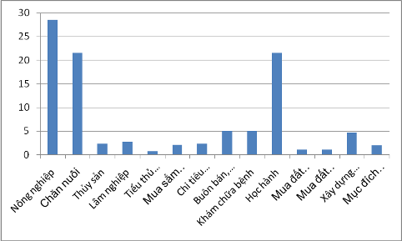
Figure 4.6. Purposes of loan

Figure 4.6 shows the different loan purposes of families. People use the loan to spend for education, livestock and agricultural production at a rate of over 20%. This indicates the top priorities and demands of local people in the project areas. Other purposes such as fisheries, forestry, industry, have a very low rate (<5%).

When considering the ratio of loan purpose social survey data shows that in the purpose of "investment loans for livestock and agricultural production" accounted for the highest percentage. This is easily explained by people still focus on production development, and life stabilization.

Social Security. It is likely that everyone will face and overcome risks or difficulties in a certain period of time in the life that need the help of other people (or organizations). The survey of difficulty/ risk that may require physical support, in the Figure 4.7, shows that people rely heavily on support from their siblings, parents, then from parents from both sides, children, government/ mass organization; and a small percentage of support from friends and neighbors of only 1-2%. This suggests that in addition to the support from parents, children; the unions and the government also play a significant part in helping people overcome difficulties in life and to develop production.

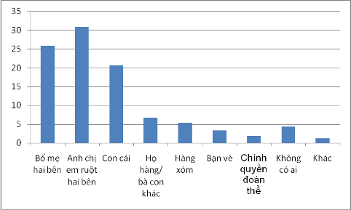
Figure 4.7. Physical support in difficulties

In terms of income group, the poor income group (group 1) receives significantly material support from governments/ organizations (31.6%), and then support from parents of the two sides (26. 3%) while the highest income group (group 5) receives the most significant support from their siblings only (28.0%).
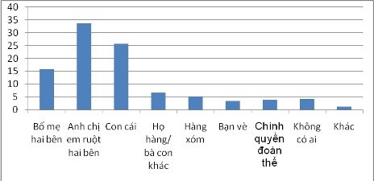

Figure 4.8. Rate of receiving moral support in difficulties

Figure 4.8 represents the results of the moral support in troubled time or in case of risks. Up to 95.7% of the respondents said that they always have someone whom to share with or receive moral support from when they face difficulties/ risks. Emotional support of people is mainly from their siblings, children, parents of the both sides; the rest of as low as 5% is from relatives, neighbors, government/ community and friends.

In terms of ethnicity, or income groups, although the indices are different but they have important role in emotional support to those siblings, children and parents in difficulty.

Thus, the above data suggests an important role in providing material support of governments / mass organizations to people in the poor income group, ethnic minorities, poor mountainous localities and people experiencing difficulties/ risks in the life. For social groups, other localities, the physical and emotional support are both from siblings, parents and children of two sides.

The data show that the majority of people in the project are now struggling, and highly need loans, accounting for 30.8%. The significant demand for people when the project is implemented shows that not all needs are reasonable and can be met, but it is a good suggestion for staffs and project implementing agencies to pay attention to concerns, worries of the people such as issues on resettlement, land, agriculture extension, new training, livelihood and vulnerable groups. From that, there should have suitable support and construction plans to help reduce negative impacts on daily life and livelihood of the people in general in the project areas.

4.4. Past Incidences

Khe Che Reservoir was designed in 1986. In 1995-1998, the works was rehabilitated and improved with some works items under the head works system. Up to now, such works has been working for nearly 30 years. During operation, some accidents happened:
- In the period of 1996 – 1998, a part of spillway face was subject to cavity because the initial construction used some concrete and gravel exploited at the local area. In order to recover such condition, entire spillway face was re-plastered with 3-5cm thick concrete (concrete coating) by the management agency. However, some positions’ above concrete coating has been blistered.
- In the period of 200-2001 the works was subject to water penetration from the dam downstream. The selected recovery method at that time was to spray concrete and apply the roofing embankment.

CHAPTER V: IMPACTS ASSESEMENT

5.1. Social and Environmental Screening

The subproject underwent environmental and social screening to, among others, check any ineligible aspects of the proposed works and determine the scope of the assessment. The following are the results of the screening:
- The screening confirmed that the proposed rehabilitation work will not change the designed water storage capacity and the surface area of the reservoir.
- There are no critical natural habitats near the dam and the area is not known to harbor any rare or endangered species. However, a small portion (0.4 ha) of secondary forest land on the side of the mountain will be permanently converted for use by the dam.
- Based on Social Assessment in the 3 communes of An Sinh, Tan Viet, Viet Dan with the participation of representative form Committee of People's Communes, (CPC) mass organization, beneficiaries show that there are 135 beneficiaries ethnic minority households in sub-project. It is necessary to prepare an Ethnic Minorities Development Plan for the sub-project. The Dam is categorized as a “large” dam under OP/BP 4.37, having a reservoir storage capacity of more than 3 million cubic meters, and therefore, the subproject is subject to review by a Panel of Expert and submission of Dam Safety Plan.
- There are no grave, temple or any culture, belief, religious structures affected in the project area.
- Although the proposed repair works will use new lands, these are currently unoccupied and hence no households will be affected. Therefore there is no need for preparation of RAP.
- The sub-project is an Environmental Category A as per World Bank OP/BP 4.01. The subproject is also required to undergo EIA under Vietnam’s Law of Environmental Protection.

The completed Environmental and Social Screening checklists are provided in Appendix A10.

Required Safeguards Instruments. Based on the screening, most of the potential impacts are of low to average magnitude. According to this impact profile, the sub-project will have to prepare the following instruments and requirements:
- Gender Development Plan
- Community Health Protection Plan
- Community Communication Plan
- Grievance Redress Mechanism
- The Ethnic Minority Development Plan

5.2. Positive Impacts

The sub-project, when it is implemented, will provide benefits in the form of improved safety for the downstream communities and stable and reliable supply of irrigation water. In particular, the repair of the headwork will improve the flood regulation function of the dam. As the dam structure is strengthened, the risk of dam breach is reduced resulting in improved safety of the downstream communities, their assets and public infrastructure. Irrigation water supply becomes stable and reliable thereby promoting agricultural development in the dam’s service area. Also, the stable water in the reservoir is expected to improve groundwater availability during the dry season.

Improved safety of the downstream communities, their assets and infrastructure - The repair and upgrade of Khe Che reservoir contributes to ensuring safety in downstream of reservoir and dam by proactively controlling flood and regulating the lake. Also, under the non-structural component of the DRSIP a better reservoir management system through the preparation and implementation of operations and maintenance plan, dam safety plan, and emergency response plan, as well as local capacity building. The communities specifically benefited from increased safety are the downstream communities of the communes of An Sinh, Tan Viet, and Viet Dan in Dong Trieu district which numbers around 3000 people.

The reservoir is designed, constructed to ensure design flood frequency of 0.5% and inspection flood of 0.1%. The reservoir will be repaired and upgraded to ensure anti-flood frequency of 1%. Calculation results of flood regulation showed reservoir’s spillway should be extended from 14 m to 24 m. This expansion will increase the capable of overflow drainage, water level in the reservoir will fall faster than that in the current status. Because flood water level in the lake has decreased rapidly, the time floodwaters deposited in the reservoir will decrease, resulting a reduced amount of reservoir sedimentation. Slower sedimentation of reservoirs would improve the life of the Work, reduce the cost of dredging the reservoir.

Risks to dam safety: dam break has a great impact on the hydrological regime of the area, affecting water, soil, aquatic ecosystems, water supply capacity of irrigated areas, agricultural production downstream. Especially, when the dam breaks, it has a major influence on the lives and assets of more than 3000 people in three communes downstream that is An Sinh, Tan Viet and Viet Dan. Overcoming the consequences of dam incident is very difficult and takes time, so, operation process must follow strictly the mitigation measures proposed in the report. The reasons that cause the dam broken: (i) the largest flow and water level of construction flood are in excess of its largest level designed. (ii) The quality of backfilling material does not ensure quality standards. (iii) During the construction process, design altitude to deal with xiam-man flood has not yet been reached. (iv) Construction does not follow design. (v) Problem of floodgate system (vi) the inaccurate of flood forecasting leads to operation of the reservoir untimely during flooding. (vii) Earthquakes. These causes should be settled by giving measures to overcome and minimize the impact on dam safety to protect downstream areas.

Stable and reliable irrigation water supply. The repair of the headworks and better management of the reservoir will ensure stable and reliable irrigation water supply for the 1,056 hectares of agricultural lands downstream. The flood regulation function will also protect these agricultural lands from seasonal floods that are within the capacity of dam. This will increase agricultural productivity and incomes of farmers.

Improved availability of groundwater for domestic water supply of nearby local residents – The stable water in the reservoir is expected to increase the water table of nearby areas, including recharge to shallow aquifers. This will improved availability of water from shallow wells during dry season.

Provision of aquatic habitat. The year round availability of water in the reservoir has created a habitat for a variety of aquatic species of flora and fauna. Continued viability of this reservoir will ensure the preservation of this aquatic habitat. Furthermore, the elevated groundwater table will ensure availability of moisture around the sites, in terms of small ponds and springs, promoting growth and proliferation of various species, thereby enhancing biodiversity.

Improved landscape of the reservoir. After repair and upgrade, the landscape around the reservoir becomes more spacious and improve the general view of the area. This will attract many visitors and promote tourism activities at the reservoir and the headworks area.

5.3. Negative Impacts and Issues

There will be no new area to be flooded as the subproject involves only rehabilitation of existing dam and will not increase the capacity of the reservoir. The negative impacts of the subproject will be due mostly to the construction activities. The impacts and issues associated with the subproject are as follows:

Loss of land, trees, vegetation and natural habitat - The sub-project require acquisition of a total 16, 706.3 sq. m of lands of which about 1,653.7 sq. m are forested lands (02 HHs),
1,079.0 sq. m are land for perennial crops (02HHs) which will be excavated at the mountain side for the expansion of the spillway and 13,737.6 sq. m unused lands at the downstream at the foot of the dam to be used for disposal area, and landfill. These lands are within the irrigation works protection corridor managed by Dong Trieu Irrigation Co., Ltd, there are 04 households are cultivating so there is no compensation for land, but households will be compensated for their crops.
The sub-project require cut about 600 pine trees (planted for exploitation purposes) of 8 households.
The subproject affects the architecture of 02 households: including brick walls and yard (15 sq. m).
Total compensation and resettlement value: VND 251,782,000
Including,
Compensation for land and assets on land is: VND 201,034,162
Support amount: VND 45,748,180
Cost for site clearance: VND 4,936,000

Impacts of construction activities. According to the calculations, the total volume of excavated soil for construction works of the project is about 55,459 cubic meters while the volume of backfill soil is 3,412 cubic meters. Thus, about 51,051 m³ needs to be moved to the disposal area. The disposal area is located along the foot of the dam with total capacity of 52,500 cubic meters. The number of workers in the peak period is about 50 workers. The number of truck-trips is estimated to be 3,600 over a period of 10 months. Based on these, the impact of construction will be as follows:
- Temporary increase in sedimentation – The construction works have potentials to cause sedimentation of the waterways and the reservoir. This potential is significant in the construction of the spillway extension which requires excavation of the mountain side. The probability of massive runoff erosion from the open excavated areas on the side of the mountain, the disposal area and the embankment works in the new spillway however is low since construction will be undertaken during periods of low precipitation, i.e. dry months.
- Elevated concentration of dust – Dusts will be generated from the excavation, loading, unloading and application of embankment materials. The bulk of the transport of these materials will occur only within a short distance from the site, i.e. from the excavation site to the spillway to the foot of the downstream slope of the dam where excess soils will be disposed. Only a small portion about 1000 cu.m will be taken from the Hai San Burrow Pit which is less than 1 km from the site. The transport of 18,000 of construction materials will occur within 10 km routes to Dong Trieu town center, for a total of 3,600 truck-trips in 10 months or an average of one truck every 45 minutes on 12 hour/day period. Thus, elevated dust levels are likely to be experienced only in the excavation area at mountain side and at the foot of the dam. A detailed assessment of the Dust generation is provided in Appendix C1.
- Elevated noise levels – Noise will be generated from the operation of equipments, including demolition of existing works, excavation and transportation of excess soil to the disposal area. According to QCVN 26:2010/BTNMT, the acceptable noise level in residential areas is from 50 to 70dBA (from 6h to 21h). The noise level from equipments is expected to be significant only within short distance from the source. In particular, noise from a bulldozer reaches a maximum of 95 dBA within 1.0 m from the equipment but drops to about 25% to a distance of 10m and up to 40% for a distance of 50m. So, the noise standards will likely be met at the nearest residential area. A detailed assessment of noise generation is provided in Appendix C2.
- Interruption in the water supply – The proposed repair works will generally not result in an interruption of water supply. The construction at the spillway (extension) will be carried out above the normal water level and at the downstream area of the dam. Only the construction of the culverts will require cut off of water for a brief period of 5-7 days which can be implemented during a period of no agricultural cultivation activity downstream.
- Damage to roadways along construction routes. The hauling of embankment materials will occur within the construction site and will passed through construction routes which will be repaired or rehabilitated under the subproject. However road damage can still occur at the 300 m route to Hai San pit. Damage could also occur along the 10-km intercommune route to Dong Trieu town center. Heavy equipment (with about 5 to 7 tons cargo) will be making approximately 3,600 trips on this route.
- Increased health and safety risk for residents and workers - Increase health and safety risks among workers and residents near the dam and along construction routes due to exposure to construction-related hazards. The specific hazards are:
  - Construction activities with heavy equipment at the Management House, Management Road, Dam and the Spillway, including the excavation at the side of the mountain will pose safety hazard to the local residents or to people using the dam access road.
  - Improperly stored construction materials, litters and wastes may cause physical injuries to workers and residents, including children who ventures into the construction area.
  - Residents along the route from construction site to Hai San pit and along from construction site to Dong Trieu town center will be exposed to heavy equipment traffic accident hazards. The density of traffic on these roads and population density along the road are only at the average level.
  - Workers moving into the local neighborhood from other areas to implement the items can also bring infectious disease and different lifestyle that maybe break traditional and local regulations.
  - Workers and residents are exposed to hazardous construction materials and wastes such as
- Domestic waste generation - Even at the peak of construction activities, the number of workers would be only around 50. They are estimated to generate a total of 4 cubic meters per day (see Appendix C3) of wastewater and 25 kg/day of solid waste. These amounts of domestic wastes is not significant but without proper management, these wastes could cause local pollution and unpleasant smell and attract the vermins such as flies and rats. Standard containment (i.e. septic tank, soak pit), collection and disposal (i.e. solid wastes to the landfill) should be able to address these wastes problem.
- Gaseous emissions - Aside from dust, construction activities emit gaseous air pollutants from engine exhausts of heavy equipment and exposed construction materials. Engine exhausts include SO₂, NO₂, CO and hydrocarbons. With only about __ motorized equipment at the peak of the construction scattered throughout the construction sites and routes, the gaseous emissions are not expected to significantly impact the air quality in the area (See Appendix C4).
- Impact on the local economy - The influx of workers during construction will promote the local businesses near the site, particularly petty services related to food and drinks. The locality is able to fully meet the needs of workers in terms of food and other services.
- Potential conflict between migrant workers and local residents. The presence of non-resident workers in the construction site who will from time to time interact with the local communities could be a source of possible conflict arising from some residents and non-residents. There is therefore a need to promote good relations between the contractor and the local residents.
- Hazardous wastes. The release of used oils, grease and spilling of fuel and used oil, improper disposal of oil contaminated materials, rags, oil sludge, discarded batteries, fluorescent bulbs, etc. could contaminate soil, underground water, and streams. These are not expected to be significant and a good housekeeping and hazardous waste management systems should address this issue.
- Impacts on the aquatic ecosystem. The reservoir and its influence area is a highly modified environment, shaped by years of human activities, the most significant of which was the original construction of the Khe Che Dam. The construction activities will not require draining of the reservoir or releasing large quantities of water into the receiving water channel. There will be only a brief (5-7) days interruption in water supply when the intake will be closed for repair of the culvert. Hence, the impacts to the aquatic environment would be limited to the temporary sedimentation or turbidity which is also likely to be of low probability as the construction will be undertaken during the dry months.
- Increased risk of dam breach during construction of spillway – The repair and upgrading works at the dam and the spillway increase the risk of dam breach during the construction period as portions of the dam may be temporarily weakened and controls are disengaged. This risk is mitigated by making sure that construction works are undertaken only during dry season when there are no floods.

Long term impacts. Long term impacts includes:

- Possible land and soil degradation at the construction site – This could happen due to loss of vegetation, alteration of terrain due to excavation, compaction, stockpiled construction spoils, litters and wastes materials. These will be significant at the construction campsite, at the material stock yard, in the excavated area of the mountain side, at the soil disposal site at the foot of the dam and the Hai San pit. If the contractor does not practice good housekeeping and waste management, the areas within and around these sites will become degraded and unsuitable for other productive uses.

- Intensified agricultural production, leading to increase use of chemical pesticides. Currently, the locals are applying safe cultivation approaches such as IBM, ACM, "3 reduction, 3 increase", "1 must, 5 reduction", etc. All these activities are aimed at minimizing use of pesticides and their impacts to human health. The improved irrigation water supply is expected to promote intensive agricultural production in the service area in the next few years. Based on the survey conducted as part of the ESIA, over a third already have plans for increasing production in anticipation of the better irrigation water supply. Use of agrochemicals may therefore increase due to increased number of crops that can be raised per year and also due to increased intensity/densities of crops on the same plot of land.

Other issues. The following are assessments of some of the issues raised about the project:

- Impact of the spillway widening to the reservoir and the receiving channel –The extension of the width of spillway from 14 m to 24 m is intended to accommodate larger floods. With this spillway floodwater will not accumulate in reservoir and therefore the reservoir will have a more stable water level even during floods thereby reducing erosion potential at its banks. The spillway is also free flowing spillway hence the discharge rate before and after the spillway extension would not change much and would be approximately equal to the volumetric flow of the flood. The receiving channel’s (Ho Lao Stream) streambed has adequate capacity to receive most flood flows and ensures that downstream area will not be flooded.

- Change in reservoir management system and relationships with communities – There will be changes in the management systems of the reservoir due to the implementation of new operations and maintenance plan and the capacity building of the local management body. This change may be received differently by the communities who are used to the old system and could be a source of conflict among or between users of irrigation water and the reservoir management.
- Long term reservoir sedimentation. Due to the steep terrain, capability of reservoir sedimentation will appear shortly after works are put into use. However, the process of sedimentation will occur in the long run, so, it can be monitored and controlled through the conversion of the reservoir upstream into protective forest to increase water storage capacity and minimize erosion and sedimentation. Operation phase is done in a long time, so if there is no action to control emissions source, it will also affect the reservoir.

- Gender issues. There are some gender issues in the scope of the sub-project.
    - Labor and Labor division: Most of women are involved in agricultural activities. Women in mountainous areas encounter severe time constraints having to work much longer hours than men especially in the areas of land cultivation, transportation, family care, housework, etc. Women can work 9-10 hours/day while men only work for 8 hours/day). The limitation of knowledge, access to technology and use of traditional agriculture methods contribute to local people often facing high risks of bad crops, diseases for cattle and undernourishment.
    - Access to education: All boys and girls have equal rights to go to school however the rate of attendance for girls is always lower than boys.
    - Women’s Involvement in group activities: In subproject area, most women are Kinh women. Women do not know how and are not trained and empowered to express their rights in front of the community. Therefore, they have few opinions in the community meeting.
    - Women’s participant in local government system: Through interviews with chairmen of commune PCs, it was recorded that women accounted for 35% within the Commune PC structure. No woman played a role as chairwoman of the An Sinh CPC. Most women do not play leadership positions that influence the decision-making process.
    - Health: Health conditions of women in An Sinh commune is not serious. However, not only women but also the community has the high potential risks of contracting diseases such as diarrhoea, skin allergies and other forms of infection.

- Lack of Grievance Redress – Despite the consultations conducted during the ESIA and the careful identification of affected persons through the RAP, there would still be people who would be accidentally affected or whose properties will be damaged or who might perceive themselves to be unfairly treated, including allegations of insufficient compensation, allegations of lack of consultations, etc. There is therefore a need for a mechanism for the peole to air their grievances and in which they can expect response from the project.

- Chance Archaeological or Paleontological Finds – Even though the area is not identified as a likely archaeological sites, the excavation activities could still encounter archaeological or paleontological objects. There is a need to have a procedure readily available to the contractors and the subproject administrator when a chance find occurs.

- Encounter of unexploded ordnance – Construction workers doing the excavations, clearing and demolition at the construction site could encounter unexploded ordnance left from the war. There is a need for the workers to be aware of what to do which such encounter occurs.

5.4. Significant Impacts and Issues that Need to addressed

Based on the above discussion the following are the significant impacts and issues associated with the proposed repair and upgrading works that needs to be addressed:

- Loss of trees and vegetation on a mountain side due to expansion of the spillway
- Impacts of construction activities
  - Temporary increase in sedimentation and turbidity
  - Elevated concentration of dust at the excavation site, the foot of the downstream slope of the dam where excess soils will be disposed
  - Interruption in the water supply for about 5-7 days during the repair of the intake
  - Possible damage to roadways along construction routes, particularly on the 300-m route to Hai San pit and the 10-km intercommune route to the Dong Trieu town center
  - Increased health and safety risk for residents and workers due to exposure to various hazards brought about by the construction activities, equipment traffic and migrant workers
  - Potential conflict between migrant workers and local residents
  - Construction waste management including domestic waste from workers, discarded or excess materials, and hazardous wastes items
  - Temporary migration of wildlife
- Long term Impacts/Issues
  - Possible land and soil degradation at the construction site, particularly at the excavated mountain side, the disposal area at the foot of the dam, the construction camp and at Hai San burrow pit.
  - Likely long term increase in use of pesticide in the irrigation service area
  - Other issues
  - Possible conflict due to change in reservoir management system and relationships with communities
  - Long term reservoir sedimentation due to watershed activities beyond the control of the managers of the reservoir
- Other Issues
  - Gender issues
  - Support for EM community
  - Possible complaints or damage claims despite the implementation of the RAP
  - Chance find of archaeological or paleontological artifacts at the excavation area
  - Encounter of unexploded ordnance from the war

CHAPTER VI: ANALYSIS OF ALTERNATIVES

The proposed repair and upgrading works are the minimum intervention required to restore the full design function of the dam while at the same time accommodating recent flood trends. Because the proposed works are the minimum necessary to restore the dam functions, the adverse environmental and social impacts are already at the minimal level. They are also mostly only temporary, occurring mainly during the construction period.

The alternative would be to do no repair. This would forgo the benefits of the proposed repair and rehabilitation which include the improved safety of residents downstream of the dam. Without the extension of the spillway, there will be possible overtopping of the dam which could further degrade the dam structure and may eventually lead to its collapse. The continued functioning of the dam is necessary for the economic viability of the surrounding communities. A dam collapse would be catastrophic to these communities. Also, the continued integrity of the dam is essential for the preservation of the aquatic environment that has developed in the reservoir and its influence areas over the years.

CHAPTER VII: ENVIRONMENT AND SOCIAL MANAGEMENT PLAN

The purpose of this Environmental and Social Management Plan (ESMP) is to address all the significant environmental and social impacts and issues with feasible mitigation measures that are discussed and agreed with the subproject owner, identifying requirements including a reference to other safeguards instruments, specificying a monitoring strategy or plan, and defining responsibilities for the measures implementation as well as monitoring. The ESMP will serve as a common reference for all those involved in the implementation of the subproject.

7.1. Mitigation Measures

The specific mitigation measures are provided in Table 7.1 below. To address some specific issues, the ESMP refers to other safeguards instruments developed for Khe Che such as the Gender Action Plan (Appendix B3), the Community Health Protection Plan (Appendix B1), the Community Communication Plan (Appendix B2), the Grievance Redress Mechanism (Appendix B4) and the Chance Find Procedure (Appendix A12).

Contractors Environmental and Occupation Health and Safety Plan – In addition, since most of the impacts are construction-related and contractors will be generally the ones in control of the construction site, the wining contractor will be required to prepare its own Contractor’s Environmental and Occupational Health and Safety Plan (CEOHSP) which incorporates all construction-related measures in the ESMP, the Community Health Protection Plan, and industry Health, Safety and Environment (HSE) standards and good practices, including good housekeeping at construction site, waste management, provision of adequate water and sanitation facilities, provision of safety corridors/passageways, installation of barrier fences around dangerous areas and wearing of PPEs. The CEOSHP will be reviewed and approved by the CPO before construction can commence in the site.

Table 7.1. Environmental and Social Mitigation Measures for the Khe Che Reservoir
Impacts/Issues | Measures (i.e. specific action, site, timing of implementation, other instruments) | Responsible Unit | Cost Estimate  (VND Millions)
1.Loss of trees and vegetation on a mountain side due to expansion of the spillway | Restoration of the top soil and landscaping of the unused portions of the 4,000 sq meter levelled mountain side, with trees and grasses. | Subproject owner
Impacts of construction activities
3.Temporary increase in sedimentation and turbidity | Earthmoving activities to be undertaken during dry season.  Immediate compaction of the newly place embankments and landfill at the foot of the dam  Stockpiling of excavated soils away from runoff
4.Elevated concentration of dust at the excavation site, the foot of the downstream slope of the dam where excess soils will be disposed | Sprinkling of the ground in the excavation area, the routes to the landfill and to Hai San pit, as necessary throughout the construction period. | Contractor | 15
Interruption in the water supply for about 5-7 days during the repair of the intake | Consulting the farmers on the exact timing of the cutoff with a leadtime of at least one month | Project owner and  Contractor
Possible damage to roadways along construction routes, particularly on the 300-m route to Hai San pit and the 10-km intercommune route to the Dong Trieu town center | Requiring the contractor as part of the contract, to undertake repairs and provide adequate detours, if necessary, along the routes and to restore any damage sustained by the routes after completion of the construction. | Project owner and  Contractor | 50
Increased health and safety risk for residents and workers due to exposure to various hazards brought about by the construction activities, equipment traffic and migrant workers | Provide safe passageways to local residents and commuters through the dam  Provide barrier fences and warning signs around dangerous areas such as deep excavation, cliffs and ravines.  Provide adequate water and sanitation at the workers camp  Require wearing of PPEs inside construction sites  Practice good housekeeping and waste management  Imposed speed limits in residential areas  Medical screening of workers | Contractors
Potential conflict between migrant workers and local residents | Contractor to constantly dialog with the host communities and promote good relations | Contractor
Construction waste management including domestic waste from workers, discarded or excess materials, and hazardous wastes items | Non-hardous wastes to be regularly collected and disposed into the designated landfill at the foot of the dam  Regular collection of domestic garbage and hazardous waste and dispose them into the community landfill/garbage dump | Contractor
Temporary migration of wildlife | Impose ban of wildlife poaching and hunting among workers  Avoid night time construction activities | Contractor
Long term Impacts/Issues
Possible land and soil degradation at the construction site, particularly at the excavated mountain side, the disposal area at the foot of the dam, the construction camp and at Hai San burrow pit. | Implement good housekeeping and wate management  Contractor as part of the contract to undertake clearing and restoration of sites after completion of works | Contractor
Likely long term increase in use of pesticide in the irrigation service area | MARD and DARD to introduce and promote the Integrated Pest Management approach among farmers in the area. An IPM Development Plan has been prepared and provided in Appendix D1. | MARD/  DARD | 320
Possible conflict due to change in reservoir management system and relationships with communities | Constant dialog with the farmers and other users of the reservoir water | Reservoir  Management
Long term reservoir sedimentation due to watershed activities beyond the control of the managers of the reservoir | Regular coordination with provincial Department of Forestry on matters of watershed management  Sediment monitoring of the reservoir | Reservoir management
Other Issues
Gender issues | Implementation of the Gender Action Plan (See Appendix B3) | Project Owner
Possible complaints or damage claims | Adoption and setting up of Grievance Redress Mechanism (See Appendix B4). The GRM should be set up at prior to the start of construction. | Project Owner
Chance find of archaeological or paleontological artifacts at the excavation area | Adoption of DRSIP Chance Find Procedure (See Appendix A12) | Project Owner and  Contractor
Encounter of unexploded ordnance from the war | Adoption of the Unexploded Ordnance Procedure | Project Owner and  Contractor

7.2. Monitoring

Compliance Monitoring - The monitoring will focus on compliance with the ESMP and CEOSHP. This will be done periodically (i.e. on a quarterly basis) by the project owner through its own staff or a hired consultant. Compliance monitoring or audit shall use the ESMP matrix and the CEOSHP for checking compliance of each item of in the instruments. The following table will be adopted in preparing a simple compliance monitoring report.

Table 7.2. ESMP Compliance Monitoring Report Format
Impact/Issue | Mitigation Measure | Status (Indicate whether complied or not. Describe any progress) | Agreed Action (if not complied, indicate proposed agreed action)
1.
2.

Similar format may be used for the compliance monitoring of the CEOSHP.

Environmental Quality Monitoring. A minimal environmental quality monitoring will be undertaken in compliance with DoNRE requirements and standard practice in Vietnam. The parameters, sampling frequency and estimated costs are provided in Table 7.3 below.

Table 7.3. Environmental Quality Monitoring Plan
Monitoring Objective | Monitoring  Parameters | Method | Monitoring  Frequency | Resource required and responsibility
Checking the trend and quantifying the impacts caused by daily activities of construction | Dust,  PM10,  PM 2.5 | Visual inspection and interview with locals;  Sampling at the transportation roads, especially in sections passing residential areas | During the peak of construction activities | QCVN 05:2009/ BTNMT  QCVN 06:2009/ BTNMT  Responsibility: PMU, EMC
Monitoring the water quality changes in the reservoir and receiving channels | pH, DO, BOD₅, NH₄⁺, TSS, Turbidity (NTU) | Field survey and measure  Analysis in the laboratory | 2 times/year up to the end of the first year after completion | QCVN 08:2008/ BTNMT  Responsibility: PPMU, EMC

7.3. Responsibilities and Capacity Building

The Ministry of Agriculture and Rural Development (MARD) - Central Project Office (CPO) will be responsible for the overall supervision of subproject, including the implementation of the ESMP. The Quang Ninh Department of Agriculture and Rural Development (DARD) Provincial Project Management Unit (PPMU) through the local reservoir management will be responsible for contract management and ground supervision of the implementation of the ESMP including the CEOHSP. The project owner will submit a quarterly compliance monitoring report to the CPO. The CPO will in turn, if it deemed necessary, conduct validation of the report through site inspections/audits of the subproject. The Quang Ninh Department of Natural Resources and Environment (DoNRE) will also undertake their own monitoring and audit of the sub-project in accordance with their mandate under the Law of Environment Protection. Likewise, the local Community Supervision Board created under Decision 80/2005 will undertake their own supervision of the environmental compliance of the subproject based on their own mandate. Table 7.4 below summarizes the functions of each of the units involved. Note that other functions/responsibilities may also be provided in other safeguards instruments (e.g., GRM, Communications Plan, Community Health Plan, etc.).

Table 7.4 ESMP Implementation and Compliance Monitoring Responsibility Matrix
Unit | Responsible Staff | Responsibilities
MARD CPO | MARD Staff or hired consultants | -Reviews and approves the CEOSHP  -Reviews the Compliance Monitoring Report  -Conducts random spot inspections/audit or validation of monitoring reports submitted by the Subproject Owner
Subproject Owner (DARD PPMU) | Staff or hired consultants | -Conducts quarterly Compliance Monitoring/Audit of the ESMP and CEOSP Implementation  -Conducts Environmental Quality Monitoring as specified in the EQM Plan  -Submits quarterly Compliance Monitoring Report to the CPO
Local Reservoir Management (Dong Trieu Irrigation Company) | Construction Supervision Consultant hired by Project Owner | -Supervises the implementation of the ESMP and contractors implementation of the CEOSHP, and other agreed actions, on the daily basis  -Alertst the contractor for any outstanding environmental issues or any violation of the ESMP and CEOSHP  -Liaises with the local communities on environmental and social management issues
Contractor | Project Engineer | -Prepares the CEOSHP based on the ESMP measures and standard construction practices, in consultation with the local reservoir management  -Submits the CEOSHP to the Subproject Owner  -Implements the CEOSHP
Quang Ninh Department of Natural Resources and Environment (DoNRE) |  | -Conducts their own compliance and environmental monitoring/audit in accordance with its mandate under the LEP.
Community Supervision Board |  | -Conducts supervision and monitoring according to their mandate under the "Decision No. 80/2005 / QD-CP dated 18/04/2005 by the Prime Minister on Regulations on investment Supervision."

CHAPTER VIII: PUBLIC CONSULTATION AND INFORMATION DISCLOSURE

8.1. Public consultation objectives
- To get the consent of the relevant agencies, local governments and communities in the sub- project implementation
- To share information about the scope of the project and its impact on the environment and society
- To increase the encourage of the participation in the community for determining the impacts of the sub-project
- To collect information about the requirement and the responsibility of the local resident and local authority on the proposing mitigation measures of the project owner, or to improve the mitigation measure in pre-construction phase or project design.

8.2. Social impact assessment consultation
Based on the basic design, the Consultant in cooperation with PPMU staffs and cadastral officials of project communes make a list of households affected by the Project in each commune. On the basis of the list of AHs provided by the locality, the Consultant selects 100% of the total number of households affected and 10% of households not affected by the Project (including 100% of the households ten to relatively required the relocation) to be interviewed by questionnaire. Samples are selected to ensure gender ratio and ethnic minorities. In case of the number of Ahs of one sub-project is less than 20, all the Ahs will be interviewed.

8.3. Environment impact assessment consultation
Public consultation and information dissemination are implemented in the ESIA and EIA preparation stage of sub-project. During detailed design, Investor is Project Management Unit of Irrigation construction 2 will consult with community and the authority in eight communes and 1 towns of sub-project area about "Repairing and upgrade Khe Che cluster works", inform them about the current state of the sub-project and the measures will be deployed to minimize the potential negative impacts to the natural environment of the area. During the consultation, if necessary, management will review the design adjustments accordingly. Especially, investors will commit to implement measures to reduce the negative impact on the natural environment.

Results of the public consultation and information dissemination of The Environmental and social impact assessment advisory unit, project management unit of Irrigation Project 2, the People's Committee, Fatherland Front Committee of the communes, towns in the sub-project area, with the following results:
- 100% of all participants agree to perform sub-project "Upgrading and repairing cluster headworks of Khe Che reservoir" because in fact Khe Che reservoir is one of the largest lakes in Quang Ninh, the safety is very essential for the lake. There have been many floods throughout history put people in downstream areas in alarm situations.
- The people in the communes are agreeing with the detailed consultative meetings held by owner, helping people understand the sub-project correctly, and propose their comment in sub-project implementation may bring negative and positive effects;
- 100% of communes and towns have been advised clearly by environmental consultant about the measures that the investor will perform in the sub-project construction process to ensure there is no hazardous impact on the environment, nature as well as landscape of the area around the lake.
- Agree with the impacts on natural environment, society and minimization measures that environmental consultants have given.-
- In the sub-project area, there are many temples, shrines, An Sinh temples is a National recognized relic. Therefore, it is necessary to have construction measures to avoid adverse effects to these building.

REFERENCES
      - Report on Socio-economy and steering activities by Dong Trieu People’s Committee, Dong Trieu Town.
      - Report on mission implementation in 2014 and orientation in 201 in Viet Dan commune
      - Report on the implementation of socio-economic development in Viet Dam commune
      - Planning map of new rural program in An Sinh commune
      - Assessment map on the Land Use Status in Viet Dan Commune
      - Description of “Repairing and upgrading head work clusters of Khe Che Reservoir”, The Company of Technology Consultancy and Transfer, University of Water Resources.
      - Monitoring Notes of Khe Che water environment.
      - Basic Design Version of “Repairing and upgrading head work clusters of Khe Che Reservoir”, The Company of Technology Consultancy and Transfer, University of Water Resources.
      - Report of the basic Design of Repairing and upgrading head work clusters of Khe Che Reservoir”, The Company of Technology Consultancy and Transfer, University of Water Resources.
      - Outline of Construction Drawings of Repairing and upgrading head work clusters of Khe Che Reservoir”, The Company of Technology Consultancy and Transfer, University of Water Resources.
      - Investment estimate of Repairing and upgrading head work clusters of Khe Che Reservoir”, The Company of Technology Consultancy and Transfer, University of Water Resources.
      - Main report of Repairing and upgrading head work clusters of Khe Che Reservoir”, The Company of Technology Consultancy and Transfer, University of Water Resources.

APPENDIX OF KHE CHE ESIA

APPENDIX A1. DRAWING OF WORKS ITEMS
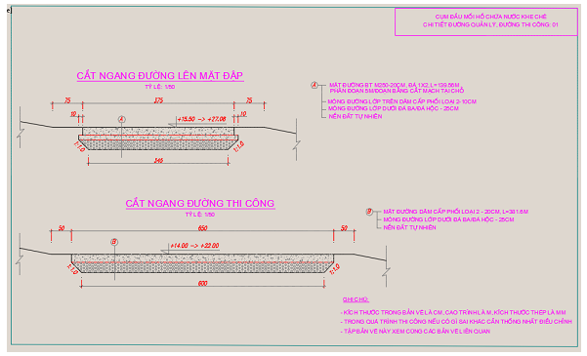
Construction Management Road
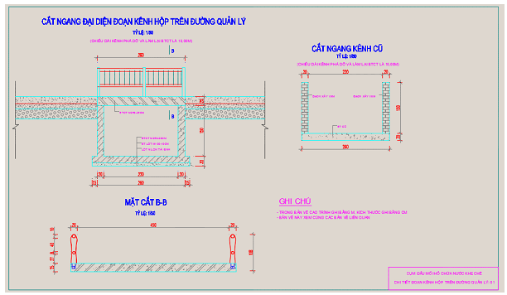
Channel on the management road
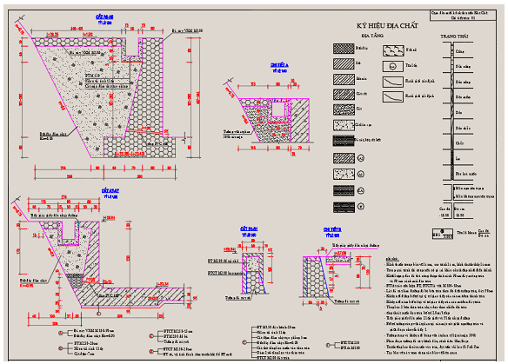
Details of spillway 1
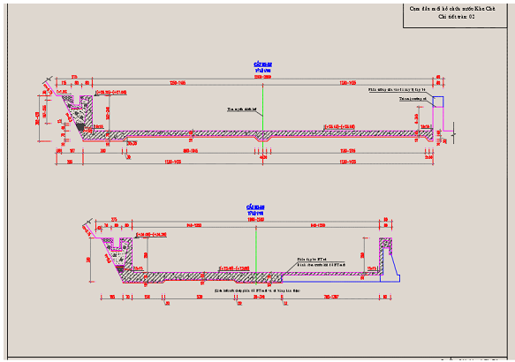
Details of spillway 2

APPENDIX A2. CLIMATIC AND METEOROLOGICAL DATA IN KHE CHE RESERVOIR AREA
Table A2.1. Average air temperature in the last 5 years in the project area
Month | I | II | III | IV | V | VI | VII | VIII | IX | X | XI | XII | Year
Avg. | 16.4 | 17.2 | 20.0 | 23.5 | 27.1 | 28.4 | 28.8 | 28.0 | 27.0 | 24.7 | 21.2 | 17.8 | 23.3
Max | 30.8 | 28.9 | 33.6 | 32.2 | 36.6 | 37.9 | 37.8 | 36.2 | 35.4 | 32.9 | 31.7 | 30.1 | 37.9
Year | 1980 | NN | 1970 | 1966 | 1967 | 1983 | 1968 | 1978 | 1968 | 1976 | 1967 | 1974 | 1983
Min | 3.3 | 5.4 | 7.9 | 11.4 | 17.5 | 19.6 | 21.9 | 22.0 | 17.3 | 12.7 | 6.7 | 3.2 | 3.2
Year | 1967 | 1974 | 1972 | 1970 | 1984 | 1967 | NN | 1965 | 1966 | 1971 | NN | 1975 | 1975
(Source: http://quangninh.gov.vn/vi-VN/huyenthi/huyendongtrieu/Trang/default.aspx/)

Table A2.2. Average air humidity in the last 5 years in the project area
Month | I | II | III | IV | V | VI | VII | VIII | IX | X | XI | XII | Year
% | 80 | 83 | 86 | 86 | 83 | 83 | 84 | 86 | 83 | 79 | 75 | 76 | 82
(Source: http://quangninh.gov.vn/vi-VN/huyenthi/huyendongtrieu/Trang/default.aspx/)

Table A2.3. Average amount of evaporation in the last 5 years in the project area
Month | I | II | III | IV | V | VI | VII | VIII | IX | X | XI | XII | Year
Z(mm) | 74.6 | 57.8 | 58.5 | 63.4 | 89.4 | 94 | 93.2 | 75.1 | 82.5 | 102.8 | 107.7 | 99.2 | 998.2
(Source: http://quangninh.gov.vn/vi-VN/huyenthi/huyendongtrieu/Trang/default.aspx/)

Table A2.4. Average wind speed in the last 5 years in the project area
Month | I | II | III | IV | V | VI | VII | VIII | IX | X | XI | XII | Year
V(m/s) | 1.8 | 1.9 | 1.9 | 2.1 | 2.2 | 2.2 | 2.3 | 1.8 | 1.5 | 1.7 | 1.6 | 1.7 | 1.9
(Source: http://quangninh.gov.vn/vi-VN/huyenthi/huyendongtrieu/Trang/default.aspx/)
Table A2.5. Average Annual Precipitation in the last 5 years in the project area
Month | I | II | III | IV | V | VI | VII | VIII | IX | X | XI | XII | Year
Avg. | 18.3 | 19.1 | 42.5 | 72.1 | 189.4 | 216.0 | 246.5 | 290.6 | 204.1 | 94.6 | 42.6 | 23.5 | 1459.4
Max | 45.5 | 37 | 335 | 96 | 166 | 140.7 | 153 | 261.3 | 335 | 140.2 | 200.6 | 72.5 | 335
NXH | 1983 | 1990 | 2005 | 1984 | 2007 | 2005 | 1997 | 1981 | 2005 | 1990 | 1984 | 1994 | 2005
(Source: http://quangninh.gov.vn/vi-VN/huyenthi/huyendongtrieu/Trang/default.aspx/)

APPENDIX A3. ANALYSIS RESULTS OF QUALITY OF SURFACE WATER ENVIRONMENT
(Time: Morning 11 March 2015)
Criteria | Khe Che Lake Area |  |  |  |  |  | Water in underground sewers 1, An Sinh commune | Water in underground sewers 2, Tan Viet commune | Tan Viet Pump Station | Duc Chinh Drainage Ditch | Surface water at pump station, Viet Dan commune | Surface water at An Sinh commune | Binh Duong Pump Station | Thuy An Pump Commune | Trang An Drainage Ditch | QCVN 08: 2008/ BTNMT
 | H1 | H2 | H3 | H4 | H5 | H6 | N1 | N2 | N3 | N4 | N5 | N6 | N7 | N8 | N9 | B1
pH | 7,1 | 7,2 | 7,2 | 7,3 | 7 | 7.3 | 1 | 7 | 7,1 | 7,2 | 6,9 | 7,4 | 7,15 | 7,2 | 7,1 | 5 -9
DO (mg/L) | 4,7 | 6,2 | 6,6 | 5,4 | 5,2 | 5.8 | 6,2 | 6,6 | 4,5 | 4,2 | 5,1 | 6,1 | 3,8 | 4,1 | 5,1 | ≥ 4
Clorua (mg/L) | 43 | 37 | 44 | 42 | 36 | 45 |  |  |  |  |  |  |  |  |  | 600
Hardness (mg/L) |  |  |  |  |  |  |  |  |  |  |  |  |  |  |  | -
TSS (mg/L) | 13 | 14 | 17 | 17 | 7 | 7 | 13 | 68 | 45 | 24 | 18 | 26 | 43 | 21 | 36 | 50
TDS (mg/L) | 89 | 135 | 96 | 107 | 72 | 81 | 43 | 83 | 76 | 51 | 47 | 61 | 91 | 73 | 65 | -
COD (mg/L) | 31 | 28 | 22 | 19 | 25 | 34 | 15 | 26 | 25 | 34 | 44 | 14 | 18 | 22 | 31 | 30
NH4-N (mg/L) | 0,15 | 0,22 | 0,11 | 0,28 | 0,16 | 0,21 | 0,12 | 0,17 | 0,15 | 0,12 | 0,13 | 0,1 | 0,22 | 0,13 | 0,21 | 0,5
NO3-N (mg/L) | 0,012 | 0,012 | 0,014 | 0,021 | 0,017 | 0,025 | 0,016 | 0,015 | 0,028 | 0,01 | 0,02 | 0,019 | 0,024 | 0,018 | 0,025 | 0,04
NO2-N (mg/L) | 0,008 | 0,011 | 0,009 | 0,009 | 0,01 | 0,01 | 0,02 | 0,013 | 0,023 | 0,01 | 0,018 | 0,01 | 0,011 | 0,054 | 0,026 | 10
Coliform (MPN/100mL) | 1200 | 7900 | 14000 | 12000 | 2800 | 370 | 22000 | 5200 |  |  | 92000 | 22000 |  | 4900 |  | 7500
E. Coli  (MPN/100mL) | 173 | 617 | 3000 | 4000 | KPH | 0 | 2333 | 2333 |  |  | 2333 | 0 |  | 900 | 2000 | 100
Note:
- QCVN 08-2008/BTNMT : National Technical Regulation on surface water;
- “-”: Unspecified value.

APPENDIX A4. ANALYSIS RESULTS OF GROUND WATER AT 3 COMMUNES: AN SINH, VIET DAN, TAN VIET
(Time: Afternoon 11 March 2015)
Criteria | An Sinh | An Sinh | Tan Viet | Tan Viet | Viet Dan | Viet Dan | Viet Dan | QCVN 09:2008/  BTNMT
 | NN1 | NN2 | NN3 | NN4 | NN5 | NN6 | NN7
pH | 6,8 | 6,9 | 6,8 | 7 | 7,1 | 6,9 | 6,9 | 5,5 – 8,5
DO (mg/L) | - | - | - | - | - | - | - | -
Clorua (mg/L) | - | - | - | - | - | - | - | 250
Hardness (mg/L) | 194 | 220 | 283 | 304 | 264 | 345 | 290 | 500
TSS (mg/L) | 2 | 2 | 11 | 4 | 27 | 85 | 17 | 1500
TDS (mg/L) | - | - | - | - | - | - | - | -
COD (mg/L) | 2 | 2 | 6 | 5 | 7 | 5 | 6 | 4
NH4-N (mg/L) | 0,08 | 0,02 | 0,04 | 0,08 | 0,01 | 0,05 | 0,07 | 0.1
NO3-N (mg/L) | 0,13 | 0,08 | 0,07 | 0,15 | 0,16 | 0,1 | 0,11 | 1.0
NO2-N (mg/L) | 0,023 | 0,02 | 0,01 | 0,04 | 0,014 | 0,028 | 0,017 | 15
Tổng coliform  (MPN/100mL) | 92000 | 310 | 400 | 1400 | 1400 | 610 | 450 | 3
E. Coli (MPN/100mL) | 1600 | KPH | 200 | 100 | 110 | 317 | 68 | KPH
Note:
- QCVN 09-2008/BTNMT: National Technical Regulation on ground water;
- “-”: Unspecified value.

APPENDIX A5. OBSERVATION RESULTS OF AIR SAMPLE
(Time: Morning 12 March 2015)
Criteria | Unit | Result |  |  |  | QCVN 05:2013/ BTNMT | QCVN 26:2010/ BTNMT
 |  | KK01 | KK02 | KK03 | KK04
Temperature | ⁰C | 16 | 15 | 15 | 15 | - | -
Humidity | % | 88,5 | 86 | 87,5 | 86,5 | - | -
Wind speed | m/s | 1,2 | 1,3 | 0,8 | 1,1 | - | -
Noise | dBA | 46 | 52 | 51 | 53 | - | 70
Pressure | mmHg | 742 | 741 | 746 | 745 | - | -
SO₂ | mg/m³ | 0,1 | 0,1 | 0,19 | 0,06 | 0,35 | -
CO | mg/m³ | 2,4 | 3 | 4,7 | 3,7 | 30 | -
NO₂ | mg/m³ | 0,09 | 0,1 | 0,08 | 0,08 | 0,2 | -
Suspended dust | mg/m³ | 0,05 | 0,05 | 0,09 | 0,11 | 0,3 | -
Note:
- QCVN05:2013/BTNMT: National Technical Regulation on ambient air quality;
- QCVN 26:2010/BTNMT: National technical regulations on noise;
- “-”: Unspecified value.

APPENDIX A6. OBSERVATION RESULTS OF SOIL QUALITY
(Time: Morning, 11 March 2015)
No | Criteria | Unit | Result |  |  | QCVN 03/2008/BTNMT
 |  |  | Đ1 | Đ2 | Đ3
1 | Humidity | - | 53.2 | 38.2 | 12.4 | -
2 | pH H₂O | - | 5.8 | 5.9 | 5.1 | -
3 | pH KCl | - | 5.5 | 5.7 | 4.7 | -
4 | Zn | mg/kg | 105.7 | 92.7 | 70.5 | 200
5 | As | mg/kg | 1.2 | 1.2 | 0.7 | 12
6 | Cd | mg/kg | 0.2 | 0.8 | 0.2 | 2
7 | Cu | mg/kg | 30.2 | 32.5 | 22.6 | 50
8 | Pb | mg/kg | 58.2 | 42.5 | 25.1 | 70

APPENDIX A7. PHYTONPLANKTON DENSITY AT SURVEY AREA
(Time: 11 March 2015)
Survey station | Biodiversity Index (D) | Density (tb/l)
 |  | Total | Bacillariophyta | Cyanophyta | Chlorophyta | Pyrrophyta | Euglenophyta
T1 | 2.54 | 3910 | 1077 | 1587 | 1190 |  | 56
T2 | 2.65 | 4023 | 850 | 1587 | 1360 | 56 | 170
T3 | 2.67 | 3796 | 1133 | 1417 | 1020 |  | 226
T4 | 2.56 | 3683 | 1020 | 1360 | 1190 |  | 113
T5 | 2.78 | 3966 | 850 | 1643 | 1247 | 56 | 170
T6 | 2.12 | 3059 | 907 | 1133 | 793 | 56 | 170
T7 | 2.73 | 2203 | 560 | 1360 | 170 |  | 113
T8 | 2.69 | 2486 | 850 | 907 | 560 | 56 | 113
T9 | 2.14 | 2775 | 963 | 793 | 793 | 56 | 170
T10 | 2.81 | 2486 | 560 | 1473 | 340 |  | 113

APPENDIX A8. ZOOPLANKTON DENSITY AT SURVEY AREA
(Time: 11 March 2015)
Survey station | Biodiversity Index (D) | General density  con/m³  (%) | Copepoda  con/m³  (%) | Cladocera  con/m³  (%) | Rotatoria  con/m³  (%)
1 | 0.72 | 15,816 | 6,122  (38.71) | 2,448  (15.48) | 7,245  (45.81)
2 | 0.92 | 17,959 | 8,980  (50.0) | 2,908  (16.19) | 6,071  (33.81)
3 | 1.15 | 13,855 | 7052  (50.90) | 2313  (1669) | 4490  (32.41)
4 | 1.94 | 6,530 | 4,864  (74.47) | 510  (781) | 1156  (17.71)
5 | 1.85 | 3,333 | 2,540  (76.19) | 204  (6.12) | 590  (17.69)
6 | 2.20 | 1,451 | 1,088  (75.0) | 136  (937) | 227  (1.56)
7 | 2.59 | 2,268 | 1,610  (71.0) | 272  (12.0) | 385  (17.0)
8 | 3.33 | 67 | 39  (57.58) | 24  (33.33) | 6  (9.09)
9 | 3.85 | 49 | 24  (50.0) | 10  (20.83) | 14  (29.17)
10 | 3.05 | 98 | 61  (62.5) | 12  (12.5) | 24  (25.0)

APPENDIX A9. MAPS
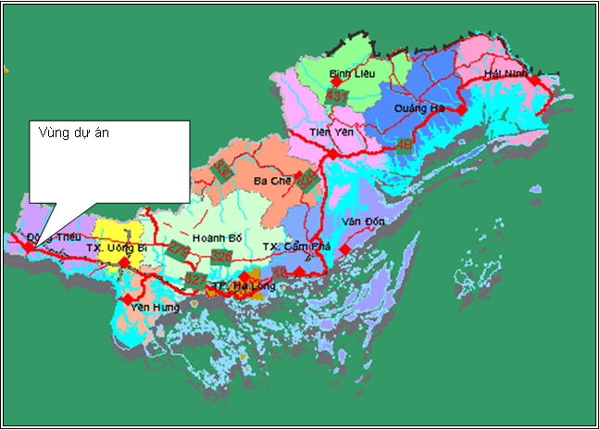
PLA5.1: Location of sub-project
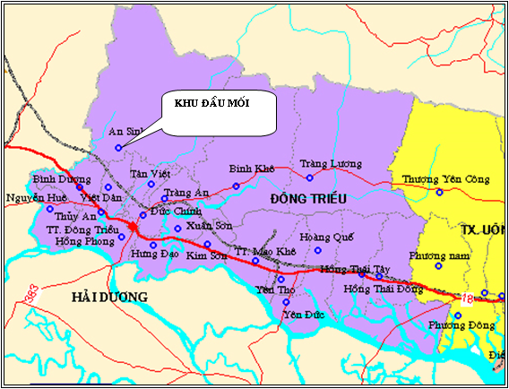
PLA5.2: Location of headworks of Khe Che reservoir
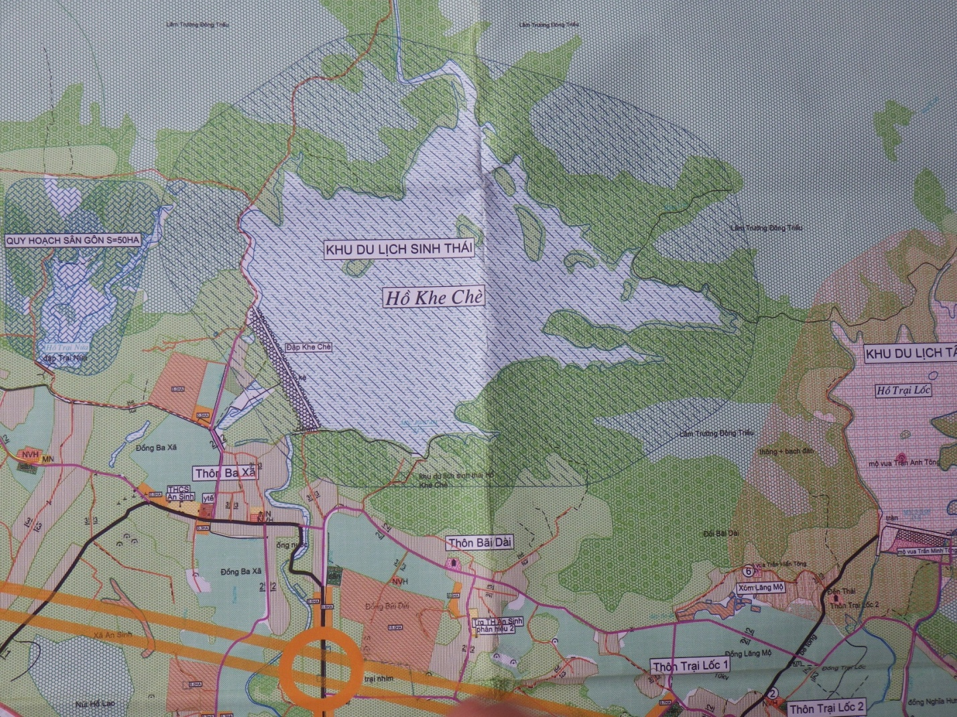
PLA5.3: The headworks of Khe Che Reservoir
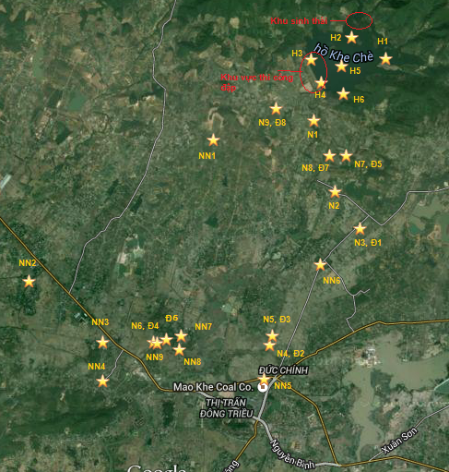
PLA5.4: Location of monitoring sampling in sub-project
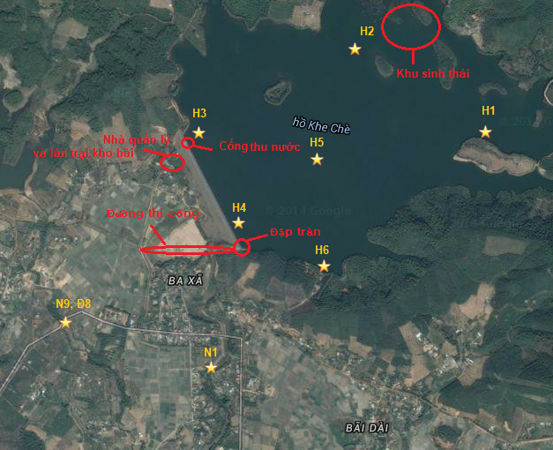
PLA5.5. Location of sampling around Khe Che reservoir area
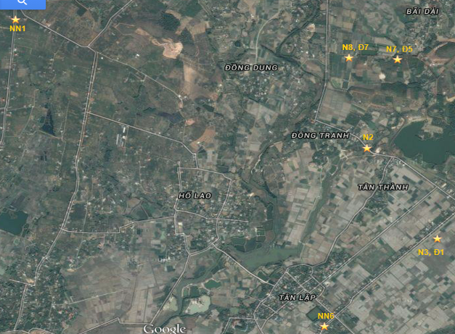
PLA5.6: Location of sampling at An Sinh and Tan Viet commune – affected and benefited from sub-project
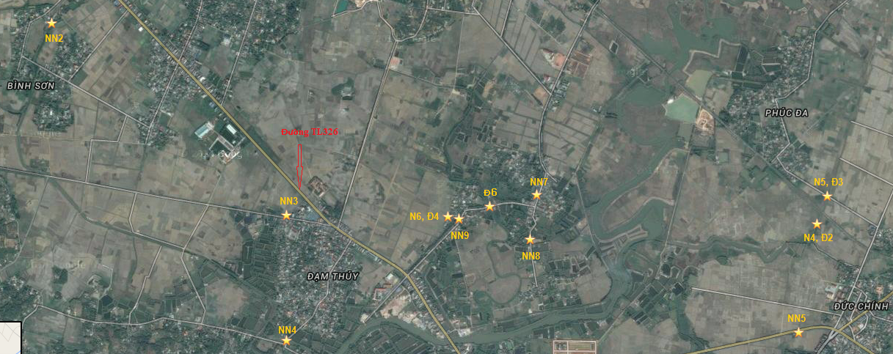
PLA5.7: Location of environment sampling at vicinity in the sub-project
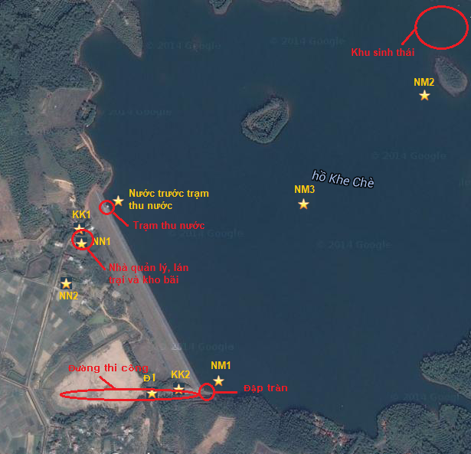
PLA5.8. Location of environmental quality monitoring during the construction progress of sub-project

APPENDIX A10. ENVIRONMENTAL AND SOCIAL SCREENING FOR SUB-PROJECT

ELIGIBILITY SCREENING
Screening Questions | Yes | No | Remarks, (If yes)
1. Does the proposed sub-project lead to an increase in the dam height and/or reservoir's design storage capacity? |  | No
2. If the answer of the question 1 is yes, does the increase is not necessary from safety management perspective?
3. Does the proposed sub-project encroach on a critical natural habitat, a protected area of natural habitat, a national park of nature or a nature reserve and would lead to temporary or permanent acquisition land in that habitat, park or reserve? |  | No
4. Does the sub-project displace, disfigure or render inaccessible any structure or site of great cultural or historical value to the country, to an ethnic group or to the local community. |  | No
5. Does the sub-project use land that is currently occupied or regularly used for natural forest areas, defensive forest or leads to a change in the land use of forest lands during project implementation? |  | No

SCREENING AND ENVIRONMENTAL CATEGORIZATION
Screening Questions | Yes | No | Remarks
- Does the subproject have the potential to cause significant adverse impacts to natural or critical natural habitats?
Leads to loss or degradation of sensitive Natural Habitats such as: land and water areas where (i) the ecosystems' bio-logical communities are formed largely by native plant and animal species, and (ii) human activity has not essentially modified the area's primary ecological functions. |  | No | Impact on water and soil sources of the sub-project is not considerable (due to the increasing of emission such as solid wastes, domestic waste-water in the construction process of workers).  At the place native species appear, the sub-project has not affect yet.  At the place human activities have not significantly changed the basic eco-functions within the scope of project, the construction and operation processes have not changed this eco-system.
Leads to loss or degradation of Critical natural habitat, i.e., habitat that is legally protected, officially proposed for protection, or unprotected but of known high conservation value. |  | No | Within the area of Dong Trieu, there is reservation zone, sacred forests, rare and vulnerable species but endangered species so the sub-project has not lost or degraded the natural environment.
- Does the subproject have the potential to cause significant adverse impacts to physical cultural resources?
Leads to loss or degradation of physical cultural resources (PCR). |  | No | The project has not exerted any impact on historical relics because locations of works are far from the historical relics, temples, churches and not violate the freedom of religion of the local residents.
Potentially results in a contravention of national legislation, or national obligations under relevant international environmental treaties and agreements, including the UNESCO World Heritage Convention or affect sites with known and important tourism or scientific interest. |  | No | Project for rehabilitating and upgrading the headwork of Khe Che reservoir totally matches with the national laws.  An Sinh Commune – the area has under influence of Khe Che Lake – has An Sinh Vuong Tran Lieu temple and relics of tombs of Tran Kings with benefits of tourism. Khe Che Dam Rehabilitation and Safety Improvement Project has not involved to these relics that are far away from the headwork.
- Does the subproject have the potential to cause significant adverse impacts on the lands and related natural resources used by ethnic minorities?
Potentially result in impacts on lands or territories that are traditionally owned, or customarily used or occupied, and where access to natural resources is vital to the sustainability of cultures and livelihoods of minority peoples. Potentially impact the cultural and spiritual values attributed to such lands and resources or impact natural resources management and the long-term sustainability of the affected resources. |  | No | Because the construction area of the sub-project has few people from ethnic minorities. All ethnic minorities immigrating in geographical areas is due to get marriage with the residents so the implementation of sub-projects do not affect to the land, their own tranditional territory, customs and have no access to natural resources which play an important for the sustainability of the culture and livelihood of ethnic minorities.
- Does the subproject have the potential to cause significant adverse effects to populations subject to physical displacement?
Leads to physical displacement of populations dependent upon lands or use of specific use of resources that would be difficult to replace or restore? Otherwise lead to difficult issues in the ability of the subproject to restore livelihoods? |  | No | The project on rehabilitating and improving the dam and reservoir safety includes repairing and strengthening the dam face and spillway, concreting the water intake without land recovery. Regarding the sub-project on rehabilitating and improving Khe Che Reservoir, An Sinh commune, Dong Trieu District, the damages caused by land used to construct works are negligible, it is ROW for irrigation works, agricultural land and works items with small scale with construction site far from the residential area.
- Does the subproject entail the construction/rehabilitation of a large dam?
Does the subproject require construction/rehabilitation of a dam that is:  - 15 meters or more in height  - between 10 and 15 meters in height with special design complexities--for example, an unusually large flood-handling requirement, location in a zone of high seismicity, foundations that are complex and difficult to prepare, or retention of toxic materials.  - under 10 meters in height but expected to become large dams during the operation of the subproject? | Yes |  | This sub-project mainly aims to expand the spillway (expanding from 12m to 24m) to avoid discharging flood to downstream area. The spillway is characterized by available height of 14m, simple structure but it is expected to become a large dam during operation of the sub-project. In future, Khe Che reservoice shall serve agricultural irrigation activities in 8 communes and Dong Trieu town and ecotourism. Therefore, such works is considered to be a large dam.  That is why as required in OP 4.37, an independent expert must be available to evaluate the dam safety
Does the operation of the subproject rely on the performance of:  - an existing dam or a dam under construction (DUC);  - power stations or water supply systems that draw directly from a reservoir controlled by an existing dam or a DUC;  - diversion dams or hydraulic structures downstream from an existing dam or a DUC, where failure of the upstream dam could cause extensive damage to or failure of the new World Bank-financed structure and irrigation or water supply projects that will depend on the storage and operation of an existing dam or a DUC for their supply of water and could not function if the dam failed. | Yes |  | Operation of sub-project only depends on performance of available dam (providing irrigation water for agriculture and operating ecotourism services at the reservoir). No electric stations and water supply system to take water from the reservoir and dam is not guided or supported with downstream structure from one available dam.  However, the works complex of Khe Che Reservoir does not require the assesment of group A but caution should be applied because the Bank has an extremly strict requirement to ensure the operation safety of available dam or dam to be built. The bank requires to inspect the dam or new dam, operation performance and O&M procedures; and recommends any repairs or safety measures; the previous evaluations are also re-conducted.
- Does the subproject entail the chemical for soil treatment?
Do the formulations of the products fall in World Health Organization classes IA and IB, or are there formulations of products in Class II?, | Yes |  | After the TDA is completed, the agricultural production conditions shall be improved (the irrigation canal system shall operate more efficiently); investing in the production activities to increase profits may increase use of fertilizers and pesticides; thereby increasing environmental pollution.
- Does the subproject have the potential to cause irreversible impacts or impacts that are not easily mitigated?
Leads to loss of aquifer recharge areas, affects the quality of water storage and catchments responsible for potable water supply to major population centers. |  | No | The subproject shall not affect the water storage location that is responsible for supplying drinking watercho các trung tâm dân
Leads to any impacts such that the duration of the impacts is relatively permanent, affects an extensive geographic area or impacts have a high intensity. |  | No | Widening the spillway shall not cause any impact that is considered to be long-term and affect the widespread geographical area or impact at high intensity for 3 communes (An Sinh, Tan Viet and Viet Dan Commune)
- Does the subproject have the potential to result in a broad diversity of significant adverse impacts?
Multiple sites in different locations affected each of which could cause significant losses of habitat, resources, land or deterioration of the quality of resources. |  | No | Widening the spillway shall be performed by excavating in the mountainous region on the spillway’s left shoulder. However, this excavation shall not lose living environment, natural resources, land or quality reduce the natural resource quality at a significant level.
Potential, significant adverse impacts likely to extend beyond the sites or facilities for the physical works. |  | No | The subproject not only causes significantly potential and adverse effects but also widen their effects out of the project of construction work.
Transboundary impacts (other than minor alterations to an ongoing waterway activity). |  | No | Widening the spillway of Khe Che resevoir only impacts three main communes (An Sinh, Tan Viet and Viet Dan) and adjacent area which belongs to Dong Trieu district.
Need for new access roads, tunnels, canals, power transmission corridors, pipelines, or borrow and disposal areas in currently undeveloped areas. |  | No | Because the workers and material yard are located in the management house area, the workers may use power and water with the management house. Machines may be transported through inter-commune road and soil road to the dam. Therefore, service road, tunnel, canal, power transmission corridor, new pipeline are not required for performing the project.
Interruption of migratory patterns of wildlife, animal herds or pastoralists, nomads or semi-nomads. |  | No | The sub-project site is not located in the area where there are activities of grazing animals, immigrants, semi residents and does not impact wild aminal’s immigration cycles.
- Is the subproject unprecedented?
Unprecedented at the national level? |  | No | There are many dam rehabilitation and safety improvement sub-projects conducted in the entire country.
Unprecedented at the provincial level? | Yes |  | This is the first sub-project conducted at Quang Ninh with the purpose of upgrading and repairing the reservoir safety.
- Is the project highly contentious and likely to attract the attention of NGOs or civil society nationally or internationally?
Considered risky or likely to have highly controversial aspects. |  | No | Conducting the sub-project is not considered as risk or potentials with the controversial issue.
Likely to lead to protests or people wanting to demonstrate or prevent its construction. |  | No | The sub-project receives the support of local people and authorities (that is expressed through the community consultation process in the project area).

ADDITIONAL REQUIREMENTS AND SUGGESTED TOOLS
Does the sub-project entail these environmental impacts? | Yes | No | If Yes, Requirements
Encroachment on historical/cultural areas |  | No
Use of explosive and hazardous chemicals |  | No
Use of sites where, in the past, there were accidents incurred due to landmines or explosive materials remaining from the war |  | No
Construction that could cause significant disturbance to the transportation, traffic routes, or waterway transport? |  | No
Increase flood levels to downstream and reservoir sedimentation |  | No
Acquisition (temporarily or permanently) of land (public or private) for its development | Yes |  | RAP is required
Use land that is currently occupied or regularly used for productive purposes (e.g., gardening, farming, pasture, fishing locations, forests) | Yes |  | RAP is required
Displacement of individuals, families or businesses |  | No
Temporary or permanent loss of crops, fruit trees or household infrastructure |  | No
Involuntary restriction of access by people to legally designated parks and protected areas |  | No
Ethnic minority groups are living within the boundaries of, or nearby, the subproject. | Yes |  | EMDP is required
Members of these ethnic minority groups in the area potentially could benefit or be harmed from the project. |  | No
Involve the construction of a large dam (i.e. higher than 15m or more than 3M cubic meter reservoir capacity)? | Yes |  | DSR is mandatory
Depend on water supplied from an existing dam or weir or a dam under construction? |  | No

LEVELS OF POTENTIAL ENVIRONMENTAL AND SOCIAL IMPACTS TO BE ADDRESSED
No | Does the subproject entail these environmental impacts? | Level of impact | Remarks
1. | Encroachment on historical/cultural areas | No | Headwork of Khe Che reservoir locates far away from the historial/cultural area (An Sinh Vuong Tran Lieu Temple and tomb of Trang Kings at An Sinh Commune)
2. | Encroachment on an ecosystem (e.g. natural habitat sensitive or protected area, national park, nature reserve etc....). | No | At Dong Trieu District, there is no sensitive natural habitat, reservation zone, conversation park, national park so the sub-project has not affected to the eco-system.
3. | Disfiguration of landscape and increased waste generation | Low | During the period of project construction and performance, there are 50 workers to frequently extend the spillway everyday so it emits (domestic solid waste, waste water). Moreover, the machines for the project also causes the emissions (petroleum and emission). However, the emission level from the workers and machines serving the works is predicted at low level.
4. | Removal of vegetation cover or cutting down of trees during clearance for construction | Low | Extending the spillway onward the mountain maybe cut the trees here when constructing.
5. | Change of surface water quality or water flows (e.g. Increase water turbidity due to run- off, waste water from camp sites and erosion, and construction waste) or long-term. | Low | The sub-project is constructed during 2 drought seasons, the construction process does not require water cutting, so the impact from the flow is not considerable.  Waste water, solid waste from the tent zone (living activities of workers) can affect to water surface quality.
6. | Increased dust level or add pollutants to the air during construction | Medium | Machines increase the emission amount of dust into the atmostphere during the construction. Because machines are reused so the level of emissions can cause the remarkable impacts on the rest of fresh-air environment.
7. | Increased noise and/or vibration | Medium | The level of noise and vibration is usually increasing on daytime mainly when the machines for digging, transporting, filling at the end of dam and probes for finding and handling the termite are starting to operate.
8. | Resettlement of households? If yes, how many households? | No | Sub-project does not require households relocation
9. | Use of resettlement site that is environmentally and/or culturally sensitive | No | The sub-project has not selected the location that is sensitive about environment and culture to relocate.
10. | Risk of disease dissemination from construction workers to the local peoples (and vice versa)? | Low | At the site of the sub-project, there are about 20 workers living here to implement the works everyday during 2 drought seasons as well as share the common water source with the localities so it can create the water-born diseases.
11. | Potential for conflict between construction workers and local peoples (and vice versa)? | Low | The workers living in the tents shall have less conflicts with the localities. However, it still happens during the living activities (go to market, entertain …)
12. | Use of explosive and hazardous chemicals | No | No blasting activities in the construction and no usage of harmful chemicals in the termite process.
13. | Use of sites where, in the past, there were accidents incurred due to landmines or explosive materials remaining from the war | No | According to the survey, the area under the sub-project has no explosive materials left since the war time.
14. | Construction that could cause disturbance to the transportation, traffic routes, or waterway transport? | Medium | The land locates 7 km far from the work site, adjacent to communal asphalt road and building materials are transported from Dong Trieu Town so the waterway can be messed during the construction.  Construction process has not caused any difficulties for waterway.
15. | Construction that could cause any damage to the existing local roads, bridges or other rural infrastructures? | Low | Road in the area of Dong Trieu District is concreted, enduring the quite huge loads. However, there are some sections of earth road and old road on the line of machine transportation so they can be damaged by activities of the sub-project
16. | Soil excavation during subproject's construction so as to cause soil erosion | Low | Rock and soil being taken away from the moutains can cause the increasing of soil erosion in this area.
17. | Need to open new, temporary or permanent, access roads? | No | Not require to newly open the temporary service roads.  Line for temporary construction is performed right at the headwork of Khe Che reservoir.
18. | Separation or fragmentation of habitats of flora and fauna? | No | The sub-project has just upgraded and extended the spillway so there is no division or diffusion into habitats of fauna and flora.
19 | Long-term impacts on air quality | No | The reused machines and tools can produce the dust into the atmosphere during the construction of spillway. However, the conditions of air pollution has not lasted for long, the self-cleaning ability reduces the air pollution in the future. Therefore, the sub-project just affects to the air quality in the temporary period.
20. | Accident risks for workers and community during construction phase | Low | This is the work for dam rehabilitation and safety improvement project so normal risks for the workers is mainly from usage of machines or accidents relating to water.  For the localities, accident risks rarely happens to them because the area for constructing the sub-project is located far from the residential zone (only 10 households under the scope).
21. | Use of hazardous or toxic materials and generation of hazardous wastes | Low | Machines and materials for construction all are buiding materials, petroleum so the harm wasted is reduced to emit.  In the process of living, the workers can release some harm wastes such the pathogens in their excrement (if that worker is sick or infected) or use several harm chemicals (detergent …).
22 | Risks to safety and human health | Low | Generally, performance of dam rehabilitation and safety improvement project has just caused the low risks for human safety and health because of:  -Discharging exhaust gas, dust and noise during 2 drought seasons.  -Releasing the petroleum that can follow with the flow into the reservoir via the irrigation systems.  -Emitting the wastes from the workers, affecting to the water source (excrement, waste-water …).
Does the subproject entail land acquisition or restriction of access to resources?
23 | Acquisition (temporarily or permanently) of land (public or private) for its development | Low | -Affected land area for forestry: 4,000 m².  -Affected unused land area: 3,120 m².
24. | Use land that is currently occupied or regularly used for productive purposes (e.g., gardening, farming, pasture, fishing locations, forests) | No | The sub-project has not utilized the land that is under the ownership or used for production purposes (for gardening, farming, grazing, fishing or covering the land with trees).
25.. | Displacement of individuals, families or businesses | No
26. | Temporary or permanent loss of crops, fruit trees or household infrastructure | No | There is no land for planting the rice or crops, fruit trees at all in the region of the sub-project.  In case of relocating 10 households to another place, the sub-project shall not utilize the infrastructure of such land lots.
27. | Involuntary restriction of access by people to legally designated parks and protected areas | No | -
Are ethnic minority peoples present in the subproject area?
28 | Ethnic minority groups are living within the boundaries of, or nearby, the subproject. | No | Only some groups of ethnic minorities have got marriage with the residents within or near to the scope of the sub-project so these impacts are not remarkably.
29. | Members of these ethnic minority groups in the area potentially could benefit or be harmed from the project. | No | In the scope of sub-project implementation, only several persons belonging to ethnic minorities (because of getting marriage with the residents) have not been under the influence of the sub-project
Does the subproject entail construction of or depend upon a dam?
30. | Involve the construction of a large dam? | Low | Dam’s height is 14m with the spillway of being extended to 24m and being in use. Dam of Khe Che reservoir can serve for activities of agriculture and aquaculture on the large scale.
31. | Depend on water supplied from an existing dam or weir or a dam under construction? | No | Water in Khe Che reservoir does not depend on amount of water supplied from some dam or existing dam or under-constructing dam.

APPENDIX A11. PICTURES OF SUB-PROJECT

PICTURES OF THE CURRENT STATUS OF THE PROJECT
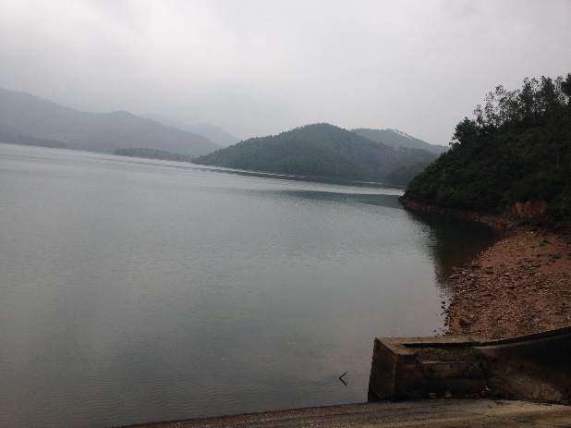 | 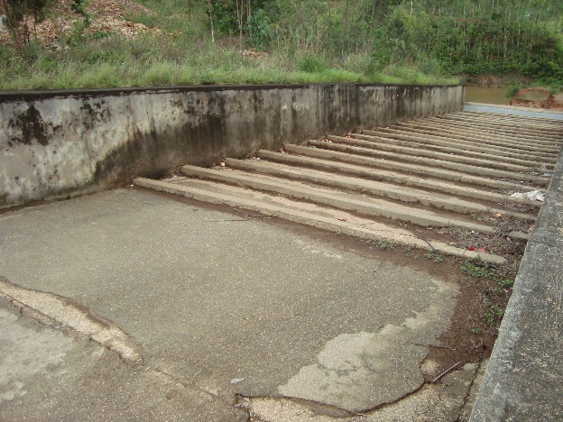
Khe Che Lake | Spill and abutment of absorption
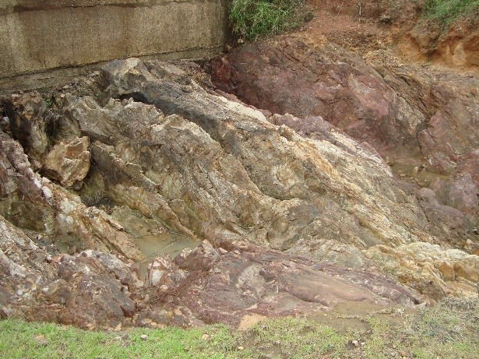 | 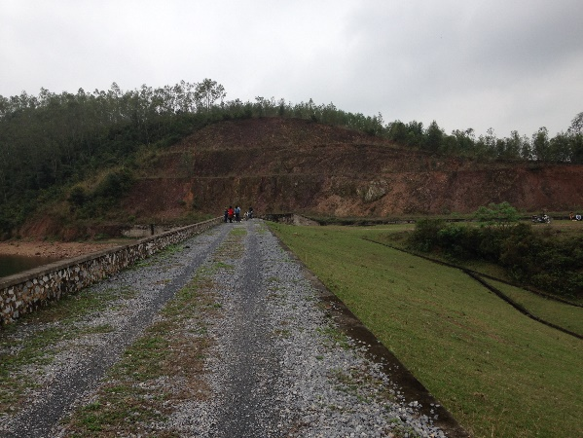
Scour hole after spilling | Khe Che reservoir dam
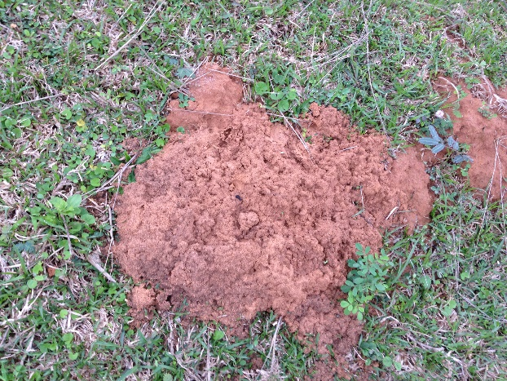 | 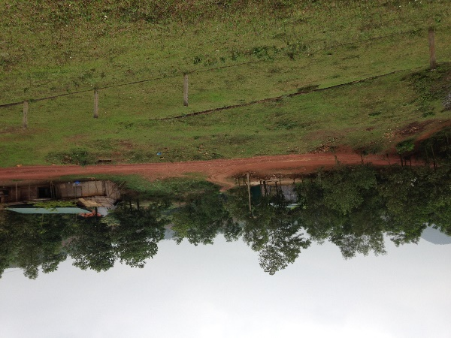
Termite nest in the dam body | Road to the dam
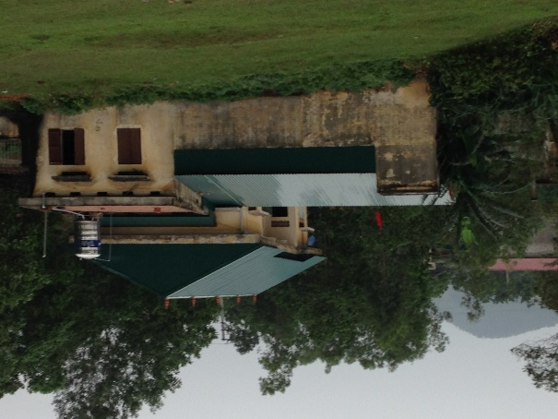 | 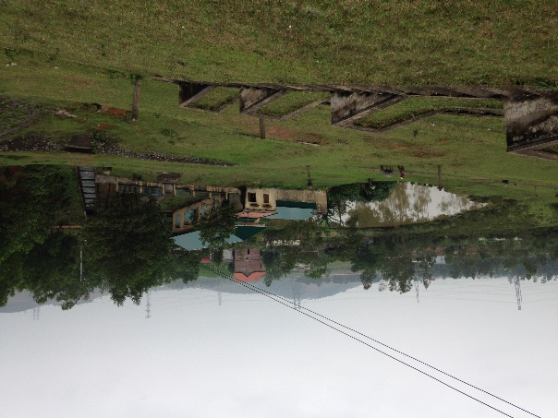
Management office | Households affected Area

PHOTOS OF FIELD SURVEY AND PUBLIC CONSULTATION
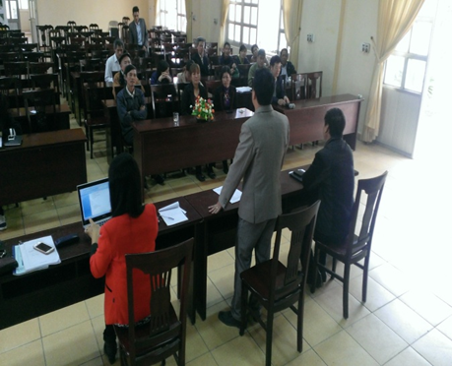 | 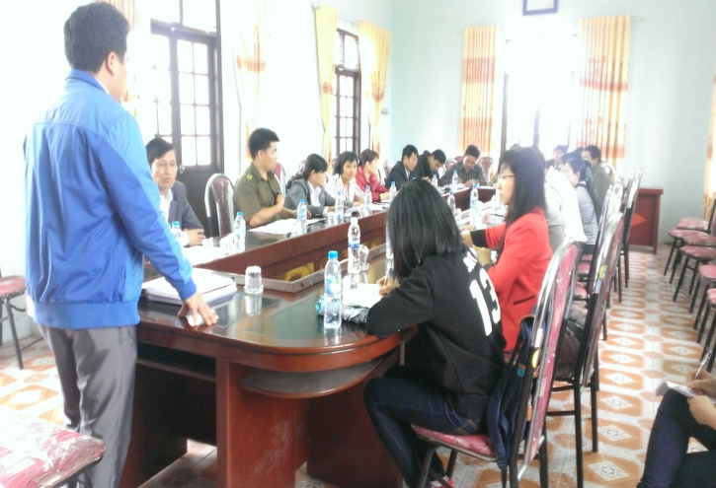
Consultation in Tan Viet commune | Consultation at People’s committee of Tan Viet commune
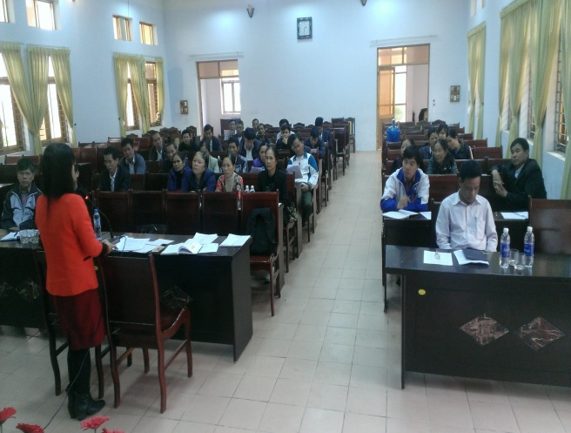 | 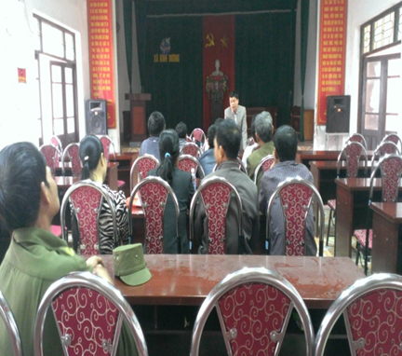
Consultation at People’s committee of Viet Dan commune | Consultation in Binh Duong Commune
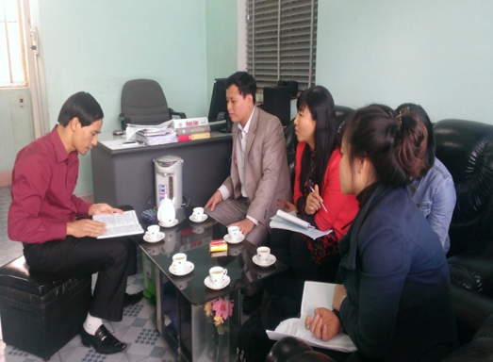 | 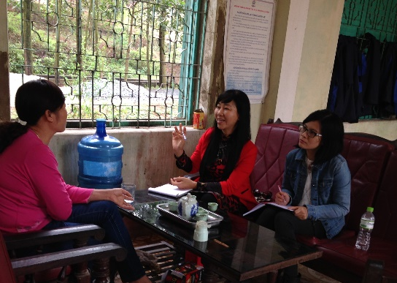
Working with Khe Che lake Management and Exploitation Co.,Ltd, in Dong Trieu, Quang Ninh | Working with management officer of Khe Che lake

PHOTOS OF SAMPLING
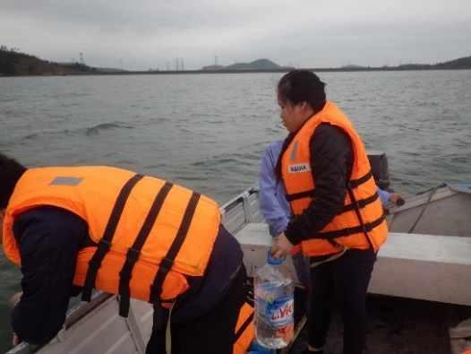 | 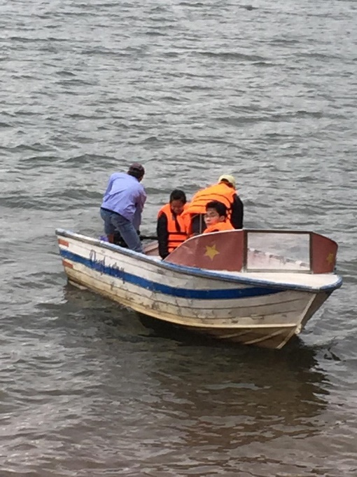
Water sampling in Khe Che reservoir | Water sampling in Khe Che reservoir
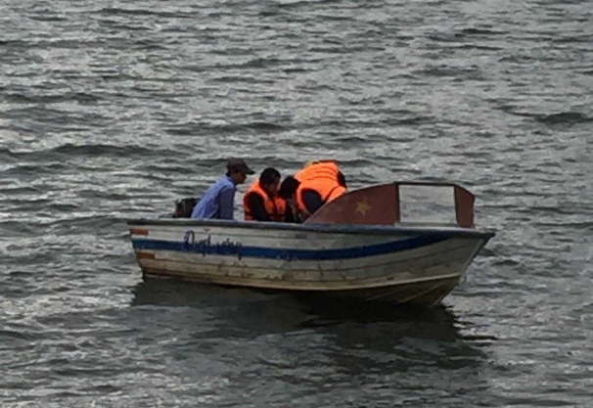 | 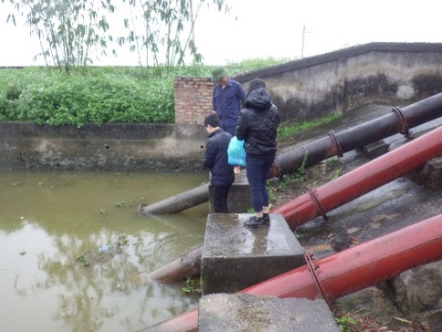
Water sampling in Khe Che reservoir | Water sampling at suntion tank of pump station in Tan Viet commune
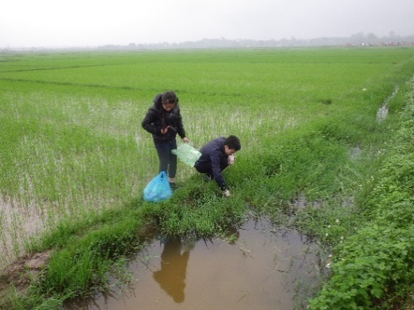 | 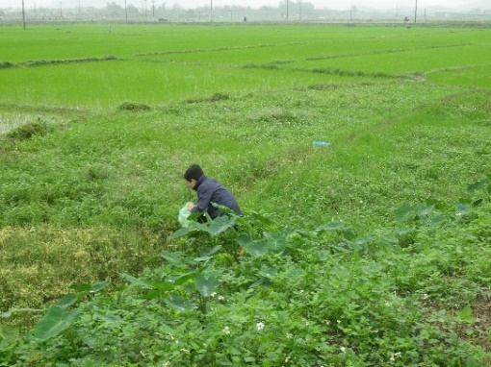
Water sampling at a trench in An Sinh commune (near Khe Che reservoir) | Soil sampling at the field in Viet Dan commune
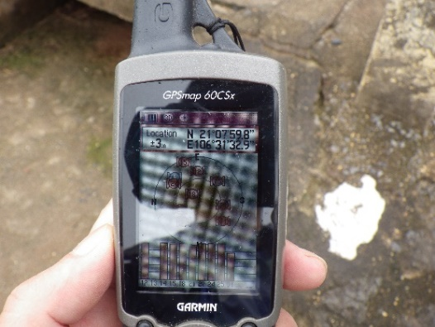 | 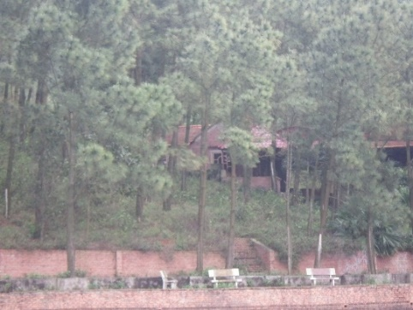
Coordiator measuring of location for sampling | An Sinh commune habitat

APPENDIX A12. CHANCE FIND PROCEDURES
The project works could impact sites of social, sacred, religious, or heritage value. “Chance find” procedures would apply when those sites are identified during the design phase or during the actual construction period.
Cultural property includes monuments, structures, works of art, or sites of significant points of view, and are defined as sites and structures having archaeological, historical, architectural, or religious significance, and natural sites with cultural values. This includes cemeteries, graveyards and graves.
In the event of finding of properties of cultural value during construction, the following procedures for identification, protection from theft, and treatment of discovered artifacts should be followed and included in standard bidding document.
- Immediately stop the construction activities in the area of the chance find.
- Delineate the discovered site or area.
- Secure the site to prevent any damage or loss of removable objects.
- Notify the supervisory Engineer who in turn will notify the responsible local authorities.
- Responsible local authorities and the relevant Ministry would be in charge of protecting and preserving the site before deciding on subsequent appropriate procedures.
- Decisions on how to handle the finding shall be taken by the responsible authorities and the relevant Ministry. This could include changes in the layout (such as when finding an irremovable remain of cultural or archeological importance), conservation, restoration and salvage.
- Implementation of the authority decision concerning the management of the finding shall be communicated in writing by the relevant Ministry of Cultural, Sport and tourist.
- Construction work could resume only after permission is given from the responsible local authorities and the relevant Ministry concerning safeguard of the heritage.
- The World Bank needs to be notified by PMU on the issues and actions taken.
- These procedures must be referred to as standard provisions in construction contracts. During project supervision, the Site Engineer shall monitor the above regulations relating to the treatment of any chance find encountered.
Relevant findings will be recorded in World Bank Supervision Reports and the overall effectiveness of the project’s cultural property mitigation, management, and activities will be assessed.

APPENDIX A13. TERMITE TREATMENT PROCEDURES
Name of chemical to be used: Metavina 10DP. This product can kill termite via directly exposure or infection. Process of survey, exploration and termite treatment and hidden risks for dam
Exploring termite net by sound
Surveying biology and ecology of termite
Collecting and analyzing samples according to the protective clothes/ safety requirement
Surveying and exploring by radar termite net

Figure : Process of surveying and exploring termite net in dam
Process of termite treatment for dam
Drill a screw and inject termiticide into termite nests then inject clay to voids created by termites in the foundation of the dam in order to protect the surrounding environment and thorough handling of potential dangers caused by termites. This measure does not harm the environment but it requires construction unit to use the specialized equipment, and experience in construction termite treatment for irrigation works. Steps of construction termite treatment as follows:
Drill a screw into termite net
Inject termiticide
Inject clay to fill the void created by termite
Reinstate site

Figure : Process of termite treatment in dam
Requirement of protective clothes/ safety for workers
For termite treatment, the potential impacts may occur such as incidents due to using construction machines in dam slope. Therefore, it is necessary to implement the requirement of protective clothes/ safety for works as follows:
  - Operating properly equipment and machine under right procedure to ensure safety.
  - Checking current status of machines, equipment before operating. The people who are not responsible for construction, without training on technical operation are not allowed in operation, repairing construction machines.
  - Staffs, workers must be equipped fully protective clothes such as shoes, gloves, helmet, name label etc.
Power line, water for constructions have to arrange tidily to not obstruct construction activities Construction signs must be available at construction site.

APPENDIX A14. MITIGATION MEASURES

MEASURES TO MINIMIZE THE ENVIRONMENTAL IMPACTS OF THE SUB-PROJECT IN THE PREPARATION PHASE
Potential impact | Mitigation measures | Instrument
Emissions of dust, gases:  During the preparation stage, any activity can also be likely to cause air pollution. The main pollutants are dust and exhaust gases released by trucks transporting materials and equipment to the project area. | Equipping sprinkling vehicles, watering the road. Water spraying in the area of levelling and transport routes.  Planning measures are needed, appropriate time transportation management, using the vehicle that meets the standards of emission, cloaking when moving to regrouping area. | -ESMP.  -Contractors Environment and Occupational Health and Safety Plan (CEOHSP).
Noise creation:  Noise source can be caused by a number of the following activities: the operations of tree cutting, demolition of existing works and transportation of the waste to dump sites. 02 110CV bulldozers, 03 1.6m³ excavators, five 7-10 ton dump trucks | Maintenance works of machines and trucks should be in best state. | - ESMP.  - CEOHSP.
 | The loud noise operation should be conducted over a period of working day
Waste disposal (solid waste, domestic wastewater) | Solid Waste Bins | - ESMP.
 | Grease Bins
 | greasy rag bins
 | Mobile toilets

MEASURES TO MINIMIZE THE SOCIAL IMPACTS OF THE SUB-PROJECT IN THE PREPARATION PHASE
Potential impact | Mitigation measures | Instrument
Loss of land (mainly forest land) | Require RAP | RAP
Possible chance finds of archaeological sites, artefacts | Adopt a Change Find Procedure | Chance Find Procedure (Appendix A12).
Possible encounter of unexploded ordnance (UXO) | Immediately stop activities, secure the site and contact authorities. Contact details of the authorities should be available.  Follow UXO procedure. | UXO Procedure
Lack of means for lodging complaints or claims for compensation of damage during construction | Set up a Grievance Redress Mechanism for the sub-project | Grievance Redress Procedure

THE MITIGATION MEASURES OF SOCIAL IMPACTS IN THE CONSTRUCTION PHASE
Potential impact | Mitigation measures | Instrument
(1)  Risk of dam safety:  when the dam breaks, it has a major influence on the lives and assets of more than 3000 people in three communes downstream that is An Sinh, Tan Viet and Viet Dan. | + Carry out all activities of upgrading during the dry season  + Speed up the construction. | Working schedule
(2)  Obstructing traffic and increasing the risk of traffic accidents and reducing the possibility of access to social services (schools, markets and health centres ...) in the sub-project area. | + Installation of signs, lights in the construction area, applying traffic guidance;  + Creating a temporary way for people to travel when necessary;  + No gathering of the materials in front of the passage of people and other busy spots.  + Installation of entry and exit signs on the field, in the densely populated areas that are near the sub-project area.  + Notice of the construction plan for the community. | - ESMP
(3)  Construction workers staying in the locality may disturb the social and affect the lives of people | + Consult local authorities about helping workers to rent houses instead of setting up camp with better advantages for the management of solid wastes.  + Orient workers how to be exposed to the community and guide them to protect the health sanitation and prevention of infectious diseases.  + Orient workers how to prevent infectious diseases such as HIV / AIDS and other social evils such as gambling, prostitution, theft ..  + Workers are prohibited to exploit local resources. | - ESMP.  - CEOHSP.
(4)  Hazards to 50 workers health and safety impacts to the project area | Safety measures in the construction site:  + Appointing safety staff to implement safety measures at construction sites and training them in emergency aid  + Provide adequate personal safety equipment for employees (such as helmets, gloves, safety belt etc.) and train them to use;  + Install the tables of safety regulations in the field  + Erect fencing around the construction site.  Reduce the risk in the material transport processes along the route:  + The speed limits along the route (road and dam management) and ensure compliance with each segment with residential areas and intersections.  + The contractor should conduct meetings / inform regularly to local authorities and local people about the progress of construction and traffic safety to help them be aware of the risks to prevent.  + Limit material transportation in the wet season and avoid overloading vehicles.  + Timely repair damaged pavement. Implement measures to reduce dust as stated; | - ESMP.  - CEOHSP.
(5)  The impacts arising from the temporary materials dump such as dust, noise and impacts on water quality | + Store material along the route, dam or near the construction site to avoid congestion;  + Store materials reasonably to avoid affecting vehicles and pedestrians passing through the construction area;  + Erect fencing around the areas that contain the pits to prevent the entry of people and animals;  + Make Reasonable compensation for the agricultural produce by local residents who are affected by gathering materials as well as the use of soil as a temporary materials dump; | - ESMP.  - CEOHSP.
(6)  Impacts around area of mines to exploit land, stone, sand such as dust, noise, safety, pollution of soil and water by mining activities | At the rock and soil pits, the Contractor must comply with the environmental protection issues, including:  - Construction plants and equipment must be periodically maintained during operation in accordance with the quality requirements.  - Hazardous wastes such as engine oil and other chemicals must be strictly managed and kept at the separated areas surrounding construction site to wait for competent authority for treatment. Workers must be provided with protection instruments when working in the borrowing site.  - Exploitation area must be provided with fence, gate and protection station to prevent the penetration of unauthorized person and animals;  - Water must be sprayed in the soil pit in dry days.  - The Contractor must select the licensed suppliers to provide building materials. | The mitigation measures are simple easy to implement without technological or technical complexity. However, the contractor should prepare the conditions for construction such as machines, warehouse and yard prior to construction. There should be coordination with the specialized  units to ensure the disposal of waste. These measures will bring good results if the construction contractors and workers are aware or educated about environmental protection and monitored by the Owner.

THE MITIGATION MEASURES OF ENVIRONMENTAL IMPACTS IN THE CONSTRUCTION PHASE
Potential impact | Mitigation measures | Instrument
(1)  Air pollution due to dust and other emissions (CO, NOx, SOx, etc):  Number of trucks are about 3,600 times for transportation of material volume (estimated use of 5-ton trucks with diesel motor) over a period of 10 months (300 days). | Undertake the mitigation measures to minimize dust and air pollution, such as:  + Use of construction serving vehicles that comply with emission standards under current regulations.  + Covering trucks with tarpaulin during transport service  + Ensuring vehicles and construction equipment are maintained in good condition.  + In the dry season, vehicles loading with materials need to be watered when passing crowded residential areas, schools (within the area surrounding the project), camping areas in the rush hours (at least twice per day).  + Regulation on speed limits should be prescribed and drivers are to know and comply with the regulations.  + The contractor will perform the proposed construction plans, approved by the PMU to minimize the time clearance, construction and pits storage. | - ESMP.  - CEOHSP.
(2)  Water pollution, aquatic environment pollution due to waste, chemicals, effluent or contaminated land:  -Domestic waste water from 50 workers (4 m³/day);  - Construction waste water (0.5 m³/day) | + Storing oil in a safe area, with concrete floors and roof to avoid rainwater and floodwater;  + Ensuring the vehicles and construction equipment is maintained in good condition.  + Use of mobile toilets in the process of construction. The mobile toilets comply with standards and are arranged in the area near worker camps. The number of mobile toilets: 02.  + Regularly collecting and processing soil spillage to prevent clogging of canals and water resources in the region.  + No chemical preparation is conducted close to water sources.  + Do not wash tanks, shells containing materials.  + Do not leave waste from10 m down in the water sector. | - ESMP.  - CEOHSP.
(3)  Soil pollution by oil or other chemical spills or leaks: from repairing and maintenancing of machinery and vehicles. | + Storing chemicals (oil, concrete chemical additives, etc.) for construction services in containers, boxes suitable for each type of chemicals in a safe areas with concrete floors and roofs to avoid rainwater and floodwater;  + Ensuring vehicles and construction equipment is maintained in good condition.  + The redundant and unused chemicals and petroleum must be wrapped carefully and transported to eligible warehouses. The containers of chemicals will not be reused, but separately collected and transported to specialized units to handle. | - ESMP.  - CEOHSP.
(4)  Rock, or dropped materials causing sedimentation in Khe Che Lake or channels, rice fields surrounding areas ... during clearance or excavation, backfilled and transportation of materials. | + Avoid clearance activities in the rainy season, and the work is completed. The clean-up must be done before moving on to a new line.  + Installation of sewer grates in the drainage ditch;  + To dredge canals in the rainy season (if necessary) if sedimentation persists.  + Clean and dredge soil, sand and rubble spilling from the vehicles down to paddy fields, canals ... | - ESMP.
(5)  Waste materials generated from construction activities on the site and the activities of workers:  - Domestic solid waste from 50 workers (25 kg/day);  - b) Solid wastes from work construction: from building activities (including rock and soil from the excavation for extending spillway, sand and gravel, ... surplus materials and spillage during construction such as broken bricks, broken roof plate, beams, formwork, cement cover, salvage ...) | + Local residents are prioritized in worker recruitment.  + Regular cleaning of waste from the construction to the dumping area (including 01 disposal area)  + Make the most amount of soil to dig up works during the construction (in the case that materials are qualified).  + Putting the garbage container in the appropriate positions in the field and worker camps  + For the hazardous waste (for example sludge, grease and other products relating to oil surplus, if any), installation of collection system and temporary storage around the site and then contact with the expertise units to handle.  + Arranging waste rock and soil in the landfill in the construction project at the construction site. Size of landfill: 35x500m. | - ESMP.  - CEOHSP.
(6)  Noise from construction equipment | + The motor vehicles, construction equipment must be maintained periodically.  + Select suitable locations to place the sources of loud noise: Some sources of noise such as concrete mixers, gathering yards ... must be located in areas away from residential areas, schools, clinics and Commune People’s Committee office and workers’ residential places.  + Avoid performing construction activities near the residential areas during lunch or dinner time or after 8 p.m.  + Regularly inform communities and local governments about construction plans by phone, loudspeaker, and documents or on the notice board of the Commune People’s Committee. | - ESMP.  - CEOHSP.

THE MITIGATION MEASURES OF SOCIAL IMPACTS IN THE OPERATION PHASE
Potential impact | Mitigation measures | Instrument
(1)  Emergency flood discharge: Flooding dam safety corridor; Increased risk of erosion and sedimentation downstream; affected production of people downstream in 3 communes: An Sinh, Tan Viet, Viet Dan Communes with more than 3000 peoples and 1065 ha of crop. | Prepare plans and training for local people to respond in case of emergency flood discharge;  Promptly inform the people and the local authorities timely of flood discharge time, flood levels and the negative effects that may occur  Prepare plans to evacuate and protect the property of people in downstream areas when necessary flood discharge | - Operation and maintenance plan (Appendix B6);  - Emergency Preparedness Planning (EPP) (Appendix B7).
(2)  Risk of water loss of reservoir: Affected ability to regulate water, causing water shortages for production, and economic damages.  Affected areas: An Sinh, Tan Viet, Viet Dan Communes with more than 3000 peoples and 1065 ha of crop. | Regular inspection and detection of incidents resulting in loss of water to notify the competent authority to handle  Annually allocate funds for maintenance and repair of damage and incidents for headworks (dams, flood discharge spillway, the offtake) | - Operation and maintenance plan (Appendix B6);  - Emergency Preparedness Planning (EPP) (Appendix B7).
(3)  Natural disaster risks causing the unsafe | + Management Unit of Khe Che Reservoir should periodically check the safety of the Reservoir  + Management unit coordinates closely with the CPC and the local people to promptly report the risks related to dam safety so that timely corrective measures are given  +During the rainy and stormy seasons prone to unsafely, appoint staff to monitor regularly to ensure reasonable water regulation  + For the flood discharge, flood mapping for downstream areas will be established. Inform people at least 01 days of the flood discharge plan (if necessary) to prevent and reduce damages and loss.  + Construction of corridor  Construction of safe corridor for flood discharge as needed on the basis of forecast scenarios of special influences due to dam failure. | - Operation and maintenance plan (Appendix B6);  - Emergency Preparedness Planning (EPP) (Appendix B7).
(4)  Regulatory reservoir to flood discharge in the case of large floods affecting downstream | - Management and operation units should promptly and accurately notify the flood discharge to people in the community to actively capture and response  - At the moments of risky unsafely such as in the rainy season, those unit should appoint regular monitoring duty to ensure reasonable water regulation  - People and the local government actively plan to cope with disaster risks | - Operation and maintenance plan (Appendix B6);  - Emergency Preparedness Planning (EPP) (Appendix B7).
(5)  there are ethnic minority in the sub-project area. | Require EMDP | EMDP

THE MITIGATION MEASURES OF ENVIRONMENTAL IMPACTS IN THE OPERATION PHASE
Potential impact | Mitigation measures | Instrument
A | Mitigation measures of environmental impacts
(1)  Domestic solid waste and hazardous waste (arising from the maintenance of machinery):  -Domestic solid waste from workers (2 kg/day). | + Arrange waste bins in the waste arising locations.  + Limit dropping viscous oil in the maintenance of machinery.  + Rent functional units to collect and handle in accordance with regulations. | - ESMP
(2)  The impacts by domestic wastewater by officials and employees at work: from 4 employees (400 litters/day). | + Use the toilet with waste water treatment tanks. | - ESMP
(3)  The impact of termites nest in the dam body | + Regularly do surveys for early detection of termites.  + Do not apply the means of digging to look for queen termite, but control termites by jet drilling technology in termite nests.  + Study and apply management measures in operating procedures for each type of reservoir dam.  + There should be solutions for comprehensive termite preventions in river dikes.  + There should be solutions for comprehensive termite preventions in river dikes | - Operation and maintenance plan (Appendix B6);  - Emergency Preparedness Planning (EPP) (Appendix B7).
(4)  Impacts caused by sedimentation: sedimentation and water pollution | Planting protective forests upstream to increase water storage capacity and minimize erosion and sedimentation.  Restrict exploitation activities on the slopes and the area of reservoir | -
(5)  Impacts caused by waste generated from agricultural, forestry and aquaculture activities | Collection of garbage (bottles, containers of pesticide, fertilizer), material waste immediately; avoid waste which is thrown away in disorder or collected for such a long time.  Project owner shall coordinate with local governments to train people to use farming methods in terms of environmental safety; develop green –clean production in aquaculture and forestry. | ESMP
(6)  Termite destroying the dam body | Termite Treatment with the Procedure | Termite Treatment Procedures (Appendix A13)
(7)  Increase in the use of pesticide due to intensification of production in irrigated areas. | The introduction or promotion of Integrated Pest Management approach by MARD/DARD in the irrigation service area  When the sub-projects go in operation, organize workshops and training of IPM (Integrated Pest Management ) officials at commune and village levels in the sub-project area | IPM (Appendix D1)
B | Measures to mitigate the social impact
(8)  Emergency flood discharge: Flooding dam safety corridor; Increased risk of erosion and sedimentation downstream; affected production of people downstream. | Prepare plans and training for local people to respond in case of emergency flood discharge;  Promptly inform the people and the local authorities timely of flood discharge time, flood levels and the negative effects that may occur  Prepare plans to evacuate and protect the property of people in downstream areas when necessary flood discharge | - Operation and maintenance plan (Appendix B6);  - Emergency Preparedness Planning (EPP) (Appendix B7).
(9)  Risk of water loss of reservoir: Affected ability to regulate water, causing water shortages for production, and economic damages. | Regular inspection and detection of incidents resulting in loss of water to notify the competent authority to handle  Annually allocate funds for maintenance and repair of damage and incidents for headworks (dams, flood discharge spillway, the offtake) | - Operation and maintenance plan (Appendix B6);  - Emergency Preparedness Planning (EPP) (Appendix B7).
(10)  Natural disaster risks causing the unsafe | + Management Unit of Khe Che Reservoir should periodically check the safety of the Reservoir  + Management unit coordinates closely with the CPC and the local people to promptly report the risks related to dam safety so that timely corrective measures are given  +During the rainy and stormy seasons prone to unsafely, appoint staff to monitor regularly to ensure reasonable water regulation  + For the flood discharge, flood mapping for downstream areas will be established. Inform people at least 01 days of the flood discharge plan (if necessary) to prevent and reduce damages and loss.  + Construction of corridor  Construction of safe corridor for flood discharge as needed on the basis of forecast scenarios of special influences due to dam failure. | - Operation and maintenance plan (Appendix B6);  - Emergency Preparedness Planning (EPP) (Appendix B7).
(11)  Regulatory reservoir to flood discharge in the case of large floods affecting downstream | - Management and operation units should promptly and accurately notify the flood discharge to people in the community to actively capture and response  - At the moments of risky unsafely such as in the rainy season, those unit should appoint regular monitoring duty to ensure reasonable water regulation  - People and the local government actively plan to cope with disaster risks | - Operation and maintenance plan (Appendix B6);  - Emergency Preparedness Planning (EPP) (Appendix B7).

ESTIMATECOST OF MITIGATION MEASURES
Sub-Project  operations | Impacts | Mitigation measures | Timing/Period | Implementation responsibility | Implementation budget (estimate)
Material transportation for temporary roads | - Increasing risks of traffic accidents.  - Generating dust, noise and air pollution in transportation roads and at construction sites. | - Arranging the stockpile at the end of the monsoon direction  - Spraying water on materials in the construction process generates dust: watering sand when transporting, watering before knocking down houses...  - Cover trucks with tarpaulins if does not have or replace if tarpaulins are in bad condition  - Spraying water to reduce dust during peak hours of transportation. | Preparation | Construction unit | + 1 mil/tarpulin x 30 = 30 mil.  + Protective clothing: clothes, gloves, masks, glasses: estimate: 300000 VND/1 set * 50 = 15 mil.
Gathering vehicles and machines | - Noise, dust, emissions and occupied premises | - Making relocation planning, gathering the right equipment to avoid affecting the daily life of residents | Preparation | Construction unit
Road construction | - Dust, noise and air pollution | - Prevent dust for individuals by using tools such as protective clothing and hats, masks, glasses  - Water spray to reduce dust  - Complying with regulations on environmental hygiene and safety | Preparation | Construction unit | 2 901 plastic bins: 800000/bin * 2 = 1,6 million
Camp building | - Dust and solid waste | - In addition to measures to reduce dust, trash bins should be fixed at site for waste collection | Preparation
- | General apprehensions by residents, farmers, women, other sectors about the impacts of and opportunities in the sub-project, which may lead to speculations and adverse perceptions about the sub-project and to conflicts | Prepare and implement a Public consultation, participation and communication strategy | Preparation | Project Owner and  DARD | 50 million
 |  | Prepare and implement a Gender Development Plan | Preparation | Project Owner and  DARD | 50 million
 |  | TOTAL COST IN PREPARATION PHASE |  |  | 146,6 million
Construction activities of work items | - Reduce the quality of air environment because of dust, emissions, noise and vibration | - Do not use obsolete equipment, maintain machinery and vehicles every 6 months | Construction | Construction unit | 15mil/time * once/1 year * 2 times =30 mil.
 |  | - Watering regularly on construction sites and along construction roads
 |  | - Cover the tarpaulin in the gathering yards of material, covering the truck with tarpaulins.
 | - Generating solid waste, soil spillage and hazardous waste (waste oil, grease rag) causing water, air and soil pollution. | - Remove, handle the amount of soil excavation and removal of weather on the ground | Construction | Construction unit | Estimate: 10 mil
 |  | - At each construction sites, 02 50-litre waste bins are set for hazardous waste; |  |  | 0,5 mil/bin x 02 = 1 mil.
 |  | - Regular clean and collect spilled materials  - Classify solid waste and throw in defined bins  - Collect and process hazardous waste in accordance with regulations |  |  | Service cost for collection and treatment: 15 mil/year *1 year = 15 million.
 | Runoff storm water, vehicle and facility washing water | - Use water economically  - Build ditches to collect waste water from carwash, construction and rainwater into the pit. | Construction | Construction unit | 15 million (estimate)
 |  |  |  | Site workers
 | - Impact on safety, working conditions and health of workers in the field. | - Arranging a reasonable schedule  - Fully equip protective tools for workers  - Training and upgrading capacity of labour safety and environmental protection prior to construction. (2 times during construction) | Construction | Construction Unit | - Training on work safety: estimate 7 million * 2 = 14 million
 | - The problems of environmental disasters, storm, oil leak, fire ... | - Making plans for prevent storm, low pressure and cyclone  - Communicate the preventing plans  - Exercise. | Construction | Specialized unit
Transportation of materials | - Air pollution due to noise, dust, emissions from transportation vehicles. | - Transport in the specified time frame  - Carry with permitted load and cover vehicles with tarpaulin. Have 10 tarpaulins for vehicles that do not have or to replace the deteriorated one.  - Follow the speed limit at sites | Construction | Construction Unit | 01 million/tarpaulin 10 tarpaulins= 10 million
 | - Impacts on the traffic infrastructure of the area
 | - Increase the risks of traffic accidents for travellers
Living, resting and eating of staff | - Generating waste | Hire 3 mobile toilets | Construction | Contract with the distribution units | 5 million/toilet x 3= 15 million
 | - Domestic waste | - 02 waste bins in the camp area  - Clean regularly  - Make contract with the local environment unit for transportation and treatment. | Construction | Construction Unit | 0,5 mil/bin x 02 bins x 01 camp = 1 million
Repair and return damaged transportation routes | - Protect the traffic roads in the project area | -Repairing, levelling, rehabilitation of damaged or poor quality roads, | Construction | Construction Unit | Estimate 50 million
 |  | Total cost for the construction phase |  |  | 200 million
Revert construction areas: camps, landfill, mining land | - Generate solid waste | - Unmounts camps and signs.  - Collect and sell.  - Gather, removes machinery and construction equipment. Operation  - Revert the exploited areas. |  | Construction Unit | Estimate 30 million
Management, operation, maintenance of dams, sluices, and overflow | Ensure the safety of the population, arable land, buildings, infrastructure | - Organize regular and periodic maintenance.  - Detect, promptly handle encroachment, improper corridor use. | Operation | PPMU | Cost for construction maintenance
Training to prevent incidents | - For checking purposes, timely detection, and rescue when occurring | - Organize training for response every year according to proposed programs by the Department of Agriculture and Rural Development | Operation | PPMU | Cost for operation
Dredging canals | - Avoid sedimentation and water pollution, changes in hydrology because of narrow canals and rivers | - Flexible operation of drains;  - Monitoring, tracking and detection of sedimentation and erosion;  - Periodic dredging of canals to ensure flow and environment | Operation | PPMU | Cost for operation
Increase in the use of pesticide | -The conditions of agricultural production have been improved, investing in production to increase profits can increase use of fertilizers and pesticides, and thus this increases environmental pollution. | the introduction or promotion of Integrated Pest Management approach by MARD/DARD in the irrigation service area  When the sub-projects go in operation, organize workshops and training of IPM (Integrated Pest Management ) officials at commune and village levels in the sub-project area | Operation | PPMU | 320 million
 |  | COST FOR OPERATION PHASE |  | 350,000,000
 |  | TOTAL COST FOR PREPARATION, CONSTRUCTION AND OPERATION PHASES (TT) |  | 696,600,000
 |  | General management cost (take 15%) |  | 104,490,000
 |  | Cost before tax |  | 801,090,000
 |  | VAT |  | 80,109,000
 |  | TOTAL COST FOR IMPLEMENTING ESMP |  | 881,199,000
 |  | Equivalent to USD |  | 41,962 USD

ESTIMATED COST FOR ENVIRONMENTAL MONITORING THE CONSTRUCTION PHASE
No | Items | Unit | Quantity | Price (VND) | Total (VND)
1 | Ambient air quality | Sample | 16 | 90,265 | 1,444,240
- | Dust PM10 | - | 16 | 90,265 | 1,444,240
- | PM 2.5 | -
2 | Surface water quality | Sample | 24 | 1,738,074 | 41,713,776
- | pH | - | 24 | 51,635 | 1,239,240
- | (DO) | - | 24 | 83,352 | 2,000,448
- | (TSS) | - | 24 | 176,147 | 4,227,528
- | Turbidity (NTU) | - | 24 | 91,483 | 2,195,592
- | BOD 5 (20oC) | - | 24 | 199,773 | 4,794,552
- | NH4+ (based on N) | - | 24 | 258,772 | 6,210,528
- | Coliform | - | 24 | 876,912 | 21,045,888
3 | Others |  |  |  | 32,250,000
- | Cost of stationery | days | 5 | 2,000,000 | 10,000,000
- | Printing | - | 5 | 2,000,000 | 10,000,000
- | Accommodation (3 people x 1 day/1 times x 5 times) | days | 15 | 150,000 | 2,250,000
- | Transportation cost | days | 5 | 2,000,000 | 10,000,000
 | (I+II+III+IV) |  |  |  | 75,408,016
 | VAT [10%*(V+VI)] |  |  |  | 7,540,802
 | Total (V+VI+VII) |  |  |  | 82,948,818
 | Equivalent to USD |  |  |  | 3,950 USD
SUPPORT PROGRAMS TO IMPROVE ENVIRONMENT MANAGEMENT CAPABILITY AND TECHNIQUES
No | Training contents | Expenditure for performance (VNĐ)
1 | Improve capability of environment management and supervision | 2 classes x 2 million VND/class = VND 4 million VND
2 | Disseminate information to raise awareness of environmental protection | 3 classes x 2million VND/class = 6 million VND
3 | Fire prevention and fighting | 4 classes x 2 million VND/class = 8 million VND
4 | Environment regulation and standards | 4 classes x 2 million VND/class = 8 million VND
5 | Environmental health and labour and environment safety | 4 classes x 2 million VND/class = 8 million VND
6 | Improve awareness of dam safety | 3 classes x 2 million VND/class = 6 million VND
7 | Raise awareness about prevention of communicable and infectious diseases | 3 classes x 2 million VND/class = 6 million VND
8 | Improve awareness of gender equality | 3 classes x 2million VND/class = 6 million VND
Total |  | 52,000,000 VND
Converted into USD |  | 2,476 USD

APPENDIX B1. PUBLIC HEALTH INTERVENTION PLAN
1. The necessity of the construction of puplic health management plan
The activities of the subproject will generate impacts on the surroundings quality: air, water and soil environment, in addition it may arise disease. All these factors will affect directly 50 workers. The consequence of these effects lead to increase occupational accidents, traffic accidents, diseases related to respiratory and intestinal system and eyes.
There are 50 workers will directly contact with sources of pollution and disease from the activities of the project, although subproject have had measures to limit pollution such as dust, emissions, wastewater and epidemics, but there are potential impacts that we do not see immediately, so need to take measures for early detection of disease and sources of disease. The plan indicates the measures to minimize and prevent those impacts.
2. Objective
To control and prevent diseases, raise awareness of the people and the workers to protect health yourself; help people access fully medical services. Organize regularly medical examination to detect early disease due to impacts of the subproject; to build treatment plans for incidents related to diseases, occupational accidents and traffic.
3. Measure and content of public health management
- To train and raise awareness, prevent impacts on health
- Organize regularly medical examination for workers and people in the subproject region
- Build plan to minimize the impact on public health
- Build plan to prevent and treat diseases
4. Role and responsibility of agencies, organizations and individuals
Department of Agriculture and Rural Development (DARD)/ Project Management Unit (PMU):
- DARD and PMU are responsible for building materials about public health safety training.
- Coordinate all levels of authorities in An Sinh, Tan Viet, Viet Dan commune (local authorities, Fatherland Front, Women's Union, Farmers’ Union, Youth Union, hamlet representative) organize propagandic activities about health safety.
Department of Health, Quang Ninh Preventive Medicine Center
- To train and raise awareness for all basic levels, contractors and residents about prevention measures and treatments of diseases;
- Check the medical examination process;
- To direct promptly when epidemics appear, resolving incidents related to public health.
People’s Committee, Social Organizations
- To direct, guide and organize the health safety work; to coordinate closely with contractor, Department of Health and Preventive Medicine Center when epidemics appear.
Health Station: To prepare the medical examination plan and guide water pollution treatment, epidemic prevention and treatment.
5. Implementation Schedule
Public Health Management Plan implemented at 3 stages of the subproject and extended 6 months at operation stage.

Table B1.1. Implementation Schedule of “Public Health Management Plan”
Measure | Content | Responsible unit | Cost | Time
To train and raise awareness, prevent impacts on health | -Identify the impact of air and water environment, food safety.  -Preventable measures (using a comforter when entering the affected area, treat water pollution by alum and chloramine B)  -Cleaning household sector, ranch house | -Department of Agriculture and Rural Development (DARD)  -Project Management Unit (PMU)  - Dong Trieu district Preventive Medicine Center  - Health Station at commune/ ward  - Contractor | 15.000.000 millions | 2 stages in the early and the mid-stage of the project
- Organize regularly medical examination for workers and people in the subproject region | - Check the health of workers 3 months/ time, residents in the affected areas 6 months / time  - The diseases related to respiratory system, intestinal tract, eyes  - To consult the affected people during examination  - Advise or handle when the detection of abnormalities related to the impact of subproject (timely notify to the authorities and functional units) | - Department of Agriculture and Rural Development (DARD)  - Project Management Unit (PMU)  - Dong Trieu district Preventive Medicine Center  -Health Station at commune/ ward  - Contractor | Budget of Dong Trieu district | 3 months/ time from the start of construction to 6th month
- Build plan to minimize the impact on public health | - Medical staffs at commune/ ward monitor regularly the implementation of the mitigation measures of construction units.  - To treat timely occupational accidents and traffic  - To vaccinate completely children, pregnant woman | - Department of Agriculture and Rural Development  - Project Management Unit (PMU)  - Budget of Dong Trieu district Preventive Medicine Center  -Health Station at commune/ ward  - Contractor  -Women's Union  -Fatherland Front | Budget of Budget of Dong Trieu district and contractor | Continuously during the construction time
Build plan to prevent and treat epidemic | - To spray fly and mosquito- spray in the project area with the frequency of 3 months/ time.  - To guide the water sanitation; use chloramine B for pretreatment of wastewater on work site and households.  - When appearing epidemic, we need localize epidemic, isolate infectious objects and spray chloramine B to disinfect. | - Department of Agriculture and Rural Development (DARD)  - Project Management Unit (PMU)  - Dong Trieu district Preventive Medicine Center  -Health Station at commune/ ward  - Contractor  -Women's Union  -Fatherland Front | Budget of Quang Ninh province (Department of Health) and contractor | Continuously during the construction time (18 months)

APPENDIX B2. PUBLIC CONSULTATION, PARTICIPATION AND COMMUNICATION STRATEGY

1. The necessity of the construction of communication plan
The subproject “Repairing and upgrading headworks complex of Khe Che reservoir” cause impacts: (i) positive impacts: ensure safely for 3000 peoples in the downstream area, ensure stability source of domestic water supply for more than 1,056ha of cultivated land, including 534 ha of rice ; (ii) negative impacts: acquire forest land, affect economy and public health, impact on gender equality…
The communication and public consultation plan is done throughout from the establishment of the investment project to the project operation. This helps local communities and managers to understand and visualize the entire impacts (positive, negative) to provide mitigation measures the impact on the natural environment and society, especially vulnerable objects include children, the elderly, women and sensitive ecosystem.
Information from communication and public consultation plan help managers, local authorities, monitoring unit to give decisions quickly or change timely decisions or plans during the project implementation.
2. Objective
To publish information about sub-project and provide all materials on the action plan to government at various levels, social organizations, unions and resident in sub-project areas. To consult local communities and organizations for the plan will be made for each stage of the project. The feedback helps the investors and the management level to improve plans to meet practical needs prior to the implementation of the action plan.
3. Contents
- Information on the subproject and policies of interest will be disseminated to people by Project Management Unit (PMU);
- Environmental and Social Management Plan: (i) the PMU and consultancy units provide information of impacts and mitigation measures; (ii) To consult the local authorities and social organizations, unions, people around the project area.
- Resettlement Action Plan: Provides information about land acquisition, resettlement, compensation cost apply framework and support policies of the subproject and the provisions of Quang Ninh Province and government at various levels, affected people
- Gender Action Plan: provides information about gender equality for the local authorities and social organizations, unions, people around the project area.
- Public Health Management Plan: provides information on the solutions, disease prevention plan, medical examination periodically.
- Social security, traffic safety, social evils: provide information about law, legal education for workers, people around the subproject area.
- Dam Safety: disseminate plans when occurring dam safety incidents in the construction process and the rainy season.
- Operate mining and flood discharge: provide information and detailed plans for the flood discharge to people around the project area and downstream area; make protection plan for the people, the buildings in downstream of the dam.
4. Forms of communication, community consultation
In order to organize the effective communication activities, need understand the basic elements of the communication process and public relations of them.

Subject
Encode
Message
Media
Decode
Receiver
Disturbance
Feedback
Reply

Diagram B2-1: The elements of the communication process
- Organize meetings to disseminate information for local authorities, social organizations, unions, people of the subproject region (An Sinh, Tan Viet, Viet Dan communes);
- Through the mass media, basis loudspeakers, commune and village boards.
- Issue brochures, consultative questionnaires to local authorities, unions, people of the subproject area;
- Through the activities of organizations and clubs;
- Training;
- Other media and information forms.
5. Role and responsibility of agencies, organizations and individuals
Department of Agriculture and Rural Development represents Quang Ninh province people’s committee is an investor, and Project Management Unit for investment and construction in Agriculture and Rural development of Quang Ninh province is the project implementation unit.
Department of Agriculture and Rural Development (DARD)/ Project Management Unit (PMU):
- DARD and PMU are responsible for building materials about communication plan and participatory public consultation.
- Coordinate government at various levels in An Sinh, Viet Dan, Tan Viet commune (local authorities, Fatherland Front, Women's Union, Farmers’ Union, Youth Union, hamlet representative) organize propaganda activities for this plan.
People’s Committee, Social Organizations
- To direct, guide and organize the propaganda activities and disseminate contents of communication, participatory public consultation.
- Direct news agencies, local propaganda agencies to spend the appropriate time for disseminating plans and the impact of the subproject.
Land Clearance Committee
- Provide information about land acquisition, resettlement, compensation cost apply framework and support policies of the subproject and the provisions of Quang Ninh Province and government at various levels, the affected people.
Health Station: disseminate information on the disease prevention plan, medical examination periodically, solutions when having epidemic.
6. Implementation Schedule
The communication plan and participatory public consultation implemented under stages of the subproject; to provide completely information for local people and government at various levels.

Table B2-1. Implementation Schedule of “Communication Plan, Consultation with Community Participation”
No | Stage | Content | Form | Responsible unit | Receptive unit | Note
1 | Preparation | Disseminate information, consult the authorities about subproject: scale, type of investment, the main works, incidence, benefits of the subproject. | Organize meeting at government at various levels, mass organizations. | DARD and PMU | Quang Ninh Province People’s Committee, Department of Planning and Investment, Department of Finance, Department of Natural Resources and Environmen, Dong Trieu district People’s Committee, Government of An Sinh, Tan Viet, Viet Dan communes.
 |  | Disseminate information about policies, compensation plan, the draft of resettlement action plan. | Meetings, leaflets, consultation votes at all government levels, the affected households around the subproject area. | PMU coordinate with design consultancy unit, resettlement action plan consultancy unit. | Dong Trieu district People’s Committee, An Sinh, Tan Viet, Viet Dan communes, Women's Union, Fatherland Front, Farmers’ Union, Cadastral Division of communes. | Perform 2 times: to prepare and present a draft of resettlement action plan
 |  | Disseminate information about project, present the draft of ESIA and ESMP reports, gender plan, public health, communication etc. | Meetings, leaflets, consultation votes at all government levels, the affected households around the subproject area | PMU coordinate with design consultancy unit, ESIA consultancy unit | Dong Trieu district People’s Committee, An Sinh, Tan Viet, Viet Dan communes, Women's Union, Fatherland Front, Farmers’ Union, Cadastral Division of communes. | Perform 2 times: to prepare and present a draft of resettlement action plan.
 |  | Compensation and resettlement | Organize meetings to disseminate information about measure, counting, compensation plan, post information in noticeboard of commune/ precinct and village/ urban groups. | PMU coordinate with Compensation, Assistance and Resettlement Board | An Sinh, Tan Viet, Viet Dan commune People’s Committee, Women's Union, Fatherland Front, Farmers’ Union, Cadastral Division of communes. | Implement according to Resettlement Action Plan report.
No | Stage | Content | Form | Responsible unit | Receptive unit | Note
2 | Construction and Operation | Gender Action Plan | Meetings, leaflets, basic broadcasting, consultation votes at government at various levels, the affected households around the subproject area | PMU and Social Supervising Consultant | An Sinh, Tan Viet, Viet Dan commune People’s Committees, Women's Union, Fatherland Front, Farmers’ Union, Cadastral Division of communes. | Implement in 3 phases of the subproject.
 |  | Public Health Management Plan
 |  | Social Management Plan
 |  | Environmental Management Plan |  | PMU and Environmental Supervising Consultant | DONRE, An Sinh, Tan Viet, Viet Dan commune People’s Committees, Women's Union, Fatherland Front, Farmers’ Union, Health Station, Cadastral Division of communes. | Implement in 3 phases of the subproject
 |  | Public order and social evils |  | PMU and contractor | An Sinh, Tan Viet, Viet Dan commune People’s Committees, Women's Union, Fatherland Front, Farmers’ Union, Health Station, Cadastral Division and Police of communes.
 |  | Traffic Safety and Fire Prevention and Extinction |  |  |  | Construction Stage.

Monitoring Assessment: PMU make a monitoring report of communication plan and participatory public consultation to control communication content, synthesize feedback from the Supervising Consultant Unit, local government, social organizations, unions and citizens to supplement or amend policies and measures of the management plan to suit each stage of the subproject.
7. Implementation Cost
The implementation cost of this plan is integrated with other plans (communication content and methods will be acquired and build by other plans. Social Management Plan chairs other plans related to social issue. Cost of this phase focuses primarily for broadcasting and organizations, the expected cost is 52,000 million (fifty two million VND) in 18 months.

APPENDIX B3. GENDER ACTION PLAN
(Summary and Details of plan can be referred to GAP report of subproject)
From the above analysis of gender, a gender action plan is needed to facilitate the full participation of women in the construction phase of the project, providing new opportunities for women to increase their income, but does not increase the burden on their lives, and contribute to increasing the role and status of women in the project area. The objectives of this plan are:
- Local contractors will use at least 30% of female workers in the maintenance, construction and repair;
- For a similar type of work, female workers should be paid as male workers;
- The safety conditions must be equal for both men and women;
- The local contractor will not use child labor;
- To encourage the use of local labor and avoid building labor camps;
- The women and women's Union will be consulted in the design of subprojects;
- Training on gender mainstreaming for the national, provincial and local authorities (ie the PMU, and other stakeholders);
- Training and capacity building for women's participation in the decision of the community and sub-projects implemented in a way that makes the most sense (ie training on participation and negotiation skills , marketing skills and training in mathematics and literacy;
- Ensure the participation of women in the study tour of the project
- The agricultural extension services aimed at women are designed and delivered to women.
- The campaign to increase awareness about HIV/AIDS will be launched before the start of civil works. PMU is responsible for monitoring and reporting of key performance indicators gender action plan, including the participation of women, objective jobs and training, and the campaign to prevent HIV pandemic.
- At least one woman shall be representative of cummune in Commual Supervision Board (about 1/3 of the members)

Gender Action Plan of the Project
Result of the project | Works and Indicators | Responsibility | Time
Output 1:  Increasing dam safety, improving irrigation | The contractor will have to prioritize the use of unskilled labor (through subcontracting); must be at least 30% of the total labor force is unskilled in the locality;  Of the 30% local labor, giving priority to female workers less skilled; Labour men and women will receive the same wages for the same type of job;  The Contractor shall not employ children;  These people want to work for the project will write their names on the list of villages/hamlets. Officer and the Head of the village and commune will provide this list to the contractor, the contractor will be selected on a priority basis poor and vulnerable households. | PMU/Project consulting coordinator will be responsible for ensuring that these terms will be specified in the contract; communal officers will submit a list of contractors who want to work for the project  The commual officers shall be responsible for ensuring the achievement of its objectives.  Women Union is also responsible for ensuring that women in commune are employed to projects. | During construction phase
Output 2:  Strengthened capacity for people to  take advantage of the subproject | At least 30% of women participates in the agricultural extension session | Provincial Project Management Unit Officer,  District officer,  Commual officer | During construction phase
Output 3:  Raising awareness about the potential social evils for those vulnerable, especially women and ethnic minorities | Programme on HIV/AIDS and human trafficking.  Risk mitigation programs based on community.  Information about risk mitigation will be transferred to the communes and villages affected by the project using a participatory approach with a focus on the poor and vulnerable households (eg ethnic minority groups, households headed by women, households with elderly and disabled people);  The documents and information must match the language, culture and gender, especially must be translated into many languages of ethnic depending on the region;  Women Union, representatives of the HIV/AIDS center and commune will train social communicators for each commune/village in the project area.  The program will be implemented at the commune and village by two propagators (village chief and one member of Women Union).  The program will be implemented in the villages and in the fair by distributing of materials on project and program using loudspeakers. | Provincial and commual Women Union shall be responsible for organizing and implementing the program (training and preparing materials) in collaboration with the communal and district healthcare center.  WU of village shall promote and disseminate information  Commune health centers, the district will have to support Women Union.  Project consulting coordinator will provide domestic and international experts on gender and ethnic minorities.  Gender and ethnic minority experts will review the existing literature, supplement the necessity for program. | Monthly, prior to and during the construction of project
 | The risk reduction in construction process:  PMU and contractors will coordinate closely with the health services in communes and districts to implement programs to raise awareness, education, prevention, diagnosis and treatment for workers;  All programs and documents are built with integration of gender issues, including vulnerability and needs of men and women.  Contractors will:  - Implement programs to raise awareness for workers and communities including information, education, communication refers to the problem of HIV infection and guidelines of the precautions.  - Free consultation and encouragement employees to do HIV test to ensure that all of them know about your health  - Supports access health services and encourage people living with HIV to admit they have HIV  - Supply of medical equipment (free condom) for workers in the camps; | PMU  Contractors  Local health center  Communal officers  Women Union will coordinate to create greater synergy in the prevention of HIV | During construction phase
Project management | - The guidelines on gender, development and training will be provided to the PMU staff, local organizations and contractors.  All capacity development activities will include targets for women's participation and EM. Project performance consultant  PMU in the design and initial implementation | - Project implementation consultancy  - PPMU | During the  process of  design and  initial  implementation

APPENDIX B4. GRIEVANCE REDRESS MECHANISM
Complaints relating to any matter of the project will be resolved through negotiations aimed at achieving consensus. The complaint will be passed through three stages before it can be submitted to court. Enforcement agencies will pay all administrative fees, related to legal complaints handling.
The resolution of complaints of the project will comply with Article 138 of the Land Law 2003; Article 28 of the Law of the Complaint; Article 63, 64 of Decree 84/2007/ND - CP; Clause 2 of Article 40 of Decree 69/2009 and regulation on complaints of Decree 75/2012/ND-CP dated 20/11/2012. Under Clause 2, Article 138 of the Land Law 2003 and 2013:
- Where the appeal with administrative decisions, administrative actions on land managed by the Chairman of the People's Committees of districts, towns and provincial cities where the first settlement of complaints, complaint does not agree with the decisions they have the right to sue at the People's Court or further appeal to the Chairman of the People's Committees of provinces and centrally-run cities. In the case of a complaint to the Chairman of the People's Committees of provinces and central cities, the decision of the President of the People's Committees of provinces and central cities is final.
- In case of complaints against administrative decisions, administrative actions on land managed by the Chairman of the People's Committees of provinces and central cities solve first, the complainants disagree with the decision resolved, and they may initiate proceedings at people court.
- The time limit for lodging an administrative decision, the administrative actions of Land Management is thirty (30) days after receiving the administrative decision or administrative decision acknowledgement. Within 45 days from the date of receiving the resolving decision of the first complaint, if the complainant disagrees, he/she has the right to appeal to the state authorized agencies or sue at the People's Court.
In complaints handling: Article 14 in the Law of Complaint: Rights and obligations of the first solver of complaints:
- The first complaint solver must:
  - Request the complainant, related agencies, organizations and individuals to supply information, documents and evidence within 07 days of the request as a basis for resolving complaints;
  - Decide to apply, cancel the emergency measures as defined in Article 35 of this Law;
- The first complaint solver have the following obligations:
  - Receive the complaint and notice in writing to the complainant, agency, organization, or individual has the right to appeal and the state inspection agencies at the same level of acceptance on resolving complaints decision administrative, administrative actions;
  - Resolve complaints against administrative decisions, administrative actions when the complainant requires;
  - Organize a dialogue with the complainant, the complaint and related agencies, organizations and individuals;
  - Decide to resolve a complaint and be responsible before the law forresolving complaints, complaints of agencies, organizations and individuals concerned shall be notified settlement results to agencies, organizations and individuals in accordance with law;
  - Provide information, documents and evidence relating to the complainant when the complainant requests to provide records of complaints resolved when dealing with second complaint or request the court.
- The compensation for the first complaint, the compensation for damage caused by administrative decisions, administrative actions must comply with the State law of responsibility.
- The first complaint solver exercises the rights and obligations prescribed by law.
Disclosure of Decision on resolving complaints: Article 12 of Decree No.75/2012/ND-CP dated October 3th, 2012 of the Government detailing the implementation of some articles of the Law on Complaints
- Within 15 days from the date of the decision to settle complaints, who have jurisdiction to resolve the second complaint shall publish the decision to settle complaints in one of the forms specified in paragraph 2 Article 41 of the Law on Complaints.
- In the case announcement at the meeting, the participants shall include the decision of resolving a complaint, complainants or their representatives, who complained and agencies, individuals concerned. Before conducting public meeting, the authorised person must notify to agencies, organizations and individuals involved 3 days before publication.
- Notification of decisions to settle complaints on the mass media is done on television, radio, print and electronic media. The athorised person shall choose one of the mass media to inform. In the case of the bodies competent to resolve complaints had portal or website, the decision must be made publicly available on electronic communications or electronic portal. Hits publicized on the radio: at least 02 times; on TV: at least 02 times; in the press: at least 02 times, while publishing electronic media, on the portal e-mail or website are at least 15 days after notification.
- In case of listing at the office or citizen reception office of agencies, organizations have settlement of complaint; listing time is at least 15 days from the date of listing.
The stages of resolving complaints of the project include four steps:
- First stage, People’s Committee of Commune:
The affected households may appeal to any members of the CPC, possibly through the village head or directly to the CPC in writen form. The mission of the CPC officials or village heads are to notify all the complaints to people's committee. The CPC will meet personally with the affected families and within 10 days will have to sign the appeal decision. Secretary of the committee is responsible for compiling and keeping documentation of all complaints that the Committee handles. The duration of the initial complaint does not exceed 30 days from the date of signing the appeal decision; for complicated cases, the prescribed time limit may be extended but may not exceed 45 days from the date of receipt of the complaint. In the remote areas, the time limit for resolving the complaint is no later than 45 days from the date of acceptance; for complicated cases, the time limit may be extended but not exceeding 60 days from the date of acceptance (Article 28, Law 02 // 2011 / QH13 dated 11/11/2011). If the first complaint is not resolved or from the date that the complainant receives the decision of the first complaint, if he/she does not agree with the decisions, they have the rights to sue a second complaint to The People's Court or District People's Committee.
- Second stage, People’s Committee of District:
According to Article 63 of Decree 84/2007 / ND - CP by the Government: the procedures for resolving complaints against administrative decisions, administrative acts of the President of the People's Committees at district level: (i) Within no more than ninety (90) days from the date that the Chairman of the district People's Committee issues an administrative decision or administrative acts in land management that is described in the Article 162 of Decree No. 181/2004 / ND - CP and if the involved people disagree with administrative decisions or administrative acts, they may sue a complaint to the district People's Committee (ii) the President of the district People's Committee is responsible to settle the complaint within 30 days from the date of signing the appealling decision. In remote areas, the time limit for appeal is 45 days from the date of acceptance; for complicated cases, the time limit for settling complaints may take longer, but not later than 60 days from the date of acceptance. (iii) The settlement decision of the President of the district People's Committee shall be published and sent to the complainant and other involved people. (iv) Within forty-five days (45) days from receipt of the decisions of the president of the district People's Committee, if the complainant disagrees with the decision, they may sue the People's Court or appeal to the Provincial People's Committee. The time limit for appeal may be longer, but not more than 60 days from the date of receipt of the decision to settle complaints for complex cases. In remote areas, time of appeal is not later than 60 days from the date of acceptance, for complicated cases, the time limit for appeal may be longer, but not more than 70 days from the date of handling (Article 37, Law on Complaints No. 02/2011 / QH13 November 11, 2011). (v) The agency that receives a complaint shall record the case in book of resolving complaints.
- Third stage, People’s Committee of Province:
The procedures of resolving complaints against administrative decisions, administrative acts of the President of the Provincial People's Committee: (i) Within thirty (30) days (or 45 days for complicated cases) or within 45 days for remote areas (or 60 days for complex cases), since the president of the provincial People's Committee has decided to administrative acts administrative action in land management according to Article 162 of Decree No. 181/2004 / ND - CP, if the people who have relevant rights and obligations disagree with administrative decisions, administrative acts, they may submit a complaint to the Provincial People's Committee.
(ii) the President of the provincial People's Committees is responsible for resolving the complaint within the time limit prescribed by the Law on Complaints and denunciations. (iii) The decision to settle complaints by Provincial People's Committees shall be publicized and sent to the complainant and other involved people. (iv) Within forty-five (45) days from the date of receiving the decisions of the President of the Provincial People's Committee, if the complainant disagrees with the decisions, they may sue at the People's Court. The time limit for appeal may be longer but not more than 60 days from the date of acceptance for complicated cases. In remote areas, time of appeal is not later than 60 days from the date of acceptance; for complicated cases, the time limit for appeal may be longer, but not more than 70 days from the date of handling. (v) The agency that receives a complaint shall record in the book of resolving complaints
Final stage, court’s arbitration: Within forty-five (45) days from the date of receiving the decision of the provincial People's Committee Chairman that the complainant is not satisfied with the decision that they may solve the petitioner's Court citizens (Article 64 of Decree 84.2007/ND-CP). While the complaint has not been solved, the decisions on land acquisition must be implemented. In the case of the authorities conclude the land acquisition is unlawful, it must be stopped; the authorities issued land acquisition decisions have to cancel the decision and compensate for damage caused by land acquisition decisions (if any). Where the authorities have jurisdiction over complaints concluded the land acquisition is lawful, who have land acquired must abide by the decision. Within 30 days of trial of expropriation cases, the compensation, resettlement assistance will be paid to the affected households by amount specified by the Court. If the Court concludes that the land acquisition is legal, the person whose land acquisition must comply with the decision (Article 54 of Decree 84/2007/ND-CP).

APPENDIX B5. DESCRIPTION OF IMPELMENTATION PREPARATION INCLUDING ORGANISING, INSTITUTION, SUPERVISION AND EVALUATION

IMPLEMENTATION OF EVALUATING REPORT
Responsibilities | Type of Report | Report content | Frequency of report submission | Receipent
Contractor | Report on  Accident/incident | Gathering information about accident and incident | Within 24 hours from occurance | Project Managment Board, Construtction  Supervision Consultant
 | Report on violation | Supply information about social and  environmental management regulation  breach | Within one week from occurance | Project Managment Board, Construtction  Supervision Consultant
 | Report on revelation | Noting and reporting to the authority about the discovered relics and tombs… | Within 24 hours from discovery | Project Managment Board,  Supervision consultant and Tourism, Information and Culture department
 | Report on  implementation of  ESMP | Report on solution to minimize the impact  to society and environment | Monthly | Project Managment Board
Construction Supervision Consultant | Report on  implementation of  solution to minimize  the impact to society  and environment | - Evaluating implementation of solution to minimize the impact to society and  environment of contractors  - Result of resolving incident and measures to overcome the shortcomings of previous reports | Monthly | Subproject Managment Board
Independent Environmental Consultant | Report on  independent  supervision of social  and environmental  security | - Results of construction site investigation  -Supervision results based on public  -Summarising supervision results of  construction superivion consultants  -Environmental supervision results  -Evaluationg mplementation results of  ESMP and proposals | Every six months or every three months | Subproject Managment Board and WB
Subproject Managment Board | Report on  environmental activities of  subproject | Implementation results of ESMP | Every six months | CPO and WB

RESPONSIBILITY OF RELATED PARTIES
Unit | Roles and Responsibilities
 | Subproject preparation | Subproject implementation | Subproject operation
CPO | Guiding for Safety Policy Officer of Provincial Project Management Unit (PMU) in the process of preparing reports on Inspection of assessment the impact of social environment  Reviewing and giving advice for the report submitted by provincial PMB | Guiding Provincial PMB on  implementation of environmental  management plan during construction;  Supervising construction progress;  Gathering half-year reports on environment from Provincial PMB; | Guiding for Safety Policy Officer of provincial PMB on implementation of environmental management plan in the first year of operation;  Supervising first year operation  progress;  Gathering reports on environment from Provincial PMB;
Provincial People’s  Committee | N/A | The project owner is the highest responsible for the environmental activities of the sub-project during construction; | The project owner is responsible for environmental activities in the operational phase, including implementation of the environmental management plan (EMP) in the operational phase;
Provincial Department of Agriculture and Rural Development/Subproject Management Unit | Hiring consultants and being  responsible for the preparation  of reports on evaluating the  social environmental impact  and obtaining approval;  Ensuring full training on  environmental issues for  officers; | Being responsible for implementation of  environmental management plan before and during construction;  Ensuring contracts’ details and tendering  document including environemental  requirements;  Investigating and supervising  environmental issues during construction;  Coordinating environmental supervision report with National PMB; | Being responsible for implementation  of environmental management plan  during the first year of operation;  Investigating and supervising  environmental issues during the first  year of operation;  Supporting project owner to propose environment requirements into operation procedures and works maintenance;
District People’s  Committee | Approving Commitment to  Environmental Protection of  subproject under Vietnam’s  regulations; | Supervising environmental management plan by their own system of internal supervision; | Supervising environmental management plan by their own system of internal supervision;
Community monitoring committee and members of  the local  community (CSBs ) | Joining in consultancy activities  and preparing subprojects;  Giving advice on environmental  assessment documents after  they’re introduced. | Joining the environmental supervision  activities under the laws of Vietnam and in the training sessions | Joining the environmental supervision  activities under the laws of Vietnam and in the training sessions
Construction Supervision Consultant | N/A | Undertaking training courses on  environmental for supervision counselor;  Joining environmental supervision under the approved EMP in the impact assessment  report on the social environment;  Preparing and submitting supervision reports to PPMUs | N/A

APPENDIX B6. OPERATION AND MAINTENANCE PLAN
- Current organization and management and existing regulations on mining, management and operation of the work
The Khe Che reservoir is being managed by Dong Trieu Irrigation Single Member Co., Ltd.
The work exploitation, management and operation must comply with the following provisions:
- Ordinance on Exploitation and Protection of Irrigation work;
- Decree No. 43/2003 / ND-CP dated on 28 of November 2003 of the Government detailing the implementation of some provisions of the Ordinance on exploitation and protection of irrigation works;
- Decree No. 154/2007 / ND-CP dated on 15 of July 2007 amending some provisions of of the Ordinance that protect mining and irrigation works.
- Operation:
Operating system includes the following tasks:
- The management operation of reservoirs and the headworks need planning annually to monitor and observe the coming water, using water, flood ... It's required to arrange personnel on duty in the 24/24 basic peak times, such as flooding, irrigation periods of service ... Scheduling details on regulating reservoir, operating damper of head regulator; testing, tracking and recording the deformation of the headworks, the operation of water storage, soil dams, flood overflow, and drain water.
- Manage and operate the canal system and works on the channel, including irrigation detailed planning for the week, closing / opening the sluice gates to regulate water as planned; inspection and protection system of canals, drains, overflows; tracking and recording of the operations of the entire canal system.
- On-farm water management including: Irrigation Scheduling details for each crop in each period of growth; closing / opening the sluice gates to regulate the planned branch canals; inspection and protection system of canals, drains, overflows; tracking and recording operations the branch canals and inland channels.
- Maintenance
- Regular maintenance
- Collect trash on the channel / drain / overflow.
- Dredge sediment infront / behind drain, overflow and channels
- Repair minor damage
- Apply repairment to minor damage on the management and operation route..
- Periodic maintenance
- Through each crop, each year, the direct management units must present inspection records, assessment to the status of headworks including distortion, bearing structures, the use compared to completion and acceptance record as a basis for periodical repair and maintenance. Based on the actual test plan and allocate funds for the maintenance and annual maintenance works.
- For headworks: Capital Allocation reasonable and periodic maintenance organizations, especially before and after each rainy season to ensure continuous operation, stability and enhance longevity.
- Arrange performance
- The entire system operation includes 1 leading operating team of at least 02 people.
- Regular maintenance for the works system after major renovation and upgrade undertaken by work repair and maintenance department of Dong Trieu Irrigation Single Member Co., Ltd on the work and costs basis.
Periodic maintenance is performed based on economic and technical report approved by the competent authorities.

APPENDIX B7. EMERGENCY PREPAREDNESS PLANNING (PPE)
- Objective
The emergency preparedness planning aims to support the functional agencies liable for public security matters to take the proper measures to prevent the death and restrict physical damages in case of dam break.
- Requirements on study level
Khe Che Reservoir is characterized by large scale and remarkable impact on lowlands including 8 communes and Dong Trieu Town in case of dam break; therefore, emergency response preparedness under EPP shall be prepared with the scope and level as follows:
- For Reservoir and headworks, the reponse preparedness and response activities shall be made in detail for the whole area of headworks;
- For the lowlands, the measures shall be given to each hamlets.
- Emergency scenario (situation) expectation
- In case of normal flood relief works (Case 1):
This is a normal work responding to the flood with the different frequencies. The bellows are typical cases:
- Case 1A: The flood P = 1,0%, dam operates as usual.
- Case 1B: The flood P = 0,2%, dam operates as usual. Rain on rivers is with the frequency of 0,2%.
- In case of breakdown after flood (Case 2)
This is a case occurring with the breakdown after appearing the flood on Reservoir and the raining frequency 0.2% on related valleys. Typical scenarios are as follows:
- The case: Soil dam is broken when the flood frequency is 0,2%. Rain has the frequency of 0,2%.
- Emergency Preparedness and Planning
To ensure the effectiveness of Emergency Preparedness and Planning in emergency cases, such plan shall cover the following contents:
- Emergency preparedness plan
- Summary of work introduction;
- Regulations on the responsibilities of agencies and related units;
- Supervision, evaluation, detection, forecast and classification of emergency levels and notification regime;
- Emergency preparedness plan (at Reservoir and lowlands)
- Emergency response activities
- Decision on the promulgation of emergency response order;
- Emergency response activities at the Reservoir;
- Emergency response activities at lowlands;
- Activities after emergency situations.
- Preparation and analysis on dam break
On the basis of the work’s real conditions, the operation process and the flood frequency of 0,01%, the analysis gives the scenarios of dam break. With such said scenarios, input statistics and the use of the dam break process mathematical model as well as the relation of water flow passing through broken holes from time to time, it is possible to create the input statistics for the preparation of removal and flooding map.
- Map preparation
It is necessary to collect the topographic map and the remote sensing map to update the terrain and regions suffering from the dam break. Investigation of residents’ living, economic and facility conditions, especially the hydraulic traffic at the lowlands suffering from the impact of dam break is vital. The dam break scenario, topographic map and the application of 3-directional mathematical model are the bases for analyzing the flooding process at the lowlands from time to time.
- Preparation of alarming plans
The alarming levels point out the dangerous ability of dam break, which is a basis for the necessary preparation of emergency removal plan and dam recovery plan. Alarming plan shall be prepared upon the unsafety signs of dam and Reservoir including the water level happening, permeability phenomena, situation of flood relief works and removal ability and danger level for residential area at the lowlands. The preparation of alarming plans shall be considered thoroughly to ensure the exact performance of removal plan and avoid to causing the troubles to the community.
- Preparation of contact information plan
Timely and accurate contact information in the task of rescue is an important matter which remarkably affects the effectiveness of the rescue task. Contact information plan shall be built up tightly and updated regularly to ensure the collection of the latest information. It is essential to prepare a plan on equipment, rules and update the objects needing to contact as per the alarming levels from time to time.
- Preparation of removal and rescue plan
Dam break is possibly stopped if the management agencies grasp the happening of bad factors for the Reservoir and dam by regular supervision, monitoring and inspection to early detect the potential risks and then prevent the breakdown from the work. In addition, in case of occurring breakdown to the dam and other related items of the Reservoir with the specific level and stage, it is essential to take the suitable work rescue measures. The timely rescue not only prepvents the dam break but also ensures the safety for the work and lowlands.
In case of force majeure, the dam break shall cause the flooding waves quickly spilling the depression of lowlands. Impacts on people and infrastructure are dependent on the spread of flooding; this process shall vary from time to time and be free from the development of dam break holes and topographic features of lowlands. Therefore, the timely and accurate residential and asset removal shall minimize the human and material losses.
- Attached appendices and guidelines
- Map of the Reservoir and valley, locations of Hydrometeorological monitoring stations;
- Tables and charts for flood prediction. Summary of calculation results of dam break and flood relief exercises.
- Map of flooded areas, landmark system for identification of flooded boundary.
- Map of evacuation alternatives in different emergency cases, road system (road leading to evacuation area, evacuation place), locations of evacuation places, gathering residents and assets, administration locations of commanders, communication station (post office), etc.
- Schedule of alarming levels equivalent to the emergency situations,
- Control and communication organization chart
- Table of duties of officers at all levels
- List of telephone directories, email, websites of individuals and related units needing to be contact.
- Forms of reports and notices and so on.
EPP training, practicing and propagandizing documents and other necessary documents.

APPENDIX B8. CIRCULAR GIUDING THE IMPLEMENTATION OF DECISION ON MANAGEMENT AND IMPLEMENTATION OF BOMB, MINE AND EXPLOSIVE MATERIALS

MINISTRY OF DEFENSE  -------- | SOCIALIST REPUBLIC OF VIETNAM  Independence - Freedom - Happiness  ---------------
No.: 146/2007/TT-BQP | Hanoi, September 11, 2007

CIRCULAR

GUIDING THE IMPLEMENTATION OF DECISION NO. 96/2006/QD-TTg DATED MAY 04, 2006 OF THE PRIME MINISTER ON MANAGEMENT AND IMPLEMENTATION OF BOMB, MINE AND EXPLOSIVE MATERIALS

In furtherance of Decision No. 96/2006/QD-TTg dated May 04, 2006 of the Prime Minister on management and implementation of bomb, mine and explosive materials. After reaching a consensus with the Ministries and sectors concerned, the Ministry of Defense provides the guidance on implementation as follows:

I. GENERAL REGULATION

1.Scope

This Circular provides guidance on implementation of bomb, mine and explosive materials nationwide, construction investment projects using state capital (development investment capital from the state budget, state development investment credit capital, credit capital guaranteed by the state and other state investment capital) and other capital sources; projects (non-project) with foreign involvement and for the purpose of investigation, survey and research related to the existence of bomb, mine and explosive materials after war.

2. Subjects of application.

This Circular applies to the Ministries, sectors, People’s Committee of provinces and centrally affiliated cities, investors, project management committees, units, businesses, national social organizations, international organizations, foreign non-governmental organizations and domestic or foreign individuals having activities related to the bomb, mine and explosive materials in the territory of Vietnam.

3. Responsibility for management and implementation organization

3.1. The duties and responsibility of the Ministry of Finance in management and implementation of bomb, mine and explosive material disposal comply with the provisions in Article 1 and 2. The duties and responsibility of the Ministries, sectors, localities and investors comply with the provisions in Article 4 of Decision No. 96/2006/QD-TTg dated May 04, 2006 of the Prime Minister.

3.2. The Ministry of Defense develops and implements the plan for investigation and survey to make a map of bomb, mine and explosive material pollution on a national scale and in detail to communal level. The Ministries, sectors, People’s Committee of provinces and cities, towns, districts and communes will coordinate with the investigation and survey force to implement and provide relevant information correctly and objectively to complete the plan. The plan result must make a map of areas still polluted with bombs, mines and explosive material in detail to communal level, assess the level of residual bombs, mines and explosive materials in each area and nationwide in service of the planning of social-economic development of the central and local governments as a basis for consultation and implementation of bomb, mine and explosive material disposal for construction works or projects.

3.3. Due to the particularly dangerous nature, the bomb, mine and explosive material disposal is implemented by the method of assigning tasks to specialized sapper units and qualified military businesses for implementation under the Decision No. 49/2007/QD-TTg dated April 11, 2007 of the Prime Minister on the special cases of appointment of contractors specified at Point dd, Clause 1, Article 101 of the Law on Construction.

3.4. The commander of units performing the bomb, mine and explosive material disposal will take the main responsibility for the result and safety for the projects and works during the construction and operation related to the issues of bomb, mine and explosive material disposal within the scope of assigned tasks.

4. Scope of activities of bomb, mine and explosive material disposal

4.1. As an item in the content of site clearance of an investment project.
4.2. As an independent project only performing a content of bomb, mine and explosive material disposal for the site clearance for general purpose.

4.3. Area, depth and safety corridor of bomb, mine and explosive material disposal for project will comply with Decision No. 95/2003/QD-BQP dated August 7, 2003 of the Minister of Defense on issuing the "Technical process of detection and disposal of bombs, mines and explosive materials" (referred to as area of bomb, mine and explosive material disposal ).

4.4. The underground bomb, mine and explosive material disposal specified in this Circular is only applied in case of depth up to 15m. In case of over 15 m deep, the separate process and norm issued by the Ministry of Defense will be followed.

5. The regulations and policies on treatment, allowance and subsidy to cadres and soldiers directly involved in tasks of bomb, mine and explosive material disposal will comply with the state current regulations.

II. PROCESS OF IMPLEMENTATION OF BOMB, MINE AND EXPLOSIVE MATERIAL DISPOSAL

1. Stages of implementation

The bomb, mine and explosive material disposal is conducted in accordance with the order of implementation of basic capital construction investment projects defined by the Government including two stages:

- Preparing the estimate of bomb, mine and explosive material disposal during the stage of preparation for investment.
- Implementing the bomb, mine and explosive material disposal during the stage of project implementation.

2. Formulation of estimate of bomb, mine and explosive material disposal during the stage of preparation for investment.

The investor will, based on the area of bomb, mine and explosive material disposal for the project (specified at Point 4.3, Section 4, Part I) and the norm and unit price of bomb, mine and explosive material disposal for 1 ha of area (specified in Annex 01) of this Circular to perform the following:

- Calculation of investment capital (estimate) of item of bomb, mine and explosive material disposal of the project or for an independent project of only bomb, mine and explosive material disposal

- Aggregation of estimated capital into the total investment of project or total investment for an independent project of bomb, mine and explosive material disposal.

- Submission of project for approval.

3. Implementation of bomb, mine and explosive material disposal during the stage of project implementation
The bomb, mine and explosive material disposal during the stage of project implementation is conducted with the following steps:

3.1. Step 1: Preparing the contents of request for bomb, mine and explosive material disposal
After the investment project is approved, the investor prepares the contents of written request for bomb, mine and explosive material disposal, including:

- Project name
- Location
- Investor
- Area of bomb, mine and explosive material disposal
- Capital
- Progress requirement

3.2. Step 2: Sending the written request for bomb, mine and explosive material disposal to the following address:
- For projects with the area of bomb, mine and explosive material disposal smaller or equal to 30 ha, the written request will be sent to the High Command of Military Zone conducting the investment project for settlement.

- For projects with the area of bomb, mine and explosive material disposal smaller or larger than 30 ha, the written request will be sent to the Department of Warfare of the General Staff for settlement.
3.3. Step 3: Assigning tasks to units of bomb, mine and explosive material disposal

- Commander of Military Zone will, based on the request of the investor, pollution degree of bomb, mine and explosive materials at the area of project, decide to assign tasks to a qualified unit or business to conduct the survey and make technical performance plan – estimate and implementation of bomb, mine and explosive material disposal.

- The Head of Department of Warfare / General Staff will, based on investor’s request, pollution degree of bomb, mine and explosive material disposal at the project area, deal with the procedures and prepare decision for report to the Ministry of Defense to assign tasks to a qualified unit or business to conduct the survey and make technical performance plan – estimate; assign tasks to the performing unit. For construction projects and works with large area of bomb, mine and explosive material disposal and requirement of urgent progress, two or many units will be assigned to perform the tasks to ensure the progress.

3.4. Step 4. Assessing and approving the technical performance plan – estimate

After making the technical performance plan – estimate of bomb, mine and explosive material disposal, the assigned unit or business will send dossier to:

- Commander of Military Zone to assess and approve the technical performance plan – estimate of projects with area of bomb, mine and explosive material disposal smaller than or equal to 30 ha carried out by units or businesses under its management.

- Commander of sapper to assess and approve the technical performance plan – estimate of projects with area of bomb, mine and explosive material disposal smaller and greater than 30 ha carried out by businesses under the management of Ministry of Defense and make a report to the Ministry of Defense for approval

4. Signing of contract for implementation of bomb, mine and explosive material disposal

Based on the decision on task assignment of the Ministry of Defense or Military Zones, the investor will sign contract with the units and businesses assigned tasks for implementation, payment and finalization.

5. Performance

5.1. After the task performance contract is signed, the unit directly performing tasks must make a performance plan for report to the superior management level for approval.

5.2. The performing unit will notify in writing the bomb, mine and explosive material disposal to the local military agency in the area of project for uniform implementation and management of area.

5.3. When receiving notice, the units and agencies concerned will create conditions for the assigned unit to carry out the bomb, mine and explosive material disposal and destroy bombs, mines and explosive materials conveniently, quickly and ensure the safety and construction progress of the project.

6. Acceptance an handover

After the completion of bomb, mine and explosive material disposal for the project (or each stage), the performing unit will make a report to the investor for organization of acceptance, payment and finalization on the basis of approved technical performance plan – estimate for the investor to receive, protect and put the site into use. The dossier of result of bomb, mine and explosive material disposal is kept with project documents.

7. Inspection and report

The superior management level of the assigned unit will inspect the result of performance quality at the site. For key projects, the Ministry of Defense will assign the Command of sapper to coordinate with competent authorities for inspection organization in case of necessity.

Every quarter, 06 months or one year, the units carrying out the bomb, mine and explosive material disposal will report the result of implementation to the Command of sapper for aggregated report to the Ministry of Defense and the Prime Minister as prescribed.

III. FUND FOR BOMB, MINE AND EXPLOSIVE MATERIAL DISPOSAL
1. For projects using state budget, the compliance with the provisions in Clause 2, Article 3 of Decision No. 96/2006/QD-TTg dated May 4, 2006 of the Prime Minister is as follows:

1.1. Expenditure of allowance for the performing force with the fee of 60,000 dong/person/day under the Decision No.122/2007/QD-TTg dated July 27, 2007 of the Prime Minister on a number of benefits for servicemen and national defense workers and officials directly carrying out the bomb, mine and explosive material disposal.

1.2. Expenditure of materials, labor and machine shift is based on the estimate norm bomb, mine and explosive material disposal issued together with Decision No. 177/2007/QĐD-BQP dated July 30, 2007 of the Minister of Defense.

1.3. The equipment for performance which the army does not have and must leased from outside must be fully and correctly calculated under current regulations.

1.4. Unit price of machine shift based on the quotation of machine shift and equipment used for bomb, mine and explosive material disposal is issued together with Decision No. 177/2005/QD-BQP dated November 04, 2005 and No.80/2007/QD-BQP dated May 03, 2007 of the Minister of Defense.

1.5. Other expenditures are calculated under current regulations.

1.6. Not calculating the pre-calculated taxable incomes and other taxes (except for leased equipment).

2. For projects using other capital sources

To comply with the provisions in Clause 3, Article 3 of Decision No. 96/2006/QD-TTg dated June 04, 2006 of the Prime Minister; the unit price of bomb, mine and explosive material disposal is fully and correctly calculated under current regulations.

3. Method of fund guarantee

The fund guaranteed for bomb, mine and explosive material disposal is taken from the fund of project as an expenditure in the total investment of each project or total investment of independent project of bomb, mine and explosive material disposal. The investor will make a payment or finalize fund directly for units under contract.

IV. WORK OF BOMB, MINE AND EXPLOSIVE MATERIAL DISPOSAL FOR PROJECTS (OR NON-PROJECT) WITH FOREIGN INVOLVEMENT

1. Foreign countries, international organizations, foreign non-governmental organizations, foreign individuals or Vietnamese people living abroad and other organizations and individuals having activities to support the development, humanitarian aid in the field of bomb, mine and explosive material disposal in the territory of Vietnam and meet the requirement of the law and regulations of Vietnam are all given the favorable conditions for implementation.

The aid from foreign countries in the field of bomb, mine and explosive material disposal includes the main forms as follows:

- Aid through programs and projects.
- Non-project aid and support (aid not under the program, project; giving aid in the form of goods, materials, equipment, finance….)

The Ministry of Defense will coordinate with the Ministries, sectors and localities concerned to receive the supporting sources and remedy the consequences of bombs, mines and explosive materials in Vietnam.

2. The receipt of official development assistance (ODA) to remedy the consequences of bombs, mines and explosive materials left over from war will comply with Decree No. 131/2006/ND-CP dated November 09, 2006 of the Prime Minister issuing the Regulation on management and use of ODA.

3. The receipt of aid from the non-governmental organizations (NGO) will comply with Decision No. 64/2001/QD-TTgdated April 26, 2001 of the Prime Minister issuing the Regulation on management and use of aid from the non-governmental organizations (NGO).

4. The participation in the bomb, mine and explosive material disposal as the international duties assigned by the Government on the basis of international agreements in which Vietnam is contracting party.

V. IMPLEMENTATION ORGANIZATION

1. This Circular takes effect 15 days after its publication in the Gazette.

The previous regulations on management and implementation of bomb, mine and explosive material disposal in contradiction with the provisions of Decision No. 96/2006/QD-TTg of the Prime Minister and the guidelines in this Circular are invalidated.

2. For projects with the items of bomb, mine and explosive material disposal approved before the effective date of this Circular but not under the performance, their expenditure estimate will be adjusted according to this Circular. For the projects of bomb, mine and explosive material disposal still not finished, the volume completed (based on the construction diary confirmed by the investor’s supervisor) as of May 25, 2006 will be entitled to the expenditure as prescribed before the effective date of the Prime Minister’s Decision No. 96/2006/QD-TTg; the volume of performance as of May 26, 2006 to the point of time this Circular takes effect will comply with the Official Dispatch No. 5972/BQP dated November 13, 2006 of the Ministry of Defense. The volume of performance after the effective date of this Circular is adjusted under the provisions of this Circular.

3. The Ministries, sectors, People’s Committes at all levels and project investors will, based on the provisions in Decision No. 96/2006/QD-TTg of the Prime Minister and the guidelines of this Circular, organize the implementation.

Any difficulty arising during the implementation of this Circular should be promptly reported to the Ministry of Defense for consideration and settlement./.

FOR THE MINISTER
DEPUTY MINISTER
GENERAL
Nguyen Khac Nghien

ANNEX 1

UNIT PRICE NORM OF BOMB, MINE AND EXPLOSIVE MATERIAL DISPOSAL TEMPORARILY CALCULATED FOR 1HA FOR ESTIMATE OF TOTAL PROJECT INVESTMENT
(Issued with Circular No 146/2007/TT-BQP dated September 11, 200)

No. | Signal density area | Unit price of bomb, mine and explosive material disposal for 1 ha  (Million dong/ha)
 |  | On ground | In water (<15m)
1 | Area 1 | 19.5 | 32.7
2 | Area 2 | 26.3 | 47.7
3 | Area 3 | 33.2 | 62.4
4 | Area 4 | 40.0 | 77.6

CLASSIFICATION OF SIGNAL DENSITY AREA
Classification | Name of locality (from district, town or higher)
Area 4 | - Vietnamese – China border region (≤ 5 km from the border line to our country inland);  - Thua Thien – Hue province: Huong Thuy and Phong Dien district
Area 3 | - Nghe An province: Ky Son, Luong, Nam Dan, Nghi Loc, Hung Nguyen, Vinh City;  - Ha Tinh province: all districts and towns except Thach Ha district;  - Quang Binh province: all districts except Dong Hoi City;  - Thua Thien Hue province: all of the remaining districts and cities.
Area 2 | - Inner cities: Ha Noi, Hai Phong, Bac Giang, Thai Nguyen, Thanh Hoa;  - Nghe An province: All remaining districts and towns;  - Ha Tinh province: Thach Ha district;  - Quang Binh Province: Dong Hoi City;  - Da Nang city: all districts except Ngu Hanh Son district;  - Quang Nam province: all districts and towns except Hoi An Town and Tra My District  - Quang Ngai province: all districts and towns;  - Ninh Thuan province: all districts and towns except Ninh Hai district,  - Kon Tum province: all districts and towns;  - Dak Lak province: MaDrak, Dak RLap, Krong Bong; Buon Don districts;  - Gia Lai Province: Peiku city; IagGrai and Chu Prong districts;  - Dong Nai province: Nhon Trach district;  - Ho Chi Minh City: Cu Chi, Can Gio districts;  - Long An province: all districts except Tan An town, Can Giuoc and Thanh Hoa districts  - Binh Thuan province: Tuy Phong, Tanh Linh, Ham Tan districts;  - Binh Duong province: Ben Cat district;  - Tay Ninh province: Ben Cau, Tan Bien, Tan Chau and Tan Chau districts;  - Can Tho city: Chau Thanh, Thot Not districts  - Hau Giang province: Vi Thanh town  - Tien Giang province: Go Cong, Cho Gao, Chau Thanh districts, My Tho City, Go Cong town.  - Soc Trang province: Soc Trang City, My Tu, Long Phu, Ke Sach districts;  - Kien Giang province: Chau Thanh district;  - Ca Mau province: Ca Mau city, Tran Van Thoi, Ngoc Hien, Dam Doi, Cai Nuoc districts;  - Tra Vinh province: Tra Vinh town  - Vinh Long province: Mang Thit, Long Ho, Vung Liem districts, Vinh Long town;  - Dong Thap province: Sa Dec town; Bac Lieu province: Bac Lieu town.
Area 1 | All remaining areas except localities of areas 2, 3 and 4 in the country

ANNEX 2

SURVEY EXPENDITURE ESTIMATE OF BOMB, MINE AND EXPLOSIVE MATERIALS
(Applied to projects and works with area of 30 ha or more)
(Issued together with Circular No. 146/2007/TT-BQP dated September 11, 2007)

No. | Expenditure item | Method of calculation | Result
I | Direct expenditure
1 | Material expenditure | Total material expenditures | VL
2 | Labor allowance expenditure | Total labor expenditures | NC
3 | Machine expenditure | Total machine expenditures | M
4 | Other direct expenditures | 1,5% x (VL + NC + M) | TT
 | Total of direct expenditures | VL + M + NC + TT | T
II | General expenditures | 70% x NC | C
 | Total survey estimate cost | T + C | Z
III | Other expenditures | K1 + K2 + K… | K
1 | Formulation of plan and report on survey result | 5% x Z | K1
2 | Temporary accommodation expenditures | 5% x Z | K2
3 | Assessment and approval expenditures | Prescribed percentage x Z | K3
... | Other expenditures (if any)… | … | K…
 | Total estimate value: | Z + K | G
Note: General expenditures and expenditure of formulation of plan and report on survey result and temporary accommodation expenditures will comply with Circular No. 14/2005/TT-BXD dated August 10, 2005 of the Ministry of Construction guiding the estimate and management of construction survey expenditures

ANNEX 3

EXPENDITURE ESTIMATE OF BOMB, MINE AND EXPLOSIVE MATERIAL DISPOSAL
(Issued with Circular No. 146/2007/TT-BQP dated September 11, 2007)

No. | Expenditure item | Method of calculation | Result
I | Direct expenditure
1 | Material expenditure | Total material expenditures | VL
2 | Labor allowance expenditure | Total labor expenditures | NC
3 | Performance expenditure | Total machine expenditures | M
4 | Other direct expenditures | 1,5% x (VL + NC + M) | TT
 | Total direct expenditures | VL + NC + M + TT | T
II | General expenditures | 40% * NC | C
 | Total construction estimate cost | T + C | Z
III | Other expenditures | K1 + K2 + K3 + … | K
1 | Expenditures of survey, formulation of technical performance plan - estimate | Prescribed percentage x Z | K1
2 | Expenditures of assessment and approval for technical performance plan | Prescribed percentage x Z | K2
3 | Camp expenditure | Prescribed percentage x Z | K3
4 | Expenditure of performance quality inspection | Prescribed percentage x Z | K4
5 | Expenditure of destruction of detected bombs, mines and explosive materials | Prescribed percentage x Z | K5
6 | Expenditure of acceptance, payment and finalization | Prescribed percentage x Z | K6
7 | Expenditure of project or works management committee (if any) | Prescribed percentage x Z | K7
8 | Expenditure of inspection or examination (if any) | Prescribed percentage x Z | K8
… | Expenditurehi… | … | k…
 | Total estimate value: | Z + K | G

Note: General expenditure is equal to 40% according to Circular No. 04/2005/TT-BXD dated April 01, 2005 of the Ministry of Construction.

APPENDIX C1. DUST ASSESSMENT FROM CONSTRUCTION ACTIVITIES

Impacts from the dust source The operations for excavation, soil transportation, construction and expansion of spillway, etc ... and other works require a large number of trucks to transport materials and fuels in or out of the site. Moreover, the risk of waste spillage on the road maybe happen, causing the unsafely for traffic and sanitation and dust generation during the process of soil, sand transportation.
According to preliminary statistics, total volume of materials to be used for the works is about 18,000 tons. With that amount of material to be transported, a required number of trucks are about 3,600 times for transportation of material volume (estimated use of 5-ton trucks with diesel motor) over a period of 10 months (300 days).

Table C1.1. Vehicle flow for material transportation in the project region
Amount of transported materials (ton) | Total  (time of transportation) | time  (day) | Flow  (vehicle/day)
18,000 | 3,600 | 300 | 12

Vehicles for transporting and moving the materials are dump trucks. These trucks release amount of dust, including dust from road surface, material spillage and the fuel combustion. According to quick assessment method of WHO, we can predict amount of dust generating from the transportation.

Table C1.2. Dust load in the process of extending the spillway and hardening the dam, road to the dam.
Source | Coefficient  (1000km) | Generated amount of dust from one (kg/1000km) | Generated average load  (kg/day) | Generated average load  (kg/h)
Material transportation | 3.7 f | 978.64 | 151.33 | 18.92
Source from WHO - Assessment of Sources of Air, Water, and Land Pollution - Vol 1 - Generva 1993.
Coefficient of pollutant diffusion is equal to:
Table C1.3. Dust diffusion coefficient in the atmosphere in the z direction
x | 5 | 10 | 15 | 20 | 25 | 30
δ_{z} | 1.716 | 2.846 | 3.826 | 4.721 | 5.556 | 6.347

Table C1.4. Dust content in atmosphere
Distance x (m) | Attitude z (m) |  |  |  |  |  | QCVN 05:2013/BTNMT
 | 0,5 | 1 | 1,5 | 2 | 2,5 | 3
5 | 0.391 | 0.374 | 0.329 | 0.266 | 0.198 | 0.135 | 0.3
10 | 0.236 | 0.232 | 0.222 | 0.205 | 0.184 | 0.160 | 0.3
20 | 0.142 | 0.141 | 0.139 | 0.135 | 0.130 | 0.124 | 0.3
50 | 0.073 | 0.073 | 0.072 | 0.072 | 0.071 | 0.070 | 0.3
100 | 0.044 | 0.044 | 0.044 | 0.044 | 0.044 | 0.043 | 0.3
150 | 0.033 | 0.033 | 0.033 | 0.033 | 0.033 | 0.032 | 0.3
200 | 0.026 | 0.026 | 0.026 | 0.026 | 0.026 | 0.026 | 0.3
250 | 0.023 | 0.023 | 0.022 | 0.022 | 0.022 | 0.022 | 0.3
300 | 0.020 | 0.020 | 0.020 | 0.020 | 0.020 | 0.020 | 0.3
500 | 0.014 | 0.014 | 0.014 | 0.014 | 0.014 | 0.014 | 0.3

During the period of transportation, vehicles operate continuously at high frequencies in the project area so it can create large amount of dust. Dust in the air will impede the vision, affecting health of workers and residents surrounding. Dust also affects to animals and plants. The leaves covered by dust layer can reduce the photosynthesis efficiency, affecting the growth and development of plants.

According to the above statistics, only at a distance of 5m in attitude of 0.5m, 1m, 1.5m, dust concentrations may exceed the allowable limits. In other distances, dust concentration is under the limit of QCVN 05:2009/BTNMT (0.3 mg/m³ for 1 hour). Subjects under these impacts are mainly residential zone within the scope of 5m comparing to roads.

APPENDIX C2. NOISE ASSESSMENT
Impacts from the noise – vibration All human activities, on-site equipment will generate the noise. The spreading level of noise depends on sound level and distance from noise source to the receiving environment. Noise affects worker's health in the site and residential zone.

Table C2.1. Maximum noise level (dBA) from the operations of means of transportation and mechanical equipment
Type | Noise level corresponding to 1-m distance |  | Noise level corresponding to distance
 | Distance | TB | 5m | 10m | 20m | 50m | 100m | 200m
Truck | 82-94 | 88 | 74.0 | 68.0 | 62.0 | 54.0 | 48 | 42
Concrete mixer | 75-88 | 81.5 | 67.5 | 61.5 | 55.5 | 47.5 | 41.5 | 35.5
Digger | 75-98 | 86.5 | 72.5 | 66.5 | 60.5 | 52.5 | 46.5 | 40.5
Excavator | 75-86 | 80.5 | 66.5 | 60.5 | 54.5 | 46.5 | 40.5 | 34.5
Compressor | 75-90 | 82.5 | 68.5 | 62.5 | 56.5 | 48.5 | 42.5 | 36.5
QCVN 26:2010/BTNMT: National Technical Regulation on Noise: 70dBA (from 6h-21h) and 55dBA (from 21h-6h)
Source: Prof. Dr. Pham Ngoc Dang, Air Environment, Science and Technics Publishing House, Hanoi – 1997
Remark:
+ QCVN 26:2010/BTNMT: National Technical Regulation on Noise
Noise level that is higher than standard level will cause the impacts on health of workers as well as insomnia, fatigue, ennui. High noise level reduces labour performance, health of officials and workers in the manufacturing area. Exposure to intense noise for a long time will reduce the ability to hear, leading to occupational deafness. According to statistics from the Ministry of Health and Institute for Scientific and Technical Research on Labour Protection of Vietnam General Confederation of Labour, the noise adversely affects most parts of the human body. The impact of noise on the human body at different frequency ranges can be shown in the following table:

Table C2.2. Harm effects of noise at the high level for human health
Noise level (dBA) | Impact on the audiences
0 | Hearing threshold
100 | Initial to change heartbeat
110 | Strongly stimulate the tympanic membrane
120 | Threshold of pain
130 ÷ 135 | Cause neuropathy, nausea, weaken touch and muscle
140 | Cause ear pain, dementia, crazy
145 | The maximum limit human can suffer the noise
150 | Being broken tympanic membrane if hearing in long time
160 | Being in danger if hearing in long time
190 | Only hearing in a short time is also dangerous.
Source: National Institute of Labour Protection

In general, noise pollution takes place in local area, directly impacts to workers in the site. Basing on NTR 26:2010/BTNMT, the impact of noise from a distance of 10m onwards is under the acceptable level so the project does not remarkably influence to the surrounding area.

Vibration generating from the excavation and operation of equipment. These activities create vibration on the site, including:
- 8-ton mechanical hammer with closing force of about 48 KJ can create vibration of 12.9 mm/s at a distance of 10 m.
- Equipment for ramming the soil down with force of 30 KJ can create vibration of 4.3 mm/s at a distance of 10 m.
- Diesel hammer can create vibrations 7 mm/s at a distance of 10m.
- Vibration at the high frequency will cause mental fatigue for the workers; Vibration from 5.0 mm/s or higher may adversely affect to the stability of the construction works. The vibrations arising from the operations of equipment on site affect within the scope of the construction area only, workers on site at the distance of 15 m from the source.

APPENDIX C3. ASSESSMENT OF WASTEWATER FROM CONSTRUCTION

Domestic wastewater arises mainly from the living activities of workers in tents located in the area of the site. Basing on demand of water supply under standards of Ministry of Construction (TCXDVN 33-2006), amount of water required for one person to use daily is 100 litters/day, and amount of waste water is 80% (80 litters/person/day). According to the plan of construction and equipment installation in the 2nd drought season (starting from October until the end of April), a number of workers mobilized for the project is 50 persons/day, total amount of wastewater per day is:
100*80%*50 = 4 m³/day
Contents of main pollutants in the wastewater are predicted as follows:
Table C3.1. Predicted content of pollutants in domestic waste-water
Pollutant | Load  (g/person .day) | Average. pollution load (kg/day) | Predicted content of pollutant (mg/l) | QCVN 14:2008/BTNMT
 |  |  |  | Column A x 1,2 mg/l) | Column B x 1,2 (mg/l)
BOD₅²⁰ | 49.5 | 2.465 | 513 | 36 | 60
COD | 93.5 | 4.675 | 974 | - | -
TSS | 195 | 9.750 | 2031 | 60 | 120
SS | 107.5 | 5.375 | 1120 | 600 | 1200
Oil | 15 | 0.750 | 156 | 12 | 24
Total nitrogen | 9 | 0.450 | 94 | - | -
Organic nitrogen | 3.6 | 0.180 | 38 | - | -
NH₄⁺ | 5.4 | 0.270 | 56 | 6 | 12
Total phosphorus | 2.4 | 0.120 | 25 | 7.2 | 12
Total Coliform | 10⁸ MPN/ 100ml | 50*10⁸ MPN/100ml | 10*10⁸ MPN/100ml | 3,6*10³ MPN/100ml | 6*10³ MPN/100ml

Concentrations of pollutants in domestic wastewater (in the case of not being handled) exceeds the largest allowable concentration of pollutants in domestic wastewater under the form of small-scale production of less than 500 people (hence coefficient K for the largest concentration, K = 1.2) in accordance with QCVN 14: 2008- Regulation prescribed the permissible maximum value of pollution parameters in domestic wastewater as being discharged into the environment. Based on the prediction table, concentration of BOD, TSS, SS, grease is higher than 10 to 20 times; Nitrogen and phosphorus are higher than 5-10; coliform raises more than thousands of times comparing to standard level of Column A specified value C of maximum allowable pollution parameters in domestic wastewater as being discharged into the water source to be used for water supply. Because the project directly takes groundwater as a source treating fresh water, the water resource can be likely to adversely affect to groundwater quality if being untreated.

Comparing with Column B that regulates value C of the maximum allowable pollutants in domestic wastewater when being discharged into unused water sources for supplying the drinking water, this is surface water in irrigation channels for irrigation and aquaculture around the project area, the concentration of BOD, TSS, coliform, especially for nitrogen, phosphorus, are higher standard level from tens to thousands of times.

APPENDIX C4. AIR EMISSION ASSESSMENT FROM CONSTRUCTION EQUIPMENT

Impacts from gases emission. The material trucks going out and in the Project area mainly consume gasoline and diesel oil. During operation of fuel combustion, amount of exhaust gases containing air pollutants such as dust, CO, CO2, SO2, NOx, hydrocarbons ... shall be released to environment. The emitted level of pollutants depends on several factors such as air temperature, vehicle speed, distance, kinds of fuel and pollution control measures. According to the World Health Organization WHO, method forecasting the load of pollutants from diesel motors including:

Table C4.1. Emission coefficient derived from one vehicle
Items | Coefficient  (kg/1000km) | Distance  (km) | Time  (minute) | Number of vehicle  (in/out) | Emission  (g/minute)
SO₂ | 4.15*S | 5 | 15.5 | 1 | 0.007
NOx | 14.4 | 5 | 15.5 | 1 | 4.645
CO | 2.9 | 5 | 15.5 | 1 | 0.935
HC | 0.8 | 5 | 15.5 | 1 | 0.258
S: Sulfur content in petroleum, S = 0.5%
Source from WHO: Assessment of Sources of Air, Water, and Land Pollution – Vol 1, Generva, 1993.

Table C4.2. Predicted exhaust gases corresponding to number of vehicles
Number of vehicle  (time) | SO₂  (g/minute) | NOx  (g/minute) | CO  (g/minute) | HC  (g/minute)
8 | 0.056 | 37.16 | 7.48 | 2.064

The scope of the impact of dust, toxic gases from the material trucks is local, mainly on the construction site.
Affect to vegetation cover along to the transport lines and agricultural ecosystem, especially for rice fields at the both sides of the roads because of being covered by the dust layer on the surface, leading to influence to photosynthesis and reduce the biological yield.
The operation of construction equipment will affect to the quality of ambient air environment because these vehicles consume gasoline or fuel oil, emitting exhaust gases from the combustion process such as dust, CO, SO2, NO2, total hydrocarbons. However, the impact is local, mainly affecting workers on the site at the mining area, auxiliary works, and storage area.

APPENDIX D1. IPM PLAN

IPM program has been proposed specifically for the sub-project. IPM program is implemented as past of Sub-project, combined with the technical guidance of the Plant Protection Department (RPPD) of Quang Ninh Province. This section describes the objectives, scope, and implementation of IPM programs for the project. However, the specific activities of the sub-projects will be approved by local authorities, farmers and other management agencies and/or stakeholders (suppliers/traders, Women Union, Farmers' Union, etc).
(a) Objectives:
IPM activities of the subproject will be designed to achieve the defined objectives in reducing use of pesticides and fertilizers, Reduction of 50% of pesticides and 10% of compost.
 | Base (2015) | Target (2020) | Notes
Fertilizers | Survey | 10% of base | Area and goals for IPM program will be determined through consultation with stakeholders
Pesticides | Survey | 50% of base
(b) Approaching methodology:
To accomplish these goals need to perform the following steps:
- Step 0: Hiring consultants: A group of consultants (IPM consulting) will be hired to assist PMU in implementing IPM programs including ensuring results and cooperation of the agencies, farmers, and other stakeholders. The task for the consultants will be implemented at an early stage of project implementation.
- Step 1: Set up basic requirements and register program of farmers. This step should be done as soon as possible with appropriate questionnaire to establish base in 2013 for the use of fertilizers and pesticides in the project area. Consultation with key agencies about training and program participation registration of farmers.
- Step 2: Set up program goals and prepare a work plan. Based on the results from the questionnaire and reference from Step 1, work plan and schedule will be prepared, including budget and implementing objects. The work plan will be submitted the Management Board to approve and reviewed and commented by the World Bank.
- Step 3: Annual implementation and evaluation. After approval of the work plan, the activities will be performed, Progress will be included in the project progress reports. An annual evaluation report will be carried out by the PMU and Department of Plant Protection.
- Step 4: Impact assessment. An independent consultant will be hired to carry out the impact assessment. This is to assess the performance of the project and give lesson learn. The PMU will hire a national consultant to perform impact assessment of IPM programs.
Tasks and activities
The tasks and activities will be implemented:
- Task 0: Base survey: In the first step, base survey will be conducted in the project area to assess the use of pesticides and other agricultural chemicals, and identify environmental conditions and current health of people in the project area. The base surveys should include: (a) Overall the use of chemicals (through quickly interview farmers, group discussions to identify vulnerable groups), (b) measuring environmental quality through testing samples (at least 2 locations), (c) identification of health problems. The baseline survey will be presented to the farmers in the implementation of Task 1.
- Task 1: Farmers implement well IPM and use safely pesticides: This task will focus on strengthening the capacity of IPM farmer organization network to facilitate the farmers to implement well IPM programs through accessing and providing knowledge, support farmers on safe use of pesticides when necessary. IPM activities will be built based on the policies of Vietnam government to minimize fertilizer and pesticide (3R3G), and with the available knowledge, the technology, they will be developed and coordinated closely with the agricultural extension program with specific technical guidance for region and/or for each province. The agricultural extension staff and farmers (after training with technical assistance in task 2) will discuss pest situation in their area and identify present to use safely pesticides when necessary. For the program reducing the use of pesticides and fertilizers should note the mobilization of women's participation in the program, and share additional costs with beneficiaries and these activities will bring sustainability of the farmers living, The 50% of reduction in pesticide and 10% of fertilizer will be considered as a target of the IPM program. The indicators will include: Reducing use of pesticides and fertilizers; increasing the participation of women, improving their knowledge, health and environmental impacts and/or increasing costs for beneficiaries. Quang Ninh Province will support the program such as providing staff, space and facilities, vehicles, and some administrative costs in the form of cash and kind to the Vietnam government to demonstrate its commitment to facilitate IPM programs. The cost of technical assistance, training, workshops, and community awareness, and vehicles (motorcycles), increase operating expenses will be part of the sub-project costs. Training may include training courses, training and study tours, community approach methods may include media and a number of other effective approach tools.
- Task 2: Implement the use of no-chemicals and approach farmers: Based on experience in the province, consult local researchers, agricultural extension officials, manufacturers, farmers and other stakeholders. An IPM groups will be formed and they will prepare a list of chemicals not to use in the sub-projects to suit to local. Preparing a work plan includes activities to receiving the technology for 2 years and a survey research when necessary. Should encourage sharing knowledge and experience to enhance knowledge for farmers. The possible activities should be encouraged farmers to apply in a long time. Efforts to implement activities also need the support of private organizations and stakeholders. The project can support technology, training, workshops, community awareness and the necessary equipment (such as motorcycles) and additional operating costs. Training may include training courses, job assignments, study tours and public awareness outreach tools may include communications, and a number of other approach tools have been used effectively.
- Task 3: Special support for poor farmers and vulnerable groups: This task will raise awareness about the health risks related to pesticide use in the free health examination (at least 2 times in 2 years) and provide safe equipment for poor farmers and those employed to spray pesticides and chemicals. Process and support mechanisms will be built by IMP farmer organizations through consultation between farmers and stakeholders. Eligible farmers Union have to be determined through the application process (task 0 and 1), and all have to be participated in training on safe use of pesticides. The design and nature of the equipment will be purchased by the IPM team through consultation with local farmers. This support has program of health care for both people and equipment. The examination and treatment (if necessary) will be done by qualified professionals, Preference is given to affected people and ethnic minorities benefited from this support.
- Task 4: Strengthen management: Quang Ninh Province and Provincial Department of Plant Protection is a member of IPM group will take the lead in the implementation of activities and detailed activities will be prepared during implementation. Activities will be designed for each IPM as described in Tasks 0-4 above. The minimum activities should do: update the registration of suppliers and retailers of pesticides in sub-project areas as well as the provinces. Training for providers to ensure they are aware of the provisions of the Government of Vietnam, on the toxicity of the pesticide and its effects on people and the local environment. Searching collaboration with non-toxic chemical suppliers and providing enough information about the products to farmers when using vendor products.
(d) The basic principles:
The following principles will be applied to all sub-projects likely to increase the use of fertilizers and pesticides:
- "Prohibited list": As defined in the screening criteria in Environmental- Social Management Framework (ESMF), the project will not finance the purchase of pesticides in large quantities. However, if there is a serious infestation of pests in the region, the project will help to buy small quantities of pesticides; the purchase, removal, pesticides, storage and transportation will comply with provisions of the government. And without objection of the WB, pesticide purchase can perform.
- IPM program and project support: All the benefits of the subproject from Repair and Upgrading Headworks Complex and the implementation of IMP program as a part of ESMP for the sub-projects. Support project will include technical assistance (consulting), safety equipment and materials necessary to perform the non-chemical options, and priority support for agricultural extension services, including additional operating costs. IMP program is an independent program and require to make detail implementing plan including contents and fee for the implementation. Detailed planning work will be completed through consultation close to farmers, local authority, and plant protecting agencies.
- The project will apply IPM programs as a method to minimize the potential negative impact of the increasing use of fertilizers and chemicals. However, the improvement of knowledge and experience in the use of fertilizers and chemicals are through research surveys and training courses in the work as well as selecting safe use of non chemicals, especially the use of straw, organic waste, other techniques, is being investigated and/or applied in Vietnam. There are also many people who have applied IPM program in different ways, the project will apply IPM methods and detailed technical guidance.
- IPM Program subproject can be set up to support the implementation of the Government's policy and objectives focusing on reducing the use of chemical fertilizers and pesticides,
- In normal conditions, if pesticide use is considered to be a necessary option, only drugs registered with the government and the international recognition in use and project will also provide technical and economic information for chemicals use demand. Should consider the options in the management of chemicals not harmful and can reduce reliance on the use of pesticides. These measures will be incorporated into the project design to reduce risks related to the handling and use of pesticides to allowed possible level and managed by users.
- The planning and implementation of mitigation measures and other activities will be carried out closely with the authorities, powers and stakeholders, including suppliers of chemicals, to facilitate cooperation and understanding each other.
(e) Preparation of implementation:
The project area belongs to Dong Trieu district, communes of Tan Viet, Viet Dan, An Sinh will establish IPM team including representatives of Department of Plant Protection of the province, local farmers and stakeholders. The IPM team will be responsible for implementation of the activities identified in Task 4 (defined measures). Department of Plant Protection of Quang Ninh province will provide policy and technical guidance for the implementation of the IPM program. Group of domestic consultants will be hired to assist in the implementation of IPM programs. The PMU is responsible for the preparation of periodic reports on the implementation to report CPO, WB. Final plan and budget will be completed and discussed with the CPO. All documents will be stored in the project file.
(f) The specific content
1 - Research and test (first stage)
Before implementing IPM programs, consultant must have the original investigation to have the necessary information such as:
- Survey to collect data on: staple crops have economic significance in the project area: seeds, crop, growth characteristics, farming techniques;
- Survey to collect data on soil conditions, pedology, local climate;
- Investigate the situation of the pest, harmful rule arises, their economic damage causing on the major crops in the project area;
- Investigate the role of natural enemies parasitic of pests on the major crops in the project area;
- Investigate the actual situation of pest control measures, pesticide use and their effect at the local;
- Investigate the socio-economic conditions, income, technical knowledge, and practices; etc.
On the basis of these findings, a proposal to evaluate IPM measures will apply on specific crops in regions and localities implement the project through the following measures:
- Cultivation methods: Soil, field sanitation, crop rotation, intercropping, crop seasons, reasonable sowing and planting density, rational use of fertilizers; appropriate caring measures;
- Using seed: the tradition seed and the proposed seed in use;
- The biological measures: taking advantage of available natural enemies in the field, using probiotics, etc;
- Determination of the level of harm and prevention threshold;
- Chemical measures: safe using with natural enemies, the economic threshold; 4 correct use of medicines.
2- Develop of demonstration models
- A demonstration model of IPM can be selected in the Sub-Project. Scale of 5-10 ha/ model depending on type of crops and economic conditions. This item will be implemented by the Department of Crop Production, Ministry of Agriculture and Rural development.
3 - Coaching and training of IPM staff
(a) TOT-Training of trainers
- Method: Combine theoretical training on practical models (Farmer Field School-FFS),
- The content of the training are: (i) identification of major pests and minor pests, (ii) identification of natural enemies of pests and diseases in the field, (iii) Method of survey to detect diseases, (iv) Understand two sides impact of pesticides, using appropriate pesticides; (v) the pest control techniques in IPM principles, (vi) advanced farming technique.
- Target of training: The technical staff of the Department of Agriculture, plant protection, pesticides, agricultural extension of districts, communes, cooperatives of these students will train to the farmers in the project area, the implementing of models,
- The size of each class is from 20 to 30 students, held in each district, Learning time in each stage, According to the thematic training session, each session may last 3-5 days on both theory and practice.
- Lecturer: hire experts from Hanoi University of Agriculture / Research institute/ Agricultural Extension Center,etc.
(b) Training of farmers
- Method: Combine theoretical training and base on practical fields of farmers and farm demonstration model;
- Content for staff as IPM;
- Participants: participating farmers, farmers who direct implement the models and farmers outside if interested;
- Class size: a class of 30-40 students, organized by each commune, Duration of 2 days;
- Instructor: staff attended TOT classes.
4 – Evaluating organization and visit the shore
- Visit the coast conference, farmers performing the demonstration models are reporters. The farmers implement ​​the model directly with the participants; visiting farmers will calculate, compare economic performance and identify lessons, limitations and the work being done and not being done.
- Scale: 50 people/ conference, There are 01 head shore tours organized in communes in each district of the TDA;
- Time to hold coast conference: 3rd year of sub-project implementation.
5 - Scientific Seminar, evaluation of result and exchange of experience
- Invite experts in related fields participating in the assessment, analysis and additional evaluation, perfecting the processes; the mass media, the propaganda extension organization, expansion and transfer the result, the technical advances to farmers, and production areas with similar conditions.
- Scale: 50 people/ conference, There are 01 shore tours organized in communes in each district of the TDA.
- Time of scientific workshop, performance evaluation: 4th year of sub-project implementation.
6- Estimated budget:
The budget will be used for technical assistance, training, community approach, and pilot activities to develop agriculture without chemicals as well as support for safety equipment and improving awareness capacity for the poor, people most affected by the use of non safe pesticides to them to participate more actively in IPM programs, particularly monitor report number of chemical use.
The budget for the IMP program of " Repair and Upgrading Headworks Complex of Khe Che Reservoir, Quang Ninh" is 320.000.000 VND implemented during period of sub-project (2015-2020).
Table D1.1. Cost estimates for implementation of IPM programs IPM
No | Implementing content | Unit price | Quantity | Sum
1 | Research and initial testing | 50 | 1 | 50
2 | Develop demonstration models | 50 | 1 | 50
3 | Coaching and training of IMP staff (1 class) | 50 | 1 | 50
4 | Funds for coaching and training of farmers (1commune/1 class) | 30 | 3 | 90
5 | Evaluation and coast visit (1 times) | 40 | 1 | 40
6 | Scientific conference, assessment of results, exchange information, experience, expanding the model (conference) | 30 | 1 | 30
7 | Funding support for IMP activities (procurement of safety equipment, materials, …) | 10 | 1 | 10
 | Sum: |  |  | 320
(7) Implementation of IPM programs
Provincial level: Extension center take charge of the establishment of provincial steering committee. Sub-department of Plant Protection will provide policy and technical guidance for the implementation of the IPM program. Group of national consultants will be hired to assist in the implementation of IPM programs. The PMU is responsible for the preparation of periodic reports on the implementation to submit CPO, WB. Final plan and budget will be completed and discussed with the CPO. All documents will be stored in the project file.
District Level: District Steering Committee with participation of components: government, unions, representatives of the people, consultants. Project area of the district will establish IPM team comprising representatives Department of plant protection in the province, local farmers and stakeholders. The IPM team will be responsible for implementation of the activities identified in Task 4 (defining the measures).
Commune level: Establish organizations, farmer groups as clubs
In which, roles, responsibilities and the rights of each member should be clarified: (i) government, (ii) the mass organization, (iii) consultants, (iv) people
Assessment of existing environmental and social management practice and capacity for dam management
- Dam management Organization
Currently, Khe Che reservoir is managed by irrigation Dong Trieu Limited Company. However, due to management staffs with thin, unstable, , limited - level specialized, so the management of the reservoir does not comply with regulations on dam safety management.
There are 7 staffs working at Khe Che reservoir, including 4 women and 3 men. currently, there is no environmental staff.
- Reservoir operation
Khe Che Reservoir does not have the operating procedures regulating, annual water storage, floodgates of reservoir. The recording and storage of data during the operation does not complete.
Because of without operating procedure, the managers often operated in experience; leads to the risk of losing high dam safety.
- Monitoring of dam and meteorological elements
Khe Che Reservoir doesn’t have monitoring station for meteorological elements (such as: rainfall, water level, flow, ...)
Dam of Khe Che Reservoir hasn’t monitoring devices of subsidence, trans, the open level of valve, ... according to current regulations, has equipment of repellent monitoring but without using and data recording.
The lack of meteorological monitoring data and dam monitoring data lead to unpredictable flood situation; not track water levels in lake, flow through the drain discharge, overflow; not assessing the permeable dam is causing a high risk of unsafe dam.
- The maintenance of dams
Khe Che reservoir was built and put into operation since 1990, operating time of about 25 years. In the course of operation has undergone a number of upgrades repaired locally.
Face dam of Khe Che reservoir exalted by building stone walls, grit coated to protect the dam.
In the years 1995-1998, the headworks of Khe Che reservoir was upgraded some items belonging to clue system.
Flood overflow items had been repaired and upgraded in 2000, flood overflow was wrapped and redone the tail spill. The nature of the repair is temporary solution.
Building capacity and improves the knowledge on the environmental and social protection training / coaching programs
In order to enhance capacity and expertise of environment management for staff of the Project Management Unit as well as the other involved people, the Project Management Unit performs the following training:
- Raising the capacity for environmental management and environmental monitoring;
- Communication to raise awareness about environmental protection;
- Training for fire prevention and protection;
- Training on the regulations and environmental standards;
- Training on environmental health and safety measures, environmental safety;
- Training and raising awareness about dam safety;
- Training and raising awareness about the prevention of diseases;
- Training and raising awareness on gender equality;
- Training and raising awareness of ethnic minority development.
Table D1.2. Support programs to improve environment management capability and techniques
No | Training contents | Expenditure for performance (VNĐ)
1 | Improve capability of environment management and supervision | 2 classes x 2 million VND/class = VND 4 million VND
2 | Disseminate information to raise awareness of environmental protection | 3 classes x 2million VND/class = 6 million VND
3 | Fire prevention and fighting | 4 classes x 2 million VND/class = 8 million VND
4 | Environment regulation and standards | 4 classes x 2 million VND/class = 8 million VND
5 | Environmental health and labour and environment safety | 4 classes x 2 million VND/class = 8 million VND
6 | Improve awareness of dam safety | 3 classes x 2 million VND/class = 6 million VND
7 | Raise awareness about prevention of communicable and infectious diseases | 3 classes x 2 million VND/class = 6 million VND
8 | Improve awareness of gender equality | 3 classes x 2million VND/class = 6 million VND
Total |  | 52,000,000 VND
Community development need Assessment
Community empowerment proposals are based on surveys, consultation and investigation of current socio-economic state of 3 communes (An Sinh, Tan Viet, Viet Dan) in the sub-project area in particular. Negative and positive impacts of sub-project are fully considered and discussed with local people.
As a typical area of sub-project with 70% of ethnic minority people whose main livelihoods are farming and forestry, during consultation process, the consultation agency have somehow grasped mainly demands of local people in the project area.
Regarding negative impacts of sub-project such as permanent and temporary land acquisition, water cut in the production season which affect daily lives of local people and ethnic minority group during project implementation, some demands of local people are summarized as follows:
- Demand on Gender development
- Demand on enhancement of production improvement, joining in Encourage agriculture.
- Demand on movement in structure employment.
It is easy to conclude that above demands closely relate to implementation of subproject. Therefore, with a demand, a proper action plan is indicated. Following by 4 demands, independent reports are also worked on such as; Resettlement Action Plan (RAP) including action plans for resettlement, movement in structure of employment for households being lost of landuse; a gender action plan is also discussed in the reports (See in attached reports for more details).
The improvement of the integrated crop management skills for local people in the region benefited by the project will be presented as follows:
ICM - Integrated Crop Management is considered a suitable measure that helps ensure the ecological stability and sustainability over a long-term period. It is a combination of two integrated management measures: IPM - Integrated Pest Management and INM - Integrated Nutrient Management.
When the sub-projects go in operation, organize workshops and training of IPM officials at commune and village levels in the sub-project area, with the following contents:
- Distinguish the main and secondary pests
- Identify the natural enemies of harmful pests and diseases for crops
- Method of detecting harmful pests and diseases
- Understand the impact of pesticides, appropriate use of pesticides
- The pest control techniques according to the principles of IPM
- Advanced farming techniques
- Requirements to manage pesticide packaging after use
- The training program will combine theory and practice in the field. The content can be chosen according to thematic groups: farming, identifying and detecting methods for pests and their natural enemies, IPM techniques in manufacturing, etc.
- Target Training: The technical staffs of cooperatives, village leaders and members. The students will be trained to go back to the farmers in the project area, the implementation of the model
- The size of each class is from 30-45 students, organize classes in commune. Time Learning is in phases under the thematic training, each session can last 3-5 days of both theory and practice
- Lecturer: hiring experts from universities, research institutes, extension centres.
Additionally, the people would like to participate in observation and implementation of subproject, focusing on stage of land reclaim, compensation, support, levelling through social and political organizations in community. These community organizations have functions of observation of the feedback related to activities of the subproject in three phases (pre-construction, construction and operation). With the management and monitoring, these organization could significantly contribute in decision making processes during implementation of subproject, making it properly with local conditions

APPENDIX D2. PUBLIC CONSULTATION AND INFORMATION DISCLOSURE

Public consultation objectives
- To get the consent of the relevant agencies, local governments and communities in the sub- project implementation
- To share information about the scope of the project and its impact on the environment and society
- To increase the encourage of the participation in the community for determining the impacts of the sub-project
- To collect information about the requirement and the responsibility of the local resident and local authority on the proposing mitigation measures of the project owner, or to improve the mitigation measure in pre-construction phase or project design.

Social impact assessment consultation
Based on the basic design, the Consultant in cooperation with PPMU staffs and cadastral officials of project communes make a list of households affected by the Project in each commune. On the basis of the list of AHs provided by the locality, the Consultant selects 100% of the total number of households affected and 10% of households not affected by the Project (including 100% of the households ten to relatively required the relocation) to be interviewed by questionnaire. Samples are selected to ensure gender ratio and ethnic minorities. In case of the number of Ahs of one sub-project is less than 20, all the Ahs will be interviewed.

The in-depth interviews and focus group discussions are selected from the survey and from those who provide key information at the provincial, district, communal levels and local people. Each discussion group consists of 6-8 people, 3 of which are female and ethnic.

At the project of Repair and upgrading for the safety of Khe Che reservoir in Quang Ninh province, the Consultant has carried out the following quantitative studies:
- In-depth interview 1 provincial leader of Project;
- In-depth interview 2 leaders of communal government;
- In-depth interview 1 female staff;
- Hold 03 group discussions with 25 representatives from affected households, in Ba Xa village, An Sinh commune, Dong Trieu district, Quang Ninh province.

Environment impact assessment consultation
Public consultation and information dissemination are implemented in the ESIA and EIA preparation stage of sub-project. During detailed design, Investor is Project Management Unit of Irrigation construction 2 will consult with community and the authority in eight communes and 1 towns of sub-project area about "Repairing and upgrade Khe Che cluster works", inform them about the current state of the sub-project and the measures will be deployed to minimize the potential negative impacts to the natural environment of the area. During the consultation, if necessary, management will review the design adjustments accordingly. Especially, investors will commit to implement measures to reduce the negative impact on the natural environment.

The objectives of the consultation: The contents of consultation: (i) Information about Project/sub-project (General information about the project, the scope, the components, the positive and negative effects and the minimization measures, the sub-project implementation plan. (ii) Discuss the historical risk/accident happened on the environment and society in the past from the construction. (iii) The key construction activities and operation issues. (iv) The potential impacts to the natural environment which is important in the construction phase and operation. (v) Mitigation measures, environmental management plans and social. (vi) Monitoring and observation (vii) Mechanism for settlement of complaint and claim.
Consultation programme:
Step 1: The owner inform to participant about projects and sub-projects.
Step 2: The environmental experts notify positive and negative impacts to environment due to sub-projects’ implementation.
Step 3: Obtaining advice from local authorities, people in the Project area who are benefited or not benefited.
The content of the consultation meetings with the relevant local authorities, direct consultation from officers and citizens of 8 communes and towns: During the public consultation on the current state of the environment, the environmental impact of the sub-project, the result is 100% of individuals, representative of households interviewed agrees with the implementation of sub-projects, wants contractors as well as investors to ensure the natural environment, social sector are not affected.

In order to prepare The environmental impacts assessment report, The environmental and social safety policy report for the sub-project, from 09/03/2015 to 13/03/2015, The sub-project Management Unit and environmental consultant divided into two groups to consult and survey in 8 communes and 1 town in the area of sub-project “Upgrading and repairing cluster headworks of Khe Che reservoir”.
Along with that, to facilitate the formulation of reports on safety policy on environment and society of the subproject, the Management Unit has sent a consultation form to relevant communities together with a summary of items as well as measures taken to mitigate the negative impacts to local residents and the People's Committee and Fatherland Front Committee of the communes of An Sinh, Viet Dan, Tan Viet. The minutes of community consultation show that these organizations totally agree with the implementation of sub-projects and submit proposals that when implementing the sub-projects, the relevant bodies and organizations at all levels manage and monitor on the basis of the contents of the reports that have been submitted.

Table D2.1. Summary of consultation process
Date | Venue | No. of participants/women participants | Participant
The morning of 10/03/2015 | Tan Viet commune People’s Committee | 25/6 people | - The owner representative  -The environmental consultant  - Communal Chairman  - Cadastral officers,  environmental officers, …  -Chief of villages using directly water source from Khe Che reservoir.
The morning of 11/03/2015 | An Sinh commune People’s Committee | 28/7 people | - The owner representative  -The environmental consultant  -Communal Chairman, vice chairman, Women Union representative  - Cadastral officers,  environmental officers  - Chief of five villages using directly water source from Khe Che reservoir  - Representative of 10 households affected by the construction.
The morning of 12/03/2015 | Viet Dan commune People’s Committee | 27/6 people | - The owner representative  -The environmental consultant  - Communal Vice Chairman, Secretary  - Cadastral officers, environmental officers...  - Chief of five villages using directly water source from Khe Che reservoir  - Representative of people using directly water source from Khe Che reservoir

Results of the public consultation and information dissemination of The Environmental and social impact assessment advisory unit, project management unit of Irrigation Project 2, the People's Committee, Fatherland Front Committee of the communes, towns in the sub-project area, with the following results:
- 100% of all participants agree to perform sub-project "Upgrading and repairing cluster headworks of Khe Che reservoir" because in fact Khe Che reservoir is one of the largest lakes in Quang Ninh, the safety is very essential for the lake. There have been many floods throughout history put people in downstream areas in alarm situations.
- The people in the communes are agreeing with the detailed consultative meetings held by owner, helping people understand the sub-project correctly, and propose their comment in sub-project implementation may bring negative and positive effects;
- 100% of communes and towns have been advised clearly by environmental consultant about the measures that the investor will perform in the sub-project construction process to ensure there is no hazardous impact on the environment, nature as well as landscape of the area around the lake.
- Agree with the impacts on natural environment, society and minimization measures that environmental consultants have given.-
- In the sub-project area, there are many temples, shrines, An Sinh temples is a National recognized relic. Therefore, it is necessary to have construction measures to avoid adverse effects to these building.
Things that most local authorities and local people are concerned about, the risk of traffic accidents that may occur during construction but this impact is measured in small degree. However, local authorities and local people require contractors and investors to properly implement measures that given by environmental advisor to avoid traffic congestion and minimize the impact to public activities. Below is a summary of the feedback of citizens and local authorities in the meetings.

ESIA disclosure
The report of ESIA of the sub-project will be published in Vietnamese version on the website of the Ministry of Agriculture and Rural Development, CPO, People's Committee of Quang Ninh province. ESIA summary will be sent to the Department of Natural Resources and Environment of Quang Ninh, Dong Trieu District People's Committee, the CPC An Sinh, Tan Viet, Viet Dan to the community and interested organizations can access, monitor the plan of ESMP implement.
The report of ESIA of the sub-project in English will be published on Information Centre of the World Bank in Hanoi.

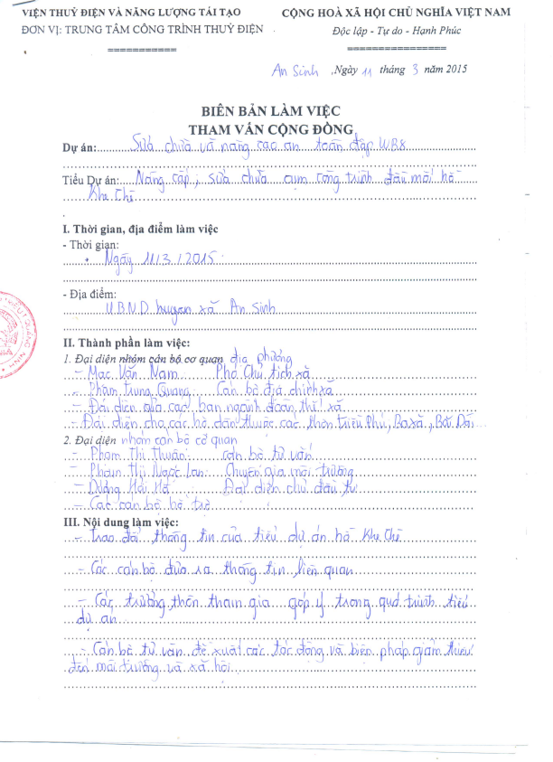
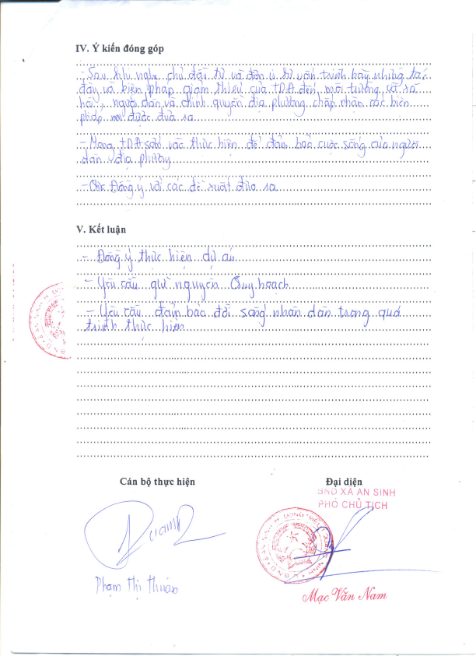
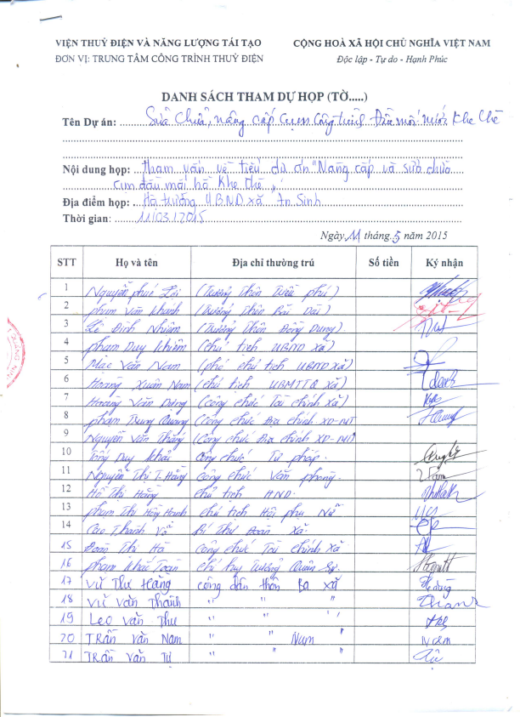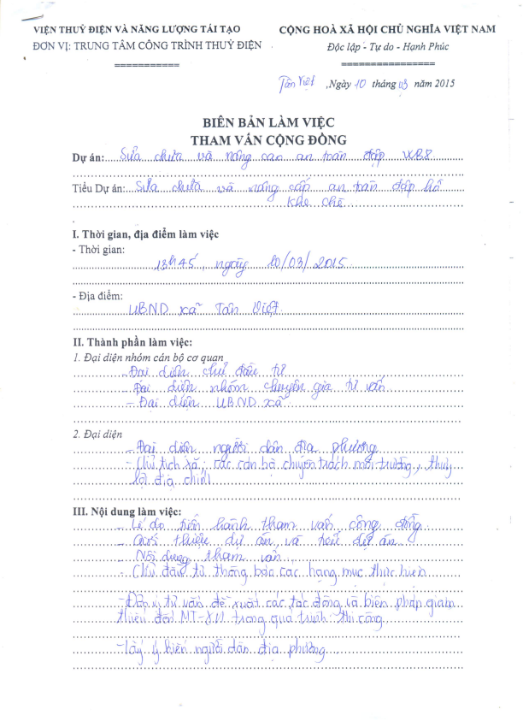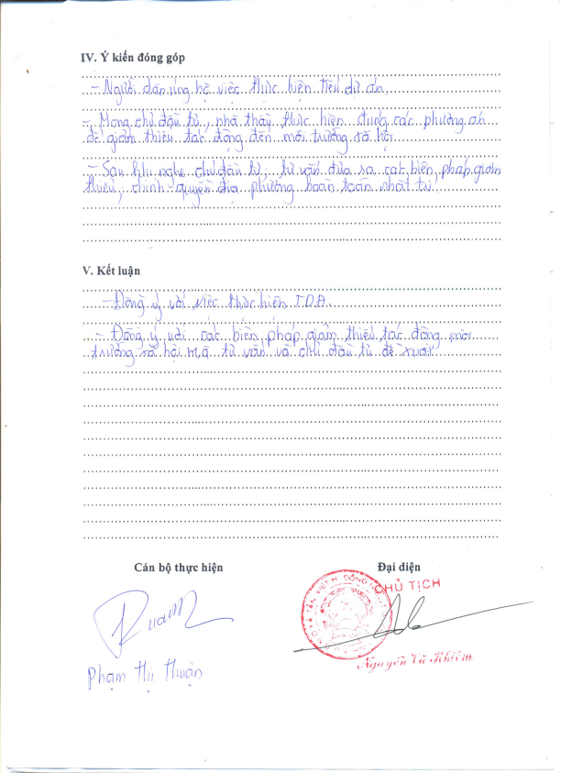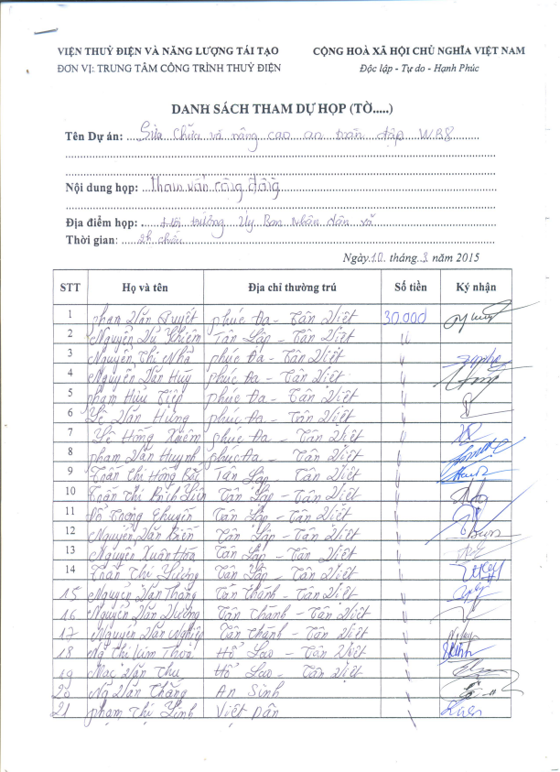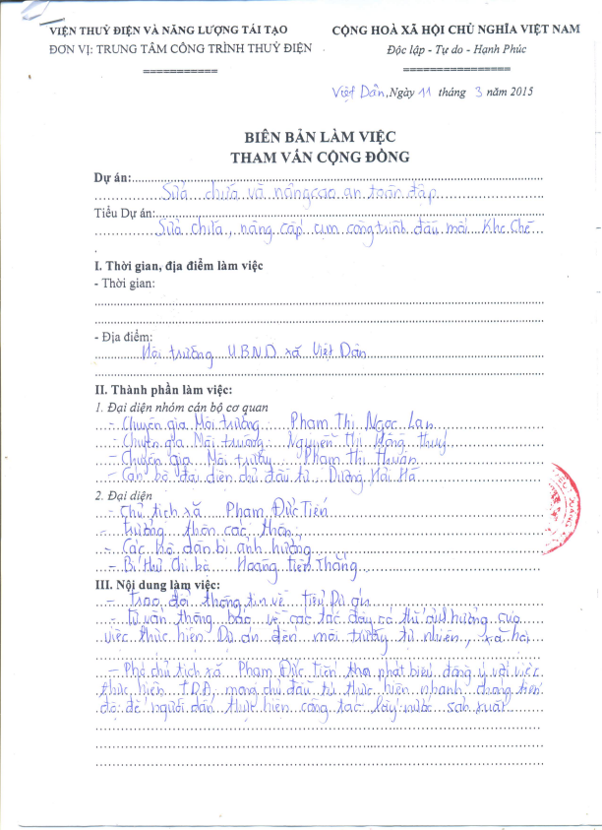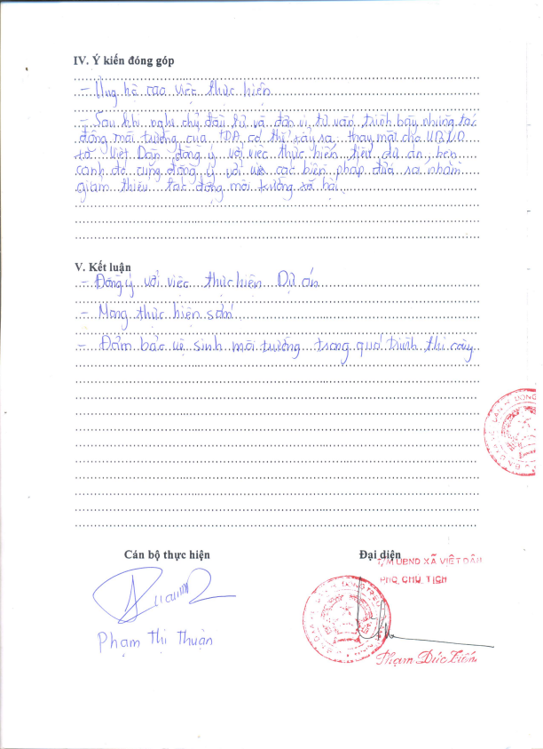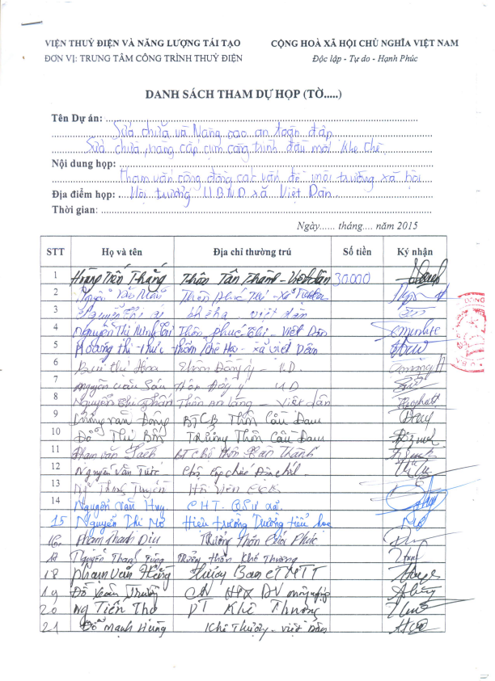

Critical habitats include existing protected areas and areas officially proposed by governments as protected areas (e.g., reserves that meet the criteria of the World Conservation Union [IUCN] classifications, areas initially recognized as protected by traditional local communities (e.g., sacred groves), and sites that maintain conditions vital for the viability of these protected areas. Sites may include areas with known high suitability for bio-diversity conservation; and sites that are critical for rare, vulnerable, migratory, or endangered species.
PCR is defined as movable or immovable objects, sites, structures, groups of structures, and natural features and landscapes that have archaeological, paleontological, historical, architectural, religious, aesthetic, or other cultural significance. They may be located in urban or rural settings, above or below ground, or under water. Their cultural interest may be at the local, provincial or national level, or within the international community.
CSBs is established in accordance with Decision No.80/2005/QD-TTg dated 18/04/2005 of Prime Minister on issuance of Public Monitoring Investment Regulation. Article 8 of Decree No.80/2006/NĐ-CP provides community opportunities to inspect the compliance, implement supervision and investment effect assessment in communes, including the environment impact.

